Generation II Coastal Risk Model   
User’s Manual

# Introduction

This user manual has been written to accompany version 4.557 of Generation II Coastal Risk Model (G2CRM). This manual was last updated on 29 January 2019. This document contains introductory general information, step-by-step procedures for working with G2CRM, and supplemental materials including a glossary of terms. Additional documentation is available on the model background, theory and framework. Walk-through videos demonstrating specific model functions are also available.

## Background

The U.S. Army Corps of Engineers (USACE or Corps) has a mission to manage flood risks:

*“The USACE Flood Risk Management Program (FRMP) works across the agency to focus the policies, programs and expertise of USACE toward reducing overall flood risk. This includes the appropriate use and resiliency of structures such as levees and floodwalls, as well as promoting alternatives when other approaches (e.g., land acquisition, flood proofing, etc.) reduce the risk of loss of life, reduce long-term economic damages to the public and private sector, and improve the natural environment.”*

As a part of that mission, the Institute for Water Resources (IWR) in cooperation with other Corps groups has developed the Generation II Coastal Risk Model (G2CRM) to support planning-level studies of hurricane protection systems (HPS). The G2CRM is distinguished from other models currently used for that purpose by virtue of its focus on probabilistic life cycle approaches. This allows for examination of important long-term issues including the impact of climate change and avoidance of repetitive damages.

Key features of the model include the ability to use readily available data from existing sources and corporate databases and integration with geographic information systems (GIS). The G2CRM generates a wide variety of outputs useful for estimating damages and costs, characterizing and communicating risk, and reporting detailed model behavior, in the without-project condition and under various plan alternatives for the with-project condition.

## Model Framework

The G2CRM is a desktop computer model that implements an object-oriented probabilistic life cycle analysis (PLCA) model using event-driven Monte Carlo simulation (MCS). This allows for incorporation of time-dependent and stochastic event-dependent behaviors such as sea level change, tide, and structure raising and removal. The model is based upon driving forces (storms) that affect a coastal region (study area). The study area is comprised of individual sub-areas of different types that may interact hydraulically and may be defended by coastal defense elements that serve to shield the areas and the assets they contain from storm damage. The model is scalable in that different levels of detail can be used for the data that drives the model, with lower levels of detail at early stages of model application (fewer storms, aggregated assets) and more refined representations used as new data become available.

Within the specific terminology of G2CRM, the important modeled components are:

* **Driving forces** - storm hydrographs (surge and waves) at locations, as generated externally from high fidelity storm surge and nearshore wave models such as ADCIRC and STWAVE;
* **Modeled areas** (MAs) - areas of various types (coastal upland, unprotected area) that comprise the overall study area. The water level in the modeled area is used to determine consequences to the assets contained within the area.
* **Protective system elements** (PSEs) - the infrastructure that defines the coastal boundary be it a coastal defense system that protects the modeled areas from flooding (levees, pumps, closure structures, etc.), or a locally developed coastal boundary comprised of bulkheads and/or hardened shoreline.
* **Assets** – spatially located entities that can be affected by storms. Damage to structure and contents is determined using damage functions. For structures, population data at individual structures allows for characterization of loss of life for storm events.

Within each general component category (e.g. PSEs, MAs, Assets), different element types exist with data needs specific to that type. Due to the object-oriented paradigm of the model, it is relatively simple to add new elements and change the characterization and behavior of existing model elements, for example to add a more sophisticated approach to rebuilding for assets.

The model deals with the engineering and economic interactions of these elements as storms occur during the life cycle, areas are inundated, protective systems fail, and assets are damaged and lives lost. A simplified representation of hydraulics and water flow is used. Modeled areas currently include unprotected areas and coastal uplands defended by a seawall or bulkhead. Protective system elements are limited to bulkheads/seawalls.

## Data Organization

The basic organizing concept for G2CRM is the “study”. It is a defined area for which the planning level analysis is to be performed. A study consists of one or more representations, each of which has a definition of the storms, assets, hurricane protection system, and plan alternatives that are to be examined. The purpose of a representation is to allow different levels of definition during the course of a study. For any given model run, a study and representation need to be selected by the user.

Data for the G2CRM is organized into themes. Each theme is represented by a corresponding database consisting of multiple tables. The major themes currently utilized are: storms, system (hurricane protection system elements); assets; and plan alternatives.

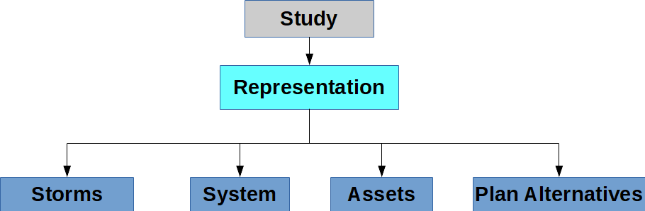

## Model Runs

A model run is a user-initiated launch of the G2CRM for a given representation within a study. The parameters of the model run are defined by a set of run conditions and a plan alternative. Results are organized by each model run. This structure allows for development of comparable analyses for different project alternatives, and comparison of results. Each model run is associated with a ‘sea level change scenario’ (low, intermediate, and high) that is reflective of Corps policy and guidance as to how sea level change is to be handled.

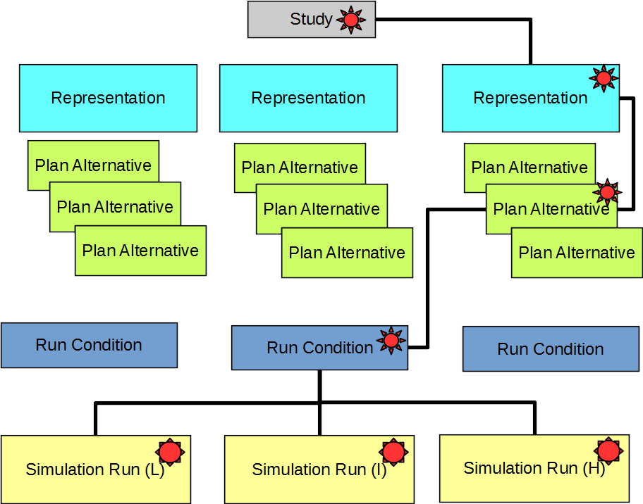

## Model User Interface

The G2CRM makes use of a modern desktop user interface (UI) containing a set of elements including:

* Dockable and resizable windows
* A ribbon toolbar to organize user activities
* A map pane displaying the study area
* A tree-view pane (explorer window) that allows for navigation, selection and editing of study, representation, and run condition data
* A data pane that presents either editable form or data grid views to the user

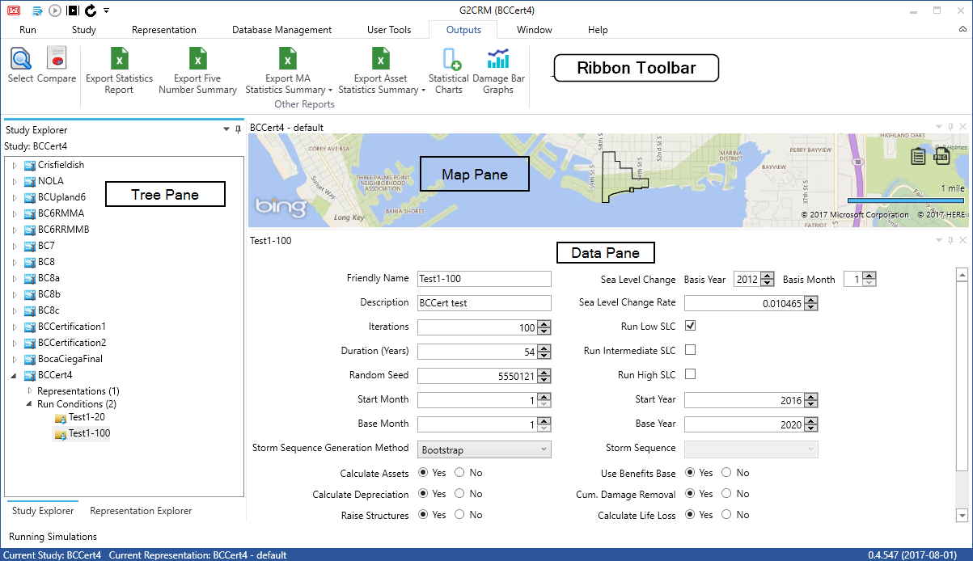

An alternate tree in the tree pane allows for exploration of the individual themes for the current representation, and viewing/editing in a data grid in the data pane.

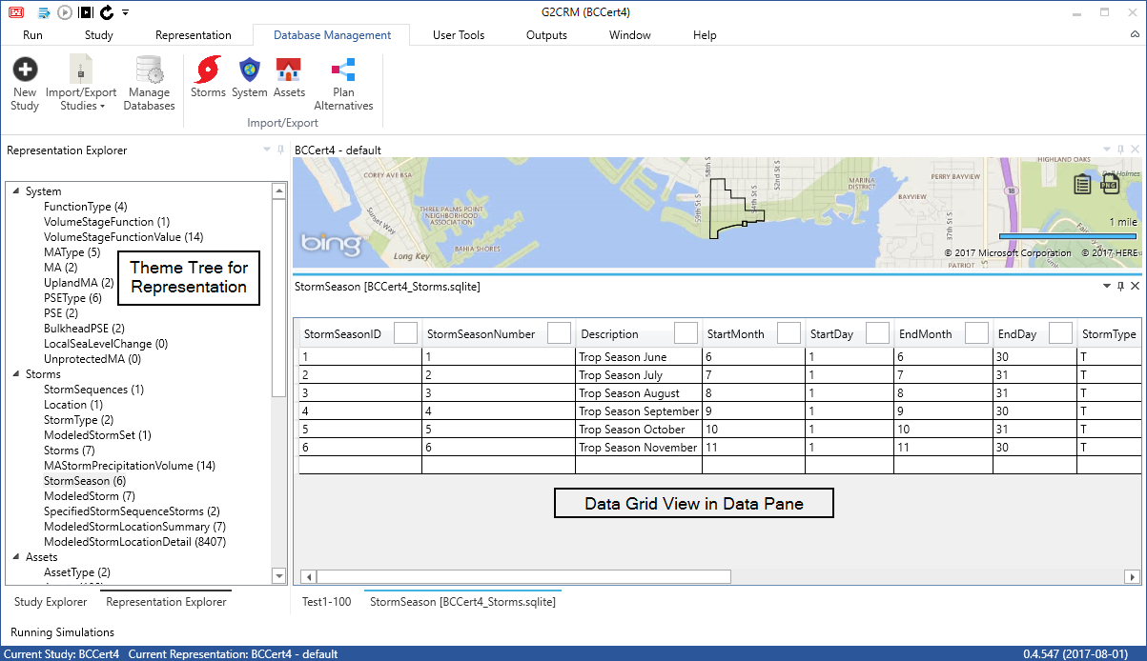

## Workflow

The G2CRM is intended to support a particular workflow for a study. The steps described in this document for creating a study assume that input data is available in the appropriate format.

This document does not contain descriptions of data development procedures for G2CRM, but the basic approaches are as follows.

Work can proceed on all data themes in parallel, but experience has shown that it is best to start with storm data first. Asset and system themes data can be developed at the same time. Plan alternative data can be developed at a later date as the G2CRM provides a default ‘without project’ plan alternatives. The G2CRM provides templates for all needed data import formats.

* Storms
  + Obtain storm data from the Coastal Hazards System in H5 file format
  + Specify storm probabilities and seasonality in an Excel™ spreadsheet
* System
  + Use a GIS to create locational and attribute information on the Modeled Areas and Protective System Elements, in shapefile format
* Assets
  + Obtain asset locational and attribute information as a shapefile using the defined G2CRM template. This is information can typically be obtained from local sources such as county auditor files, or the National Structure Inventory (NSI) can be used to generate synthetic assets based on census information.
  + Damage functions and other auxiliary data is provided in an Excel™ spreadsheet.

Once the relevant information has been assembled, the G2CRM UI supports workflow as follows:

1. Create a new (empty) study
2. Import data from ‘raw’ data sources – storms, system, assets, and plan alternatives, in that order
3. Perform data checks
4. Create run conditions, specify desired outputs, and generate model runs
5. Review simulation run outputs and compare results

Additional capabilities exist within the UI to import/export data in various formats and to manage representations. Populated study databases can be shared between users through a simple ‘one-click’ export that compiles study data into a single ‘zip’ file that can then be imported by another user.

## Quick-Start

This guide contains detailed information on all aspects of using the G2CRM. The key steps to be followed in creating and using a study are described in the ‘Quick-Start’ Appendix of this documented.

# Study Management

Studies are the top-level organizational structure in G2CRM. Any representations, run conditions, or databases all exist within a study.

## Creating Studies

To create a new study, users should go to the “Database Management” tab and click “New Study”.

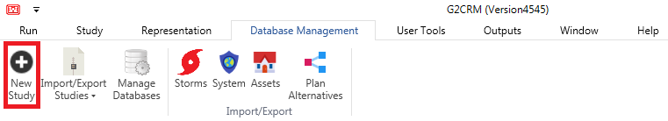

This will open a new window with a form:

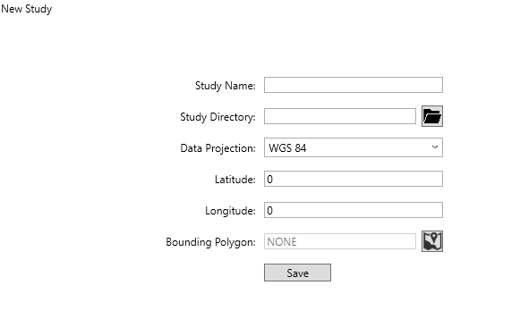

This form can then be filled out. The user must provide a study name, a study directory, the data projection (geographic projection) to be used for storing locations, and a bounding polygon in the form of a shapefile that gives the boundary of the study area.

|  |  |
| --- | --- |
| **Field** | **Description** |
| Study Name | Unique description for the study |
| Study Directory | Master directory folder, inside which the study directory will be created |
| Data Projection | Spatial reference code that should be used for the bounding polygon and all study spatial imports/exports |
| Latitude | Auto-fills depending on the bounding polygon |
| Longitude | Auto-fills depending on the bounding polygon |
| Bounding Polygon | Shapefile that is used to zoom the map in the application and to determine local tide stations for the study locations |

The study creation will take some time to complete, but will automatically open when it is done. A study is created with a default set of template databases and a default representation present.

## Opening an Existing Study

To open a study that already exists, right-click the study in the study explorer and select “Open Study”.

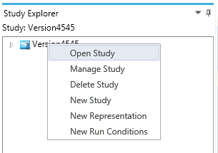

## Maintaining Study Settings

There are many configurable and non-configurable settings stored at the study level. The configurable settings are exposed and editable on the “Study” tab. Default settings are provided but can be changed by the user.

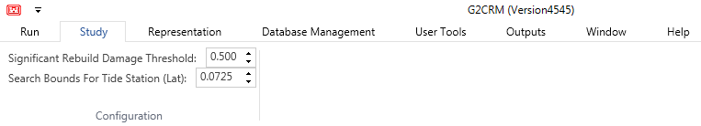

### Significant Rebuild Damage Threshold

Each study has a significant rebuild damage threshold associated with it. This is defaulted to 0.5. If the ratio of the damaged amount to the last pre-damage structure value exceeds this amount, then the rebuild will count towards the number of times the structure can be rebuilt. After the structure exceeds the number of times it can be rebuilt, it is taken out of the asset inventory for the remainder of the iteration. It is recommended that this value does not exceed the raising damage threshold of 0.5, as that would make the structure eligible for raising without counting as a rebuild.

### Search Bounds for Tide Station

Each study also has a parameter for the search bounds of the local tide stations. This is defaulted to 0.0725 degrees, which is approximately five miles when converted from latitude. This setting adjusts which tide stations are added to the local tide stations table during the H5 import.

## Importing/Exporting Studies

In some cases, the studies that need to be created already exist on another account or machine. Users can transfer studies using the study zip file import/export. This functionality can be found on the “Database Management” tab in the “Import/Export Studies” drop-down button.

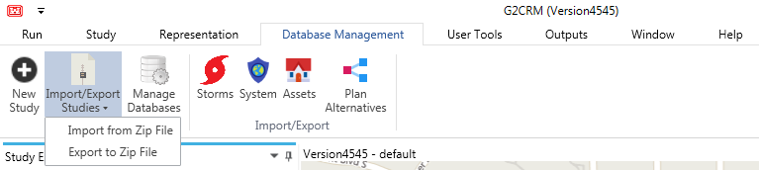

### Exporting Studies

To export a study, go to the “Database Management” tab and select the “Export to Zip File” option from the “Import/Export Studies” drop-down. Select a name and location for the zip file. Select which study should be included from the drop-down. Select as many representations and run conditions as desired (using the control key to select multiple items). Click export study when all selections have been made. A pop-up will appear when the study has exported.

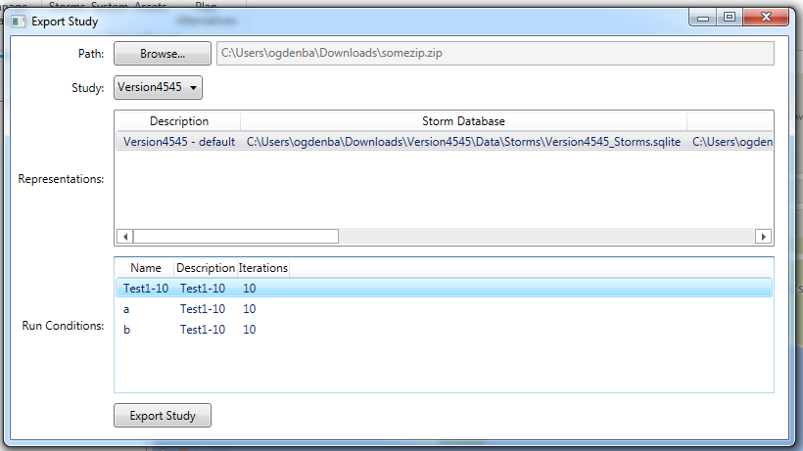

### Importing Studies

To import a study from a zip file, go to the “Database Management” tab and select the “Import from Zip File” option from the “Import/Export Studies” drop-down. Select a unique name for the study. Select a study folder (not required to be empty, as explained in the section on creating a study). Select a zip file created from the study export (explained above). After all selections, have been made, select “Import Study”. Please note that databases can only exist in one study within the application at a time, so a user would likely not find it useful to import their own studies. This functionality is intended to be used to share studies, representations, run conditions, and databases between users.

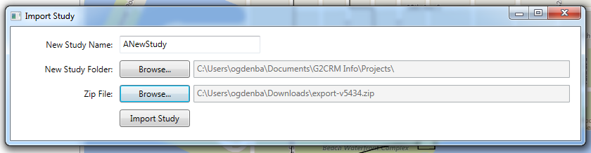

## Deleting Studies

To delete a study, users will need to right-click the study in the study explorer. In the context menu, users should select “Delete Study”. Users will confirm that they want to delete the specified study in the pop-up dialog and will receive a confirmation that the study has been deleted. This will delete the study from the G2CRM database, but will not delete the study folder and its outputs.

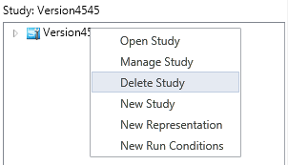

# Representation Management

Representations are the second layer of organization in the structure of G2CRM. Any databases that exist within a study may be used in that study’s representations. A representation is a collection of one of each type of database (Asset, Storm, System, and Plan Alternative) that make up the data that is used in a simulation. A study may have multiple representations, if desired.

When a study is created, a default representation (and an empty database of each type) are created and opened. Managing representations can allow the user to customize the use of G2CRM. However, creating/managing/deleting representations is not required for beginner users of G2CRM.

## Creating Representations

A new representation may be created by right-clicking the desired parent study in the study explorer. Select “New Representation” from the context menu. Choose a unique description for this representation and select the desired representation databases. One databases of each type must be selected.

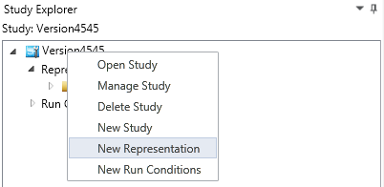

## Opening an Existing Representation

To open an existing representation, expand the group for the desired representation’s study in the study explorer. Expand the “Representation” group. Right-click the desired representation from the “Representation” group and select “Open” from the context menu.

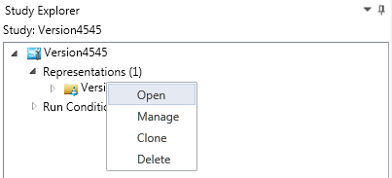

## Maintaining Representations

By right-clicking on the desired representation from the study’s “Representation” group in the study explorer, users can produce a context menu with a “Manage” option (shown in the image above). Select this option from the context menu. Make changes to the representation’s name or databases, as desired. Users must save changes or they will be lost.

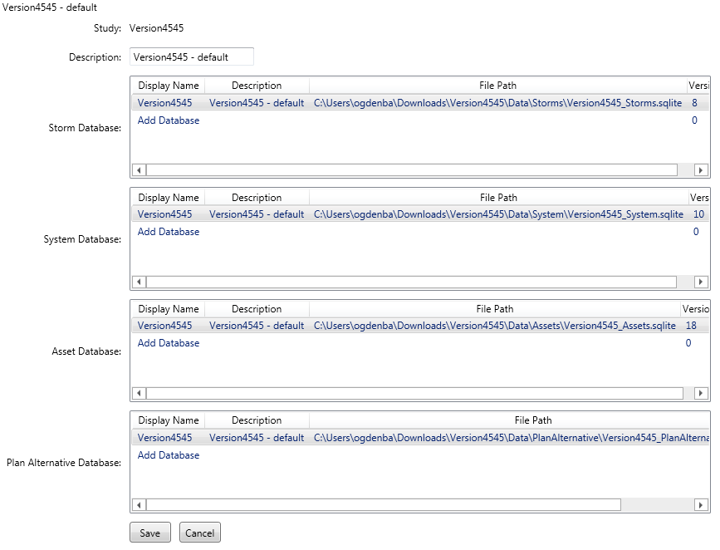

## Deleting Representations

To delete an existing representation, expand the group for the desired representation’s study in the study explorer. Expand the “Representation” group. Right-click the desired representation from the “Representation” group and select “Delete” from the context menu. Confirm the deletion in the pop-up dialog.

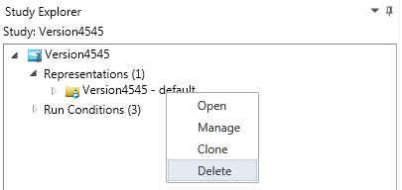

# Run Condition Management

Run conditions are a group of editable settings for a simulation run. These settings span a wide variety of variables from the sea level change rate to the number of years of an iteration. Run conditions exist within the context of a study and may be simulated with any representation inside of the parent study.

|  |  |
| --- | --- |
| **Setting** | **Definition** |
| Name | Unique string identifier given to identify the run conditions |
| Description | String identifier given to describe the run conditions to the user |
| Iterations | Number of iterations that the simulation should perform |
| Duration | Number of years that should be simulated for each iteration |
| Random Seed | A large prime number used to initialize the pseudorandom number generator |
| Start Month | The month of the year (1-12) that the simulation is to begin in |
| Start Year | The year (YYYY) that the simulation is to begin in |
| Base Month | The month of the year (1-12) that the simulation measures present value from |
| Base Year | The year (YYYY) that the simulation is to measure present value from |
| Storm Sequence Generation Method | The method that storms are generated can either be bootstrap (the model controls the generation of storms) or read as stored (the user imports data for manual storm generation) |
| Calculate Assets | A Boolean indicating whether the simulation should use assets (“Yes”) or run the simulation with no assets (“No”) (default is on) |
| Calculate Depreciation | A Boolean indicating whether the simulation will depreciate assets linearly over the lifecycle of the simulation (default is on) |
| Raise Structures | A Boolean indicating whether the assets should be raised (default is on) |
| Interest Rate | Decimal format of the interest rate used to calculate the net present value factor for the simulation |
| Sea Level Change Basis Year | Basis year for sea level change, which is controlled at the study-level and defaulted to 2012. Can be overridden with the storms import by a basis year for an individual storm. |
| Sea Level Change Basis Month | Basis month for sea level change, which is controlled at the study-level and defaulted to 1 |
| Sea Level Change Rate | Sea level change rate in average feet per year over the time period start month/year to simulation end date |
| Run No SLC | A Boolean indicating whether the no sea level change scenario should be run |
| Run Low SLC | A Boolean indicating whether the low sea level change scenario should be run |
| Run Intermediate SLC | A Boolean indicating whether the intermediate sea level change scenario should be run |
| Run High SLC | A Boolean indicating whether the high sea level change scenario should be run |
| Storm Sequence | The numerical identifier of the storm sequence that should be ran if the generation method is “read as stored” (actual storm sequence that will run depends on the representation selected and its current storm database) |
| Use Benefits Base | A Boolean indicating whether the statistics for the simulation should recognize the in-benefits base status of the structure (“Yes”) or assume all structures are in the benefits base (“No”) (default is on) |
| Cumulative Damage Removal | A Boolean indicating whether the model should remove structures from inventory once they reach the cumulative damage threshold (default is off) |
| Calculate Life Loss | A Boolean indicating whether the model should calculate life loss during the simulation (default is on) |

## Creating Run Conditions

A new set of run conditions may be created by right-clicking the desired parent study in the study explorer. Select “New Run Conditions” from the context menu. Choose a unique (within the study) name for this set of run conditions and make the desired selections in the run conditions form. Save changes before exiting the form.

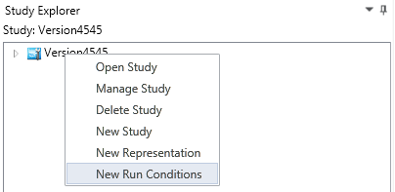

## Maintaining Run Conditions

By right-clicking on the desired set of run conditions from the study’s “Run Conditions” group in the study explorer, users can produce a context menu with a “Manage” option. Select this option from the context menu. The form shown below will allow changes to be made to the run conditions. After making the changes, save the run conditions.

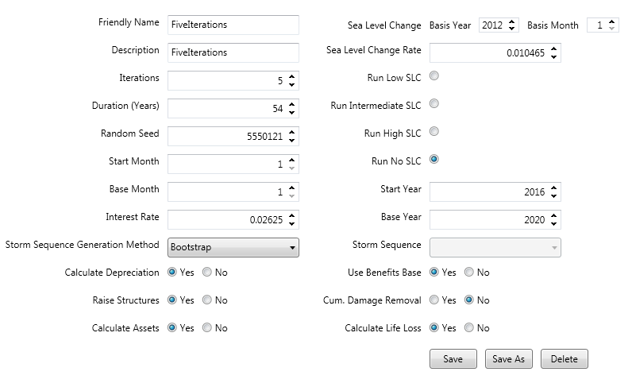

## Deleting Run Conditions

To delete existing run conditions, expand the group for the desired run conditions’ study in the study explorer. Expand the “Run Conditions” group. Right-click the desired run conditions from the “Run Conditions” group and select “Delete” from the context menu. Confirm the deletion in the pop-up dialog. A pop-up dialog will confirm deletion.

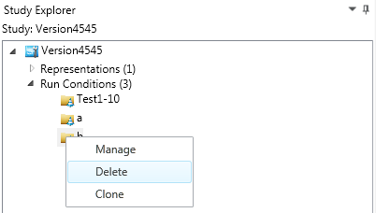

# Database Management

A database, in G2CRM, exists within the context of the study. A database may be used inside multiple representations within a study, but may not be used in representations with different parent studies.

## Importing Databases

To import a database into a study, expand the study in the study explorer. Expand the “Representations” item. Right-click on any representation inside the desired study. (It’s recommended to right-click on the representation for which the database will be used.) Select “Manage” from the context menu. Click “Add Database” within any of the database grids in the representation view.

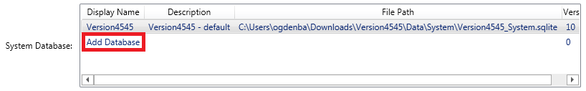

Fill in the information in the “Import Database” pop-up and click “Save”. The newly imported database may now be saved as a database in the representation that is open in the view, if desired.

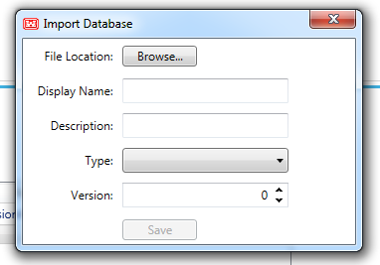

## Deleting Databases

As mentioned above, databases exist inside of studies. To delete a database from a study, follow the directions above for opening the desired study (if it is not already opened). Once the study is open, go to the “Database Management” tab and select “Manage Databases”.

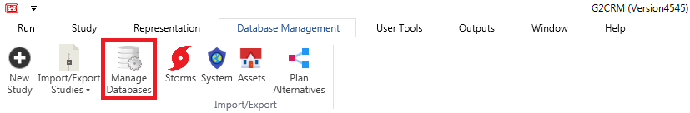

A pop-up will appear and on the far-right there will be three icons for each database. Select the left-most icon (“Remove database”) for each database that you would like deleted. In the pop-up to follow, select whether you would like to delete the database or just remove the database from the model.

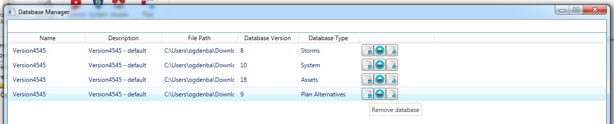

# Importing/Exporting Data

Data imports are done in most cases through excel files for non-spatial data and through shapefiles for spatial data. To import data, users will need to export the data templates, fill the data in, and import the completed file. In general, imports to G2CRM should be done working left to right across the “Import/Export” button group and from left to right across the Storm/System/Asset/Plan Alternative button groups.

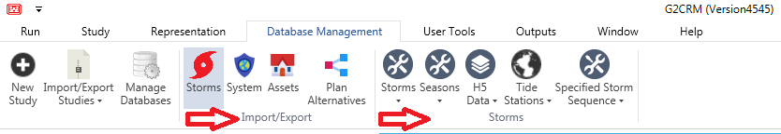

While it is important that users are in the correct study when they import data, it is also important that users are in the correct study when they export the templates. Spatial templates are made using the spatial reference code selected at the time of study creation (shown in the image below). Exports read this code to set the spatial reference for the file and imports assume the spatial reference code for the import matches the study.

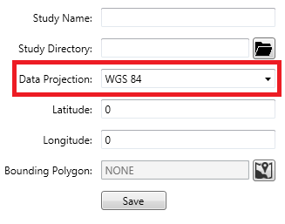

After the import is completed, it is recommended that users go to the "Window" tab and click "Refresh Explorers" to update the trees in the representation explorer and the drop-downs on the ribbon menu's "Run" tab.

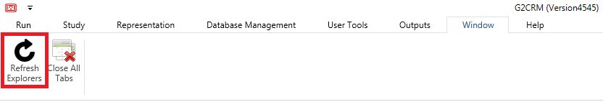

## Storms Data

Importing/exporting of the storms data can be found on the “Database Management” tab by clicking the “Storms” button.

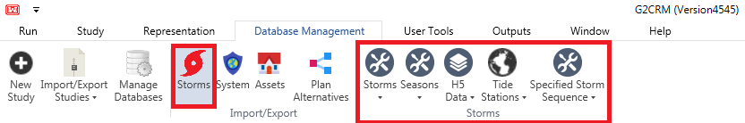

### Storms Data

From the “Storms” button, select “Storm” inside the newly produced “Storms” button group. This button will have drop-down options “Import Data” and “Export Data”.

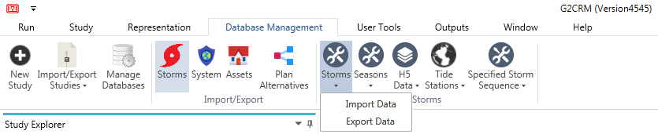

Before users are ready to import, they will first need to export a storms template and fill it with data. An example of the storms data is shown below.

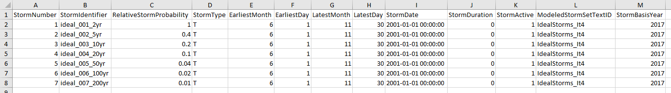

When filling out the storms template, it is important to reference the corresponding H5 file(s). The StormIdentifier column should be obtained from the StormName attribute for the storm as shown highlighted in red below. (Example is from a different data set, so this value doesn’t match the StormIdentifier shown above.) This is a common issue with storm imports, especially when using CHS data.

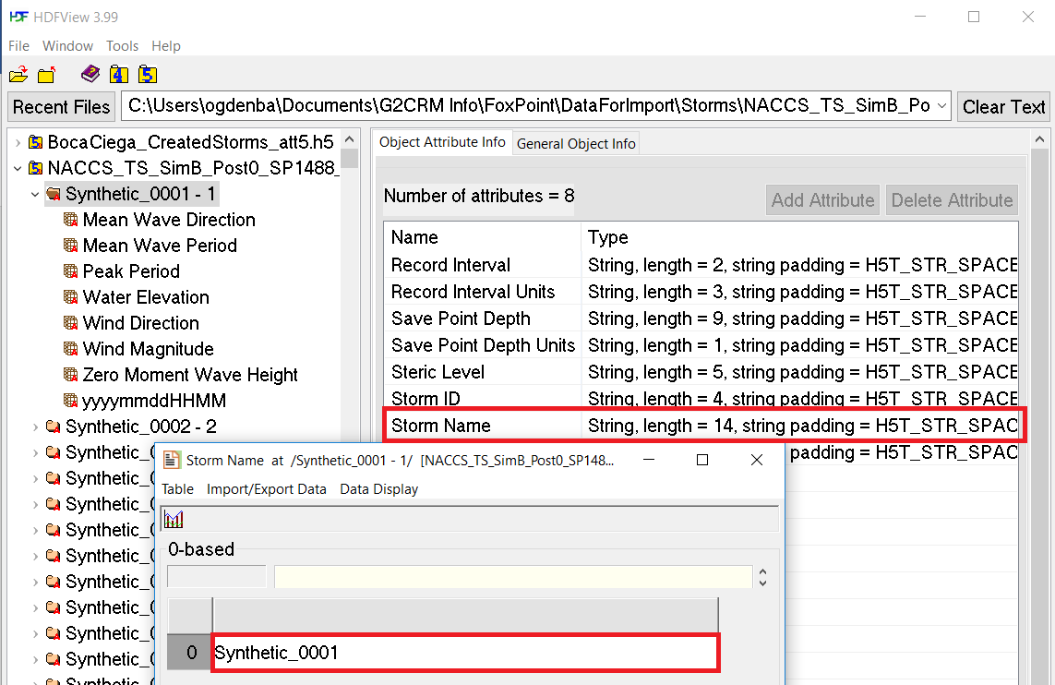

Export a storms template by selecting the “Export Data” item from the drop-down. The file explorer will request a name for the file and will produce the file when “Save” is clicked. This file will contain the names, storm windows, and relative probabilities of the storms within the modeled storm set. The modeled storm set names needs to correspond to names within the H5 import file (later in the storms import). For more information about the storms data, see the table below:

|  |  |
| --- | --- |
| **Column** | **Description** |
| StormNumber | Unique numerical identifier for the storm |
| StormIdentifier | Unique text identifier for the storm |
| RelativeStormProbability | Relative probability of this storm occurring in a season as compared to other storms of the same type (tropical or extratropical) |
| StormType | Type of storm (T = Tropical, ET = Extra-Tropical) |
| EarliestMonth | Earliest month of the year that the storm can occur (1-12) |
| EarliestDay | Earliest day in the earliest month that the storm can occur (valid input depends on month) |
| LatestMonth | Latest month of the year that the storm can occur (1-12) |
| LatestDay | Latest day in the latest month that the storm can occur (valid input depends on month) |
| StormDate | Date historical storm occurred (in format YYYY-MM-DD H24:mm:ss) |
| StormDuration | Duration of the storm in hours (or 0 to auto-generate the duration) |
| StormActive | A Boolean indicating whether the storm is active (0 = No, 1 = Yes) |
| ModeledStormSet | Storm’s modeled storm set (should correspond with H5 import) |
| StormBasisYear | Basis year used in the calculation of sea level change for the storm. The basis year in the run condition is used if this is not set. |

Import a storm data set by selecting the “Import Data” item from the drop-down. The file explorer will request a path to the storm data file and will import the file when “Open” is clicked. A pop-up confirming import will display when the import is complete. When storms data is imported, the data is inserted or updated in the database. This import can be redone at any time and will replace the old data with the newly imported data.

### Seasons Data

From the “Storms” button, select “Seasons” inside the “Storms” button group. This button will have drop-down options “Import Data” and “Export Data”. Before users are ready to import, they will first need to export a seasons template and fill it with data. An example of the seasons data is shown below.

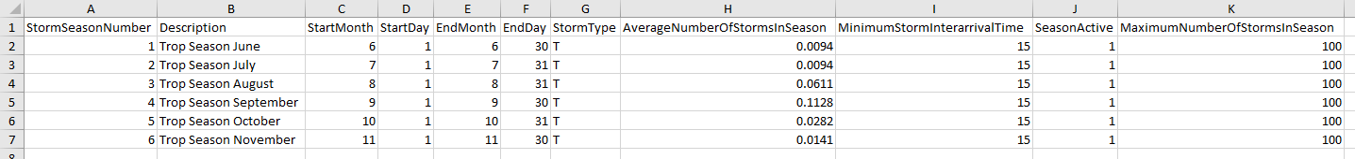

Export a seasons template by selecting the “Export Data” item from the drop-down. The file explorer will request a name for the file and will produce the file when “Save” is clicked. The Seasons file contains the description of the seasonality to be used by the model and the average number of storms per season, for purposes of random generation of storms in each season/year. For more information about the seasons data, see the table below:

|  |  |
| --- | --- |
| **Column** | **Description** |
| StormSeasonNumber | A unique numerical identifier for the storm season |
| Description | A description of the season |
| StartMonth | The month (1-12) that the season starts |
| StartDay | The day (valid values depend on the StartMonth) that the season starts |
| EndMonth | The month (1-12) that the season ends |
| EndDay | The day (valid values depend on the EndMonth) that the season ends |
| StormType | Storm type (T = Tropical, ET = Extra-Tropical) |
| AverageNumberOfStormsInSeason | Average number of storms in the specified season |
| MinimumStormInterarrivalTime | Minimum number of days between generated storm events |
| SeasonActive | A Boolean indicating if the season is active (1 = yes, 0 = no) |
| MaximumNumberOfStormsInSeason | An upper limit on the number of storms that can occur in a season |

Import a storm season data set by selecting the “Import Data” item from the drop-down. The file explorer will request a path to the storm season data file and will import the file when “Open” is clicked. A pop-up confirming import will display when the import is complete. When storm season data is imported, existing data is removed from the database before the import is performed. This import can be redone at any time and will replace the old data with the newly imported data.

### H5 Data

Storm data is expected to be in the H5 (HDF5) format, as provided by the Coastal Hazards System (<https://chs.erdc.dren.mil/default.aspx>).

Before beginning the H5 data import process, users will need to make sure that their search bounds (found in the “Study” tab) are the desired degrees. These search bounds will be used to determine which tide stations are considered local to the study and available for selection as a location’s tide station.

There are two parts to the H5 import. The H5 file and the metadata excel file. The H5 data is generated outside of the model, and has no export capability. Before users are ready to import, they will first need to export a metadata template and fill it with data.

From clicking the “Storms” button, select the “H5 Data” drop-down from the “Storms” group. The metadata file template is available in the “H5 Data” drop-down on the “Export Template” button. The file explorer will request a name for the file and will produce the file when “Save” is clicked. The excel file has two tabs: Metadata and StormsToKeep. StormsToKeep is just a list of storm names to keep from the H5 file (example shown below). These storm names should correspond with the storms import and the storm name metadata in the H5 file.

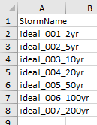

When filling out the H5 metadata template, it is important to reference the corresponding H5 file(s). The StormName column should be obtained from the top-level storm identifier for the storm as shown highlighted in red below. (Example is from a different data set, so this value doesn’t match the StormIdentifier shown above.) This is a common issue with storm imports, especially when using CHS data.

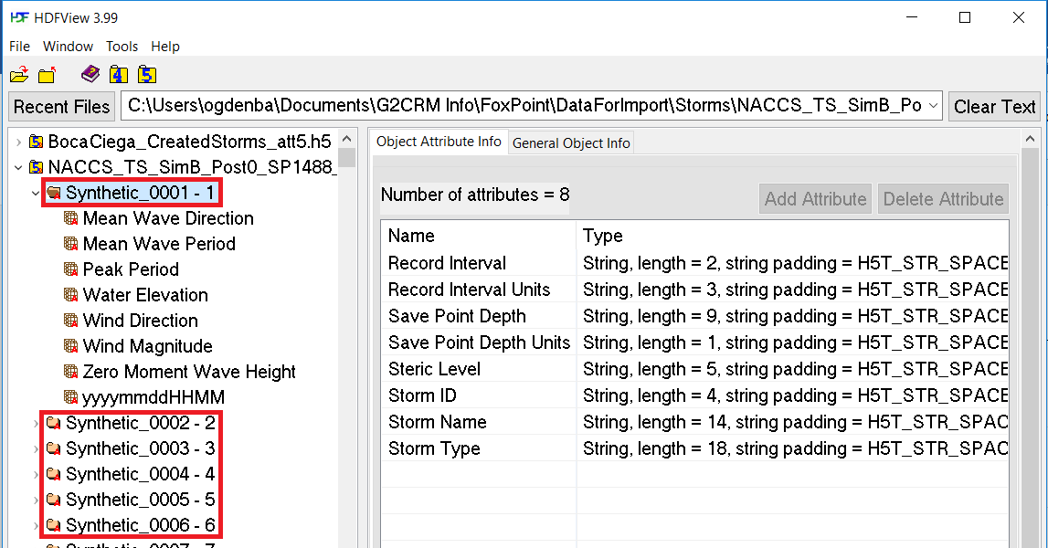

More details about the Metadata tab can be obtained from the example and table shown below:



|  |  |
| --- | --- |
| **Column** | **Description** |
| IsStwaveFormat | Format of the H5 file (1= STWAVE, 0 = ADCIRC) |
| ModeledStormSetTextId | Unique (within the representation) text identifier for the storm set |
| ModeledStormSetDescription | Description of the modeled storm set |
| StormDatumToAssetInventoryDatumConversion | Vertical conversion from storm datum to asset inventory datum (conversion from MSL to NAVD88) |
| MllwToStormDatumConversion | Vertical conversion from MLLW to MSL storm datum |
| UseWaveDataAsIs | 1 = Use wave data from H5, 0 = auto-generate wave data in model |

Users will generate the H5 file outside of the model. Keep in mind that meters are the expected units in the H5 files and are converted to feet during this import.

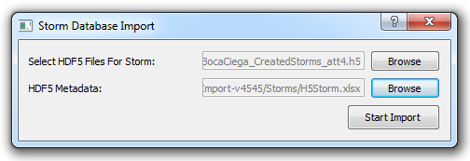

When the metadata excel file has been filled out and the H5 data has been generated, click the “Import Data” button from the “H5 Data” drop-down. The dialog shown above will appear. Use the “Browse” buttons to locate the H5 and excel files and click “Start Import”. An “Import Complete” pop-up will appear when the import has finished successfully. If this import is done multiple times, the data inside the model will be added to, rather than replaced.

### Tide Locations Data

Before the user is ready to set the tide stations for locations, they will need to use the “Export World Tide Stations Shapefile” and “Export Storm Locations” capabilities in the “Tide Stations” drop-down to generate location and tide station shapefiles. These files can be imported into a GIS viewer to determine which tide stations correspond with the locations. The tide stations file is shown in QGIS below.

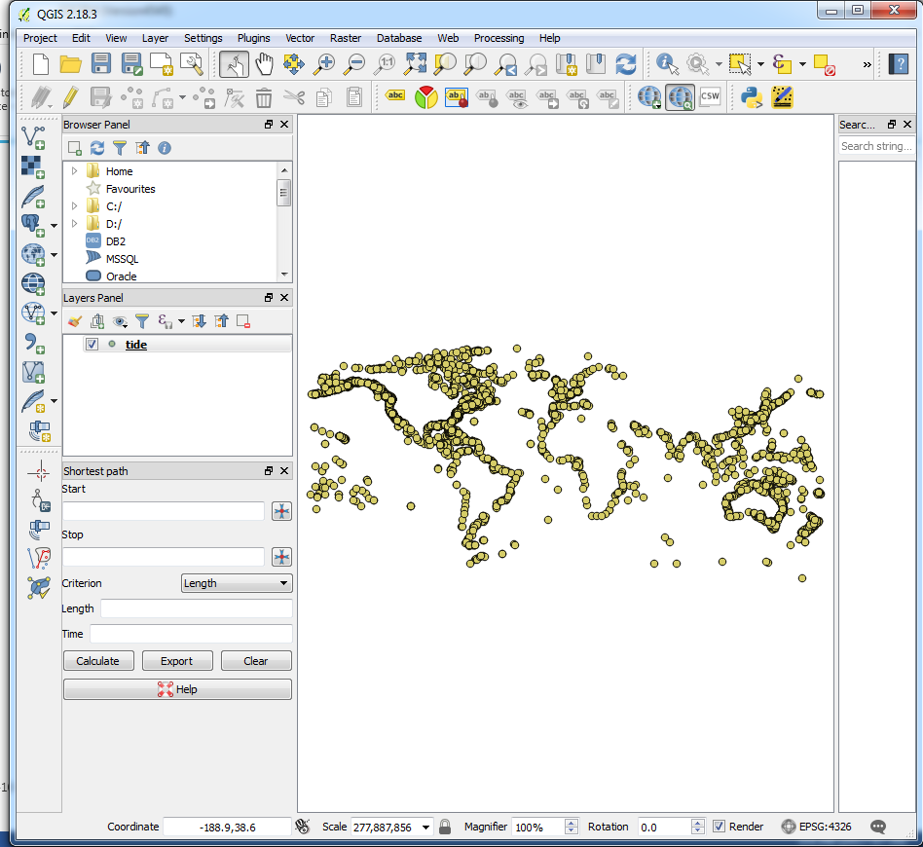

After the user decided on corresponding tide stations for each location, they can add the tide stations to the locations. This is done by going to the “Tide Locations” button in the “Storms” group and selecting the “Select Location Tide Stations” button from the drop-down. This will display a form (shown below) with all the locations where tide data can be edited. Change which location is displayed by selecting the location in the “Location” drop-down in the form. It is important that the user click “Save” before using the drop-down to open a new location. Each location should have at least one tide station.

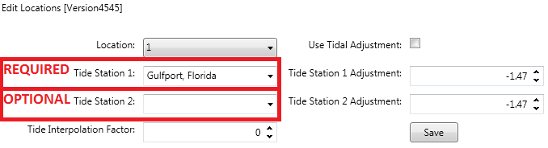

### Specified Storm Sequence Data

This functionality is only used if storm generation is to be done by specifying individual storms to be run, rather than through the random generation process (bootstrapping). This choice is made on the run conditions form, if ReadAsStored is selected.

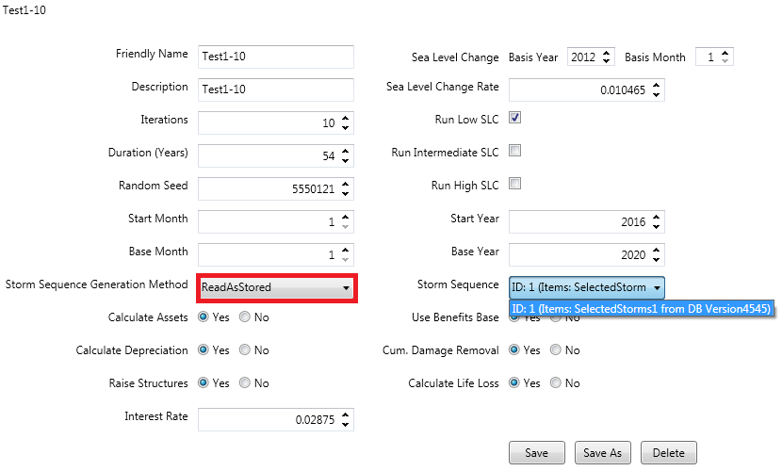

From the “Storms” button, select “Specified Storm Sequence” inside the “Storms” button group. This button will have drop-down options “Import Data” and “Export Data”. Before users are ready to import, they will first need to export a specified storm sequence template and fill it with data. An example of this data is shown below.

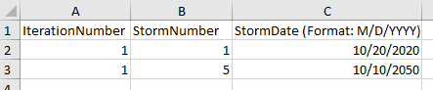

Export a template by selecting the “Export Data” item from the drop-down. The file explorer will request a name for the file and will produce the file when “Save” is clicked. If the database is empty, then there will be one page (a placeholder) generated for the export. If there is data in the database, there will be one page generated for each group of storm sequences. To add a new storm sequence, add a new tab and name it the desired name of the storm sequence or rename the placeholder sheet. For more information about the specified storm sequence data, see the table below:

|  |  |
| --- | --- |
| **Column** | **Description** |
| SpecifiedStormSequenceID | Unique ID used to specify a storm |
| StormSequenceID | Unique ID used to specify a storm sequence |
| IterationNumber | Iteration number that the storm should be run in |
| StormNumber | Storm number (from the storms import and storms table) |
| StormDate | Date that the storm should occur in the given iteration |

Import a specified storm sequence by selecting the “Import Data” item from the drop-down. The file explorer will request a path to the specified storm sequence data file and will import the file when “Open” is clicked. A pop-up confirming import will display when the import is complete. When specified storm sequence data is imported, existing data is removed from the database before the import is performed. This import can be redone at any time and will replace the old data with the newly imported data. After re-import, users may need to check that they have a valid storm sequence ID selection made in any run conditions that were set to be read as stored.

## System Data

Importing/exporting of the system data can be found on the “Database Management” tab by clicking the “System” button.

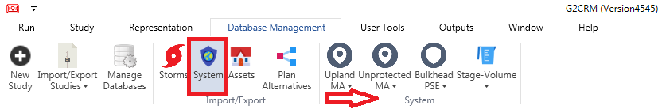

### Upland Modeled Area Data

From the “System” button, select “Upland MA” inside the “System” button group. This button will have drop-down options “Import Data”, “Export Data”, and “Export Template”. Before users are ready to import, they will first need to export an upland modeled area (MA) shapefile template and fill it with data. This can be done in a GIS viewer (QGIS, for example, mentioned in the “Additional Software” section). An example of upland data displayed in QGIS is shown below.

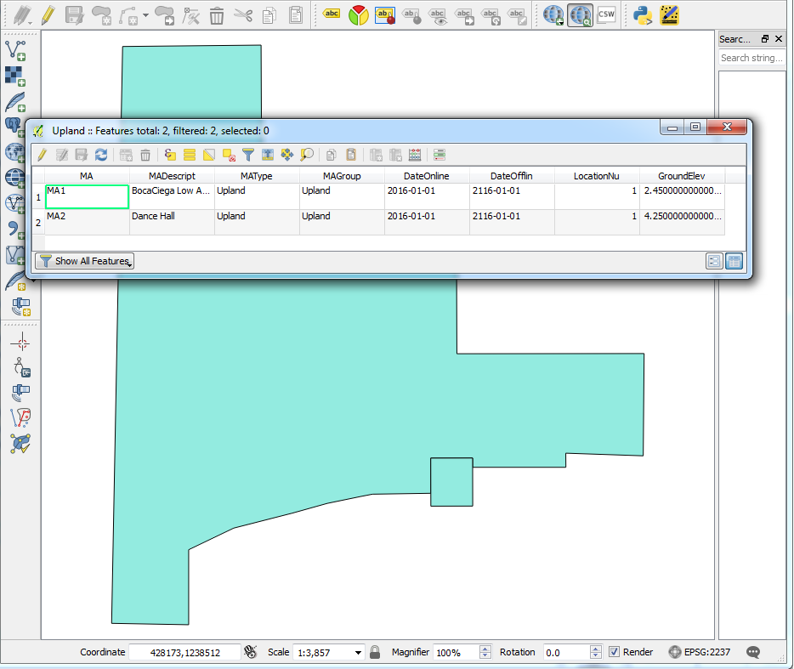

Export a template by selecting the “Export Template” item from the drop-down. The file explorer will request a name for the file and will produce the file when “Save” is clicked. Use a GIS viewer to add data to the shapefile. For more information about the data, see the table below:

|  |  |  |
| --- | --- | --- |
| **Shapefile Column** | **Database Column** | **Description** |
| MA | MA | Unique (with respect to all MAs) text name for the modeled area |
| MADescript | MADescription | Description of the modeled area |
| MAType | MAType | Type of modeled area (should be “Upland” for this file) |
| MAGroup | MAGroup | Group to which this modeled area belongs |
| DateOnline | DateOnline | Date the MA is online (YYYY-MM-DD) |
| DateOfflin | DateOffline | Date the MA is offline (YYYY-MM-DD) |
| LocationNu | LocationNumber | Location number (corresponding to the H5 import) of the modeled area |
| GroundElev | WatersideGroundElevation | Waterside ground elevation |

Depending on if the modeled area has a storage area, the volume-stage export may also need to be done at this time. There should be one volume-stage export (with exactly one volume-stage function, VSF) for each storage area. This file can be exported from the “Volume-Stage” button under “Export Data”. An example is shown below. Notice how there is just one VSF, and the VSF appears on the “VolumeStageFunction” sheet and corresponds with the name of the sheet with the coordinates.

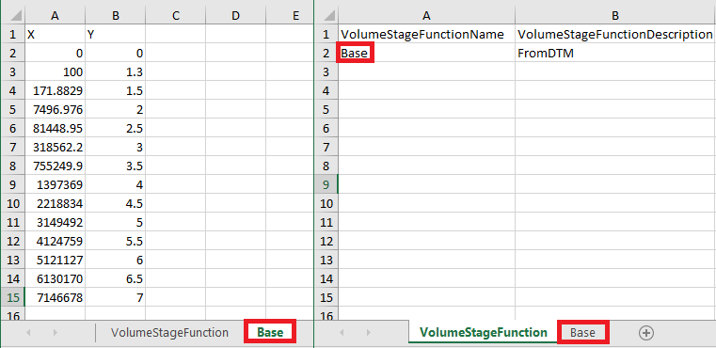

Import the upland modeled areas by selecting the “Import Data” item from the drop-down. The file explorer will request a path to the upland MA shapefile and will import the file when “Open” is clicked. For each upland MA, the user will be prompted to select if it has an associated storage area. If the user selects “Yes” then they will need to provide the corresponding volume-stage function. Once all data has been imported, a pop-up confirming import will display. When upland MA data is imported, existing upland data will be removed from the database before the import is performed.

This import can be redone at any time and will replace the old data with the newly imported data. After re-import, users will need to reassign the asset-MA correspondences (as shown below).

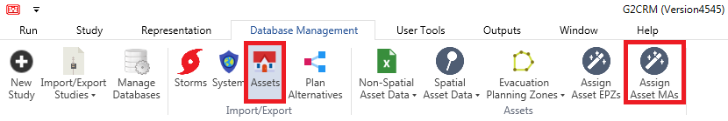

If reimport is needed, it may be useful to “Export Data”, which gives a shapefile of all the upland data in the database, rather than “Export Template”. This speeds up making small changes and reimporting.

### Unprotected Modeled Area Data

From the “System” button, select “Unprotected MA” inside the “System” button group. This button will have drop-down options “Import Data”, “Export Data”, and “Export Template”. Before users are ready to import, they will first need to export an unprotected modeled area (MA) shapefile template and fill it with data.

Export a template by selecting the “Export Template” item from the drop-down. The file explorer will request a name for the file and will produce the file when “Save” is clicked. Use a GIS viewer to add data to the shapefile. For more information about the data, see the table below:

|  |  |  |
| --- | --- | --- |
| **Shapefile Column** | **Database Column** | **Description** |
| MA | MA | Unique (with respect to all MAs) text name for the modeled area |
| MADescript | MADescription | Description of the modeled area |
| MAType | MAType | Type of modeled area (should be “Upland” for this file) |
| MAGroup | MAGroup | Group to which this modeled area belongs |
| DateOnline | DateOnline | Date the MA is online (YYYY-MM-DD) |
| DateOfflin | DateOffline | Date the MA is offline (YYYY-MM-DD) |
| LocationNu | LocationNumber | Location number (corresponding to the H5 import) of the modeled area |
| GroundElev | WatersideGroundElevation | Waterside ground elevation |
| WaveAdjust | WaveAdjustment | A multiplier for adjusting the wave height (either generated or read from the database) of the unprotected area |
| FBPSE | FloodBarrierPSE | Name of the flood barrier PSE, as found in the flood barrier PSE’s PSE field. Blank if there is no associated flood barrier PSE. |

Import the unprotected modeled areas by selecting the “Import Data” item from the drop-down. The file explorer will request a path to the unprotected MA shapefile and will import the file when “Open” is clicked. Once all data has been imported, a pop-up confirming import will display. When unprotected MA data is imported, existing unprotected data will be removed from the database before the import is performed.

This import can be redone at any time and will replace the old data with the newly imported data. After re-import, users will need to reassign the asset-MA correspondences.



If reimport is needed, it may be useful to “Export Data”, which gives a shapefile of all the unprotected data in the database, rather than “Export Template”. This speeds up making small changes and reimporting.

### Flood Barrier Protective System Element Data

From the “System” button, select “Flood Barrier PSE” inside the “System” button group. This button will have drop-down options “Import Data”, “Export Data”, and “Export Template”. Before users are ready to import, they will first need to export a flood barrier protective system element (PSE) shapefile template and fill it with data. An example, displayed in QGIS, is shown below.

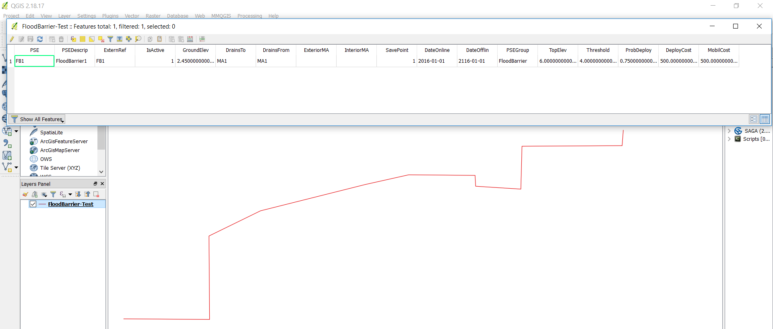

Export a template by selecting the “Export Template” item from the drop-down. The file explorer will request a name for the file and will produce the file when “Save” is clicked. Use a GIS viewer to add data to the shapefile. For more information about the data, see the table below:

|  |  |  |
| --- | --- | --- |
| **Shapefile Column** | **Database Column** | **Description** |
| PSE | PSE | Unique (with respect to all PSEs) name for the PSE |
| PSEDescrip | PSEDescription | Description of the PSE |
| ExternRef | PSEExternalReference | Unique (with respect to all PSEs) reference name for the PSE |
| IsActive | PSEActive/IsActive | Status of the PSE (1 = Active, 0 = Not Active) |
| GroundElev | WatersideGroundElevation | Waterside ground elevation of the PSE |
| DrainsTo | DrainsToMA | MA that the PSE drains to |
| DrainsFrom | DrainsFromMA | MA that the PSE drains from |
| ExteriorMA | ExteriorMA | Not used |
| InteriorMA | InteriorMA | Not used |
| SavePoint | AssociatedLocationNumber | Location number (from the H5 import) of the PSE |
| DateOnline | DateOnline | Date the PSE is online (YYYY-MM-DD) |
| DateOfflin | DateOffline | Date the PSE is offline (YYYY-MM-DD) |
| PSEGroup | PSEGroup | Name of the group that the PSE belongs to |
| TopElev | TopElevation | Top elevation of the PSE |
| Threshold | Threshold | Water level necessary for attempt at deployment. Checked before the storm and deployed at the beginning of the storm if the threshold is met. |
| ProbDeploy | DeploymentProbability | Fractional probability of successful deployment |
| DeployCost | DeploymentCost | Cost of maintaining deployment of a successfully deployed flood barrier PSE (applied on successful deployment) |
| MobilCost | MobilizationCost | Cost of attempting deployment of a flood barrier PSE (applied on unsuccessful and successful deployments) |

Import the flood barrier PSE by selecting the “Import Data” item from the drop-down. The file explorer will request a path to the flood barrier PSE shapefile and will import the file when “Open” is clicked. Once all data has been imported, a pop-up confirming import will display. When flood barrier PSE data is imported, existing flood barrier data will be removed from the database before the import is performed.

This import can be redone at any time and will replace the old data with the newly imported data. If reimport is needed, it may be useful to “Export Data”, which gives a shapefile of all the upland data in the database, rather than “Export Template”. This speeds up the process of making small changes and reimporting.

### Bulkhead Protective System Element Data

From the “System” button, select “Bulkhead PSE” inside the “System” button group. This button will have drop-down options “Import Data”, “Export Data”, and “Export Template”. Before users are ready to import, they will first need to export a bulkhead protective system element (PSE) shapefile template and fill it with data. An example, displayed in QGIS, is shown below.

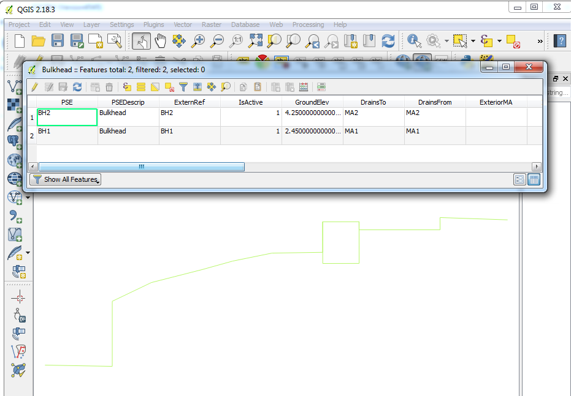

Export a template by selecting the “Export Template” item from the drop-down. The file explorer will request a name for the file and will produce the file when “Save” is clicked. Use a GIS viewer to add data to the shapefile. For more information about the data, see the table below:

|  |  |  |
| --- | --- | --- |
| **Shapefile Column** | **Database Column** | **Description** |
| PSE | PSE | Unique (with respect to all PSEs) name for the PSE |
| PSEDescrip | PSEDescription | Description of the PSE |
| ExternRef | PSEExternalReference | Unique (with respect to all PSEs) reference name for the PSE |
| IsActive | PSEActive | Status of the PSE (1 = Active, 0 = Not Active) |
| GroundElev | WatersideGroundElevation | Waterside ground elevation of the PSE |
| DrainsTo | DrainsToMA | MA that the PSE drains to |
| DrainsFrom | DrainsFromMA | MA that the PSE drains from |
| ExteriorMA | ExteriorMA | Not used |
| InteriorMA | InteriorMA | Not used |
| SavePoint | AssociatedLocationNumber | Location number (from the H5 import) of the PSE |
| DateOnline | DateOnline | Date the PSE is online (YYYY-MM-DD) |
| DateOfflin | DateOffline | Date the PSE is offline (YYYY-MM-DD) |
| PSEGroup | PSEGroup | Name of the group that the PSE belongs to |
| TopElev | TopElevation | Top elevation of the PSE |
| DesignElev | DesignWaterElevation | Not used |
| WeirCoef | ReachWeirCoefficient | Weir coefficient used to calculate the flow rate in the event of overtopping with an MA with an associated storage area |
| Length | Length | Length of the PSE |
| FragFuncN | InitialFragilityFunctionNumber | Not used |
| Material | Material | Not used |
| FBPSE | FloodBarrierPSE | Name of the flood barrier PSE, as found in the flood barrier PSE’s PSE field. Blank if there is no associated flood barrier PSE. |

Import the bulkhead PSE by selecting the “Import Data” item from the drop-down. The file explorer will request a path to the bulkhead PSE shapefile and will import the file when “Open” is clicked. Once all data has been imported, a pop-up confirming import will display. When bulkhead PSE data is imported, existing bulkhead data will be removed from the database before the import is performed.

This import can be redone at any time and will replace the old data with the newly imported data. If reimport is needed, it may be useful to “Export Data”, which gives a shapefile of all the upland data in the database, rather than “Export Template”. This speeds up the process of making small changes and reimporting.

### Stage-Volume Data

The volume-stage import is an optional data import. It should only be used in the event that users want to add multiple volume-stage functions to experiment with for a single upland MA. If users choose to do that, then they will need to create the association manually by altering the VolumeStageFunctionNumber in the UplandMA table after import, as shown below.

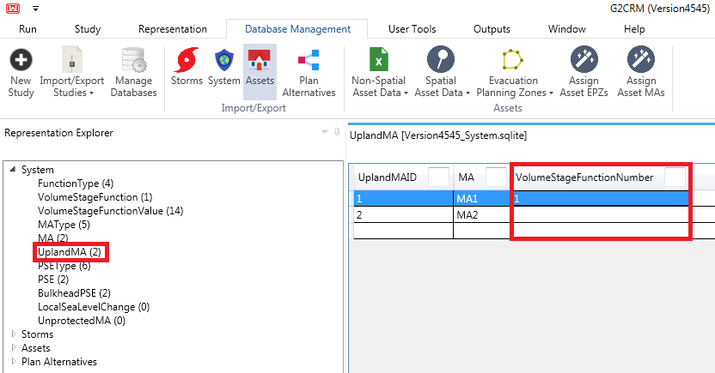

From the “System” button, select “Volume-Stage” inside the “System” button group. This button will have drop-down options “Import Data” and “Export Data”. Before users are ready to import, they will first need to export a template and fill it with data. An example of an import with one VSF is shown below.



Export a template by selecting the “Export Data” item from the drop-down. The file explorer will request a name for the file and will produce the file when “Save” is clicked. If there is data in the database, this data will be included in the export. If there is no data in the database, an example function will be included. The export consists of one “VolumeStageFunction” sheet with the unique function name and description, as well as a sheet named after each function with the stage in feet as a function of volume in cubic feet. If the export is being filled out for the volume-stage import, rather than the upland MA import, then all volume stage functions must be in the same workbook.

Import the volume-stage function by selecting the “Import Data” item from the drop-down. The file explorer will request a path to the file and will import the file when “Open” is clicked. Once all data has been imported, a pop-up confirming import will display. When data is imported, existing volume-stage function data will be removed from the database before the import is performed, so please note to include any upland MA storage area volume-stage functions in this import and to check the UplandMA table in the “Representation Explorer” (as pictured above) for valid VolumeStageFunctionNumbers after import.

This import can be redone at any time and will replace the old data with the newly imported data. If reimport is needed, it may be useful to “Export Data”, which gives a file with all the upland data in the database, rather than “Export Template”. This speeds up the process of making small changes and reimporting. After any volume-stage function import, users will need to check that they have valid volume-stage function numbers in the UplandMA table.

## Asset Data

Importing/exporting of the assets data can be found on the “Database Management” tab by clicking the “Assets” button.

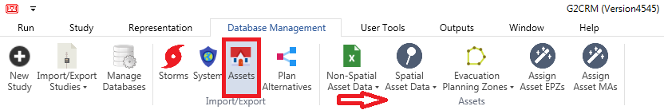

### Non-Spatial Asset Data

From the “Assets” button, select “Non-Spatial Asset Data” inside the “Assets” button group. This button will have drop-down options “Import Data”, “Export Data”, and "Export Template". Before users are ready to import, they will first need to export a non-spatial asset data template and fill it with data.

Export a non-spatial asset template by selecting "Export Template" (if you want an empty data file) or "Export Data" (if you want to work off of what is currently in the database) from the drop-down. The file explorer will request a name for the file and will produce the file when "Save" is clicked. This file contains metadata about assets like damage functions, information on occupancy types, lethality data. There are six tables in this work book, each described in detail and shown with an example below:

|  |  |
| --- | --- |
| **DamageFunction** | |
| **Column** | **Description** |
| DamageFunctionName | Unique name for the damage function |
| DamageFunctionType | Damage function type (from the model's DamageFunctionType table) |
| DamageFunctionNumber | Unique numeric identifier for the damage function |
| ZeroPoint | Exact floating point number at which the damage function is zero. |
| Values | The x-values (water level above first-floor in feet) of the function go along the top of the sheet in row 1, while the y-values (fractional damage) are written in their corresponding row for each x-value. |

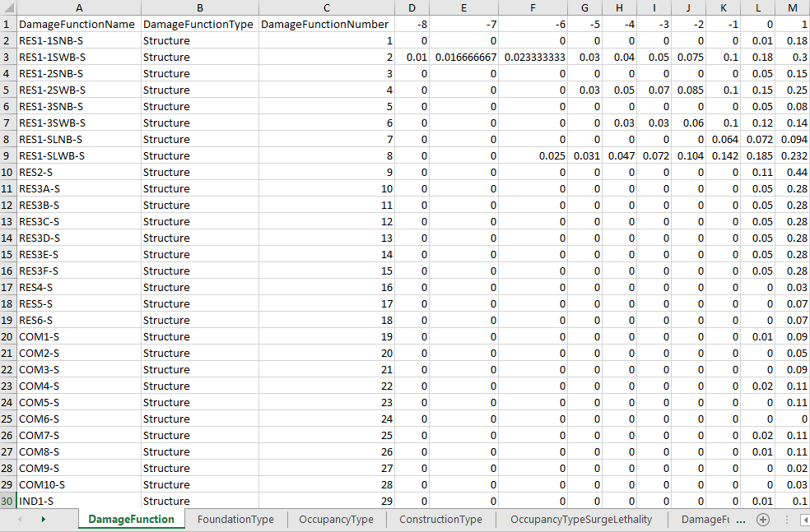

|  |  |
| --- | --- |
| **FoundationType** | |
| **Column** | **Description** |
| FoundationType | Text representation of the type of foundation for an asset (slab, crawl, or any other relevant types) |
| FoundationTypeDescription | Description of the foundation type |
| ShallowFoundation | Boolean indicating if the foundation is shallow (1 = true, 0 = false) |

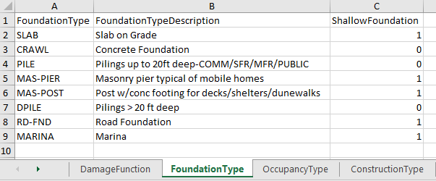

|  |  |
| --- | --- |
| **OccupancyType** | |
| **Column** | **Description** |
| OccupancyType | Text representation of the type of occupancy for an asset (residential, commercial, etc.) |
| OccupancyTypeDescription | Description of the occupancy type |
| FunctionalLifeYears | Float representing the number of functional years of a structure with the occupancy type, which is used to calculate depreciation linearly over the lifecycle of the simulation |
| MinResidualValuePercent | Float (0-100) representing the minimum residual value percent of the asset, which is used to create a lower limit that the asset depreciates to |
| CanRaise | Boolean indicating whether structures with the occupancy type can be raised (1 = true, 0 = false) |
| MaxRaisingFt | Float that creates a limit for the amount (in feet) that structures with the occupancy type can be raised |

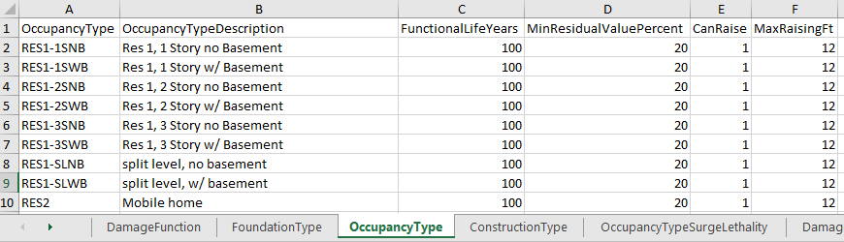

|  |  |
| --- | --- |
| **ConstructionType** | |
| **Column** | **Description** |
| ConstructionType | Text representation of the type of construction (wood, steel, etc.) |
| ConstructionTypeDescription | Description of the construction type |

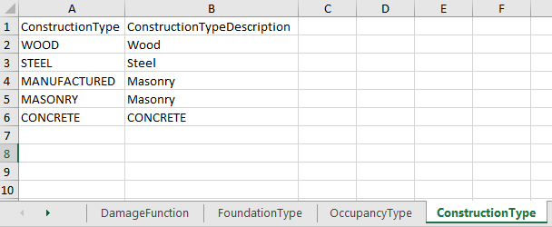

|  |  |
| --- | --- |
| **OccupancyTypeSurgeLethality** | |
| **Column** | **Description** |
| OccupancyType | Text representation of the occupancy type (from the OccupancyType table) |
| SurgeAboveFoundationUnder65 | Water level above foundation for the specified occupancy type that results in the specified lethality zone for those under 65 |
| SurgeAboveFoundationOver65 | Water level above foundation for the specified occupancy type that results in the specified lethality zone for those 65 or over |
| LethalityZone | Lethality zone (from the model's LethalityZone table) for the occupancy type at the specified surges |

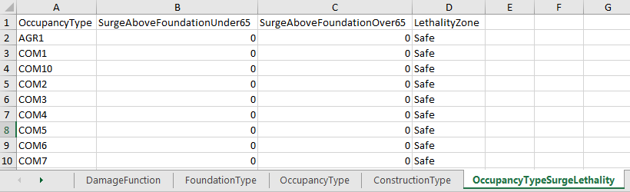

|  |  |
| --- | --- |
| **DamageFunctionLookup** | |
| **Column** | **Description** |
| OccupancyType | Text representation of the occupancy type (from the OccupancyType table) |
| DamageComponent | Damage component (from the model's DamageComponent table) |
| DamageType | Damage type (from the model's DamageType table) |
| DamageFunctionNumberP1 | Minimum damage function number (from the DamageFunction sheet) |
| DamageFunctionNumberP2 | Mode damage function number (from the DamageFunction sheet) |
| DamageFunctionNumberP3 | Maximum damage function number (from the DamageFunction sheet) |

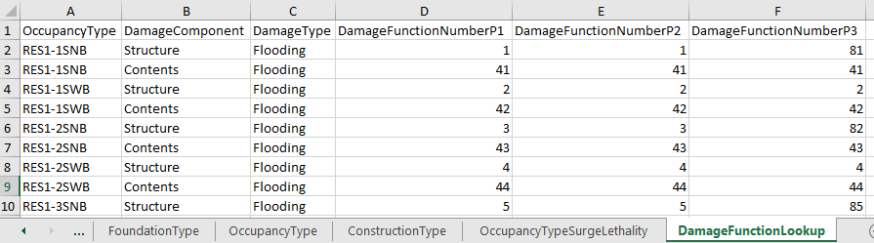  
  
From the “Assets” button, select “Non-Spatial Asset Data” inside the “Assets” button group. Select "Import Data" from the drop-down. The file explorer will request a path to the assets data file and will import the file when “Open” is clicked. A pop-up success message will display when the import is complete. When non-spatial asset data is imported, the old non-spatial and spatial data is removed from the database and the new non-spatial data is imported. After non-spatial asset data is imported, users will always need to go back and redo the spatial data import and the MA/EPZ-Asset correspondence calculations, on the buttons highlighted in the image below.

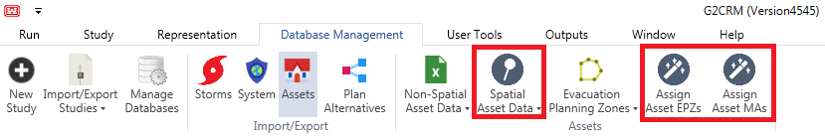

### Spatial Asset Data

Before users are ready to import spatial asset data, they must first export an asset template and fill it with data. Export an asset template by selecting the “Spatial Asset Data” button from the “Assets” group. From the drop-down menu, choose "Export Data" to work from any data currently in the database and "Export Template" to create an empty file. Select a file name and location. When the asset template has been created, a pop-up will display a success message. The spatial reference code will be the one selected at the time of creation for the current study. An example of the spatial asset data is shown in QGIS below.

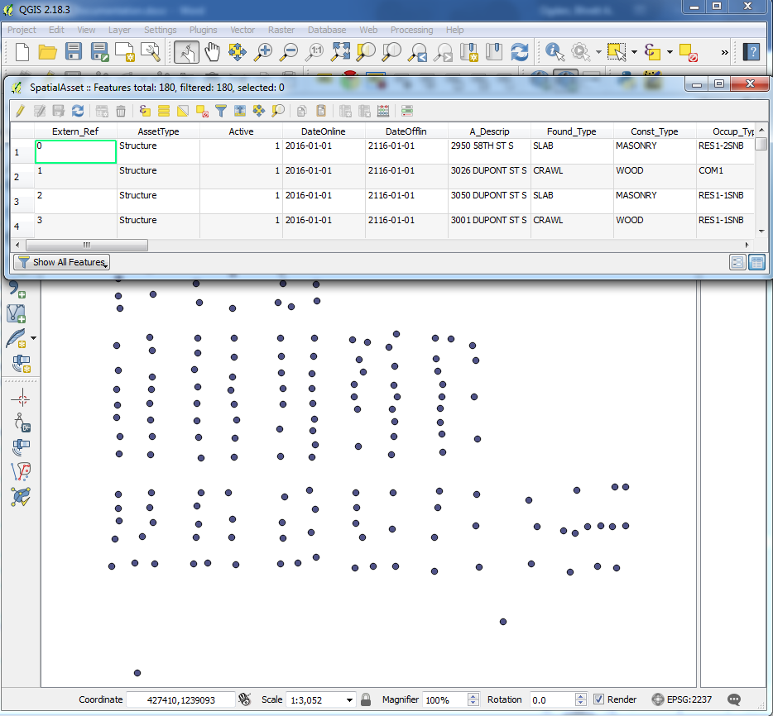

For more information about the spatial asset template fields, see the table below:

|  |  |  |
| --- | --- | --- |
| **Shapefile Column** | **Database Column** | **Description** |
| Extern_Ref | AssetExternalReference | Unique asset text identifier |
| AssetType | AssetType | Type of asset (from the model's AssetType table) |
| Active | AssetActive | Boolean indicating if the asset is active (1 = true, 0 = false) |
| DateOnline | DateOnline | Date the asset is online in YYYY-MM-DD format |
| DateOfflin | DateOffline | Date the asset is offline in YYYY-MM-DD format |
| A_Descrip | Description | Description of the asset (an address, for example) |
| Found_Type | FoundationType | Type of foundation for the asset (from the FoundationType sheet in the non-spatial asset import) |
| Const_Type | ConstructionType | Type of construction for the asset (from the ConstructionType sheet in the non-spatial asset import) |
| Occup_Type | OccupancyType | Type of occupancy for the asset (from the OccupancyType sheet in the non-spatial asset import) |
| S_Value_P1 | StructureValueP1 | Minimum value (in USD) to be used in the triangular distribution that calculates the structure value |
| S_Value_P2 | StructureValueP2 | Mode value (in USD) to be used in the triangular distribution that calculates the structure value |
| S_Value_P3 | StructureValueP3 | Maximum value (in USD) to be used in the triangular distribution that calculates the structure value |
| C_Value_P1 | ContentsValueP1 | Minimum value (in USD) to be used in the triangular distribution that calculates the contents value |
| C_Value_P2 | ContentsValueP2 | Mode value (in USD) to be used in the triangular distribution that calculates the contents value |
| C_Value_P3 | ContentsValueP3 | Maximum value (in USD) to be used in the triangular distribution that calculates the contents value |
| Depr_Fact | DepreciationFactor | Not used |
| Width | Width | Width of structure (not used) |
| Length | Length | Length of structure (not used) |
| Found_Ht | FoundationHeight | Height of the foundation in feet |
| G_Elev | GroundElevation | Ground elevation with respect to NAVD 88 |
| FF_Elev_P1 | FirstFloorElevationP1 | Minimum value to be used in the triangular distribution that calculates the first-floor elevation as defined by the lowest horizontal member of the lowest walking floor in feet with respect to NAVD 88 |
| FF_Elev_P2 | FirstFloorElevationP2 | Mode value to be used in the triangular distribution that calculates the first-floor elevation as defined by the lowest horizontal member of the lowest walking floor in feet with respect to NAVD 88 |
| FF_Elev_P3 | FirstFloorElevationP3 | Maximum value to be used in the triangular distribution that calculates the first-floor elevation as defined by the lowest horizontal member of the lowest walking floor in feet with respect to NAVD 88 |
| Num_Floors | NumberOfFloors | Number of floors in the structure |
| RebTime_P1 | TimeToRebuildP1 | Minimum value in days to be used in the triangular distribution that calculates the time to rebuild value |
| RebTime_P2 | TimeToRebuildP2 | Mode value in days to be used in the triangular distribution that calculates the time to rebuild value |
| RebTime_P3 | TimeToRebuildP3 | Maximum value in days to be used in the triangular distribution that calculates the time to rebuild value |
| N_Rebuilds | NumberOfTimesRebuildingAllowed | Number of times this structure can be rebuilt (where rebuilds are calculated using the significant rebuild damage threshold) |
| Pop_N_U65 | PopulationNightUnder65 | Nighttime population aged under 65 |
| Pop_D_U65 | PopulationDayUnder65 | Daytime population aged under 65 |
| Pop_N_65 | PopulationNight65AndOver | Nighttime population aged 65 or older |
| Pop_D_65 | PopulationDay65AndOver | Daytime population aged 65 or older |
| WaveDamage | WaveDamageActive | Not used |
| InBeneBase | IsInBenefitsBase | Benefits base status of the structure per WRDA 1990 (1 = in benefits base, 0 = outside benefits base if not raised) |
| TargFstFlr | TargetFirstFloorElevation | Elevation in feet of first-floor as defined by the lowest horizontal member of the lowest walking floor with respect to NAVD 88 that the structure should be raised to on repetitive damages |
| RaiseCstFt | RaisingCostPerFoot | Raising cost (in USD) incurred per foot of difference between the initial first-floor elevation and the target first-floor elevation |
| CumDmgThld | CumulativeDamageThreshold | A decimal number, e.g. 1.8 means 180% of the initial value, to be used in removing structures from inventory when the cumulative damage threshold is exceeded |
| PR_SVal_P1 | PostRaisingStructureValueP1 | Minimum value (in USD) to be used in the triangular distribution that calculates the post-raising structure value |
| PR_SVal_P2 | PostRaisingStructureValueP2 | Mode value (in USD) to be used in the triangular distribution that calculates the post-raising structure value |
| PR_SVal_P3 | PostRaisingStructureValueP3 | Maximum value (in USD) to be used in the triangular distribution that calculates the post-raising structure value |
| PR_CVal_P1 | PostRaisingContentsValueP1 | Minimum value (in USD) to be used in the triangular distribution that calculates the post-raising contents value |
| PR_CVal_P2 | PostRaisingContentsValueP2 | Mode value (in USD) to be used in the triangular distribution that calculates the post-raising contents value |
| PR_CVal_P3 | PostRaisingContentsValueP3 | Maximum (in USD) value to be used in the triangular distribution that calculates the post-raising contents value |
| PR_RebT_P1 | PostRaisingTimeToRebuildP1 | Minimum value in days to be used in the triangular distribution that calculates the post-raising time to rebuild value |
| PR_RebT_P2 | PostRaisingTimeToRebuildP2 | Mode value in days to be used in the triangular distribution that calculates the post-raising time to rebuild value |
| PR_RebT_P3 | PostRaisingTimeToRebuildP3 | Maximum value in days to be used in the triangular distribution that calculates the post-raising time to rebuild value |

Once users have used a GIS viewer to add information to the asset template, users should go to the “Spatial Asset Data” button in the “Assets” button group and select “Import Data” from the drop-down. The spatial reference code will be assumed that it matches the one chosen at the time of study creation. When the import to the database is complete, users will receive a success message.

When spatial asset data is imported, the current data is deleted and the new data is imported. If the user is updating the spatial asset data after the initial import, the user will need to remember to also update the asset correspondences. This is done by clicking the “Assign Asset EPZs” button and the “Assign Asset MAs” button (marked below) after the spatial asset data import has been completed.

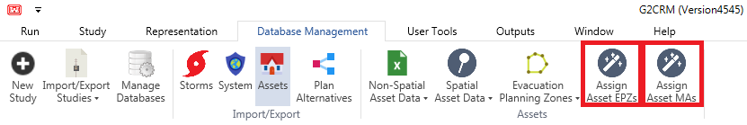

### Evacuation Planning Zone Data

Before users are ready to import evacuation planning zone (EPZ) data, they must first export an asset template and fill it with data. Export a template by selecting the “Evacuation Planning Zones” button from the “Assets” group. From the drop-down menu, choose "Export Data" to work from any data currently in the database and "Export Template" to create an empty file. Select a file name and location. When the template has been created, a pop-up will display a success message. The spatial reference code will be the one selected at the time of creation for the current study. An example of the EPZ data is shown below in QGIS.

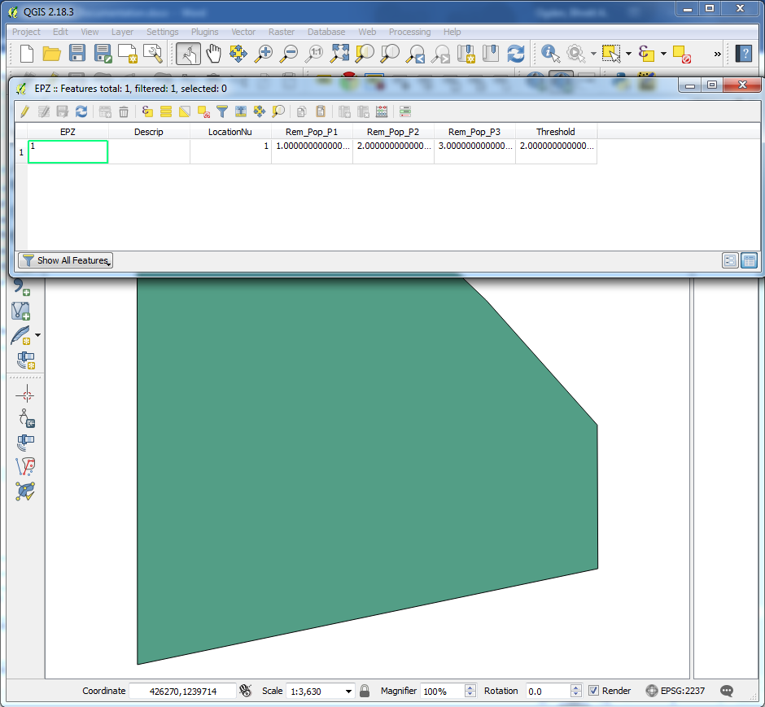

For more information about the EPZ template, see the table below:

|  |  |  |
| --- | --- | --- |
| **Shapefile Column** | **Database Column** | **Description** |
| EPZ | EvacuationPlanningZone | Unique identifier for the evacuation planning zone |
| Descrip | Description | Description of the evacuation planning zone |
| LocationNu | AssociatedLocationNumber | Location number (from the location table in the storms database) for the evacuation planning zone |
| Rem_Pop_P1 | RemainingPopulationP1 | Minimum value [0,1] to be used in the triangular distribution that calculates the remaining population of the evacuation planning zone |
| Rem_Pop_P2 | RemainingPopulationP2 | Mode value [0,1] to be used in the triangular distribution that calculates the remaining population of the evacuation planning zone |
| Rem_Pop_P3 | RemainingPopulationP3 | Maximum value [0,1] to be used in the triangular distribution that calculates the remaining population of the evacuation planning zone |
| Threshold | SurgeThreshold | Surge threshold after which evacuation should be modeled |

Once users have used a GIS viewer to add information to the EPZ template, users should go to the “Evacuation Planning Zones” button in the “Assets” button group and select “Import Data” from the drop-down. The spatial reference code will be assumed that it matches the one chosen at the time of study creation. When the import to the database is complete, users will receive a success message.

When EPZ data is imported, the current data is deleted and the new data is imported. If the user is updating the EPZ data after the initial import, the user will need to remember to also update the asset-EPZ correspondences. This is done by clicking the “Assign Asset EPZs” button after the import has been completed.

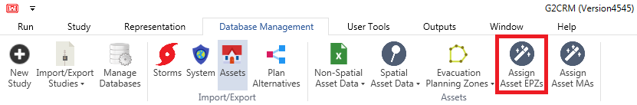

### Asset Correspondence Calculations

Each time that the MAs, EPZs, or assets are updated, the asset correspondences will need to be recalculated. If only EPZs are updated, only the asset-EPZ correspondences will need to be updated. If only MAs are updated, only the asset-MA correspondences will need to be updated. If assets or both MAs and EPZs are updated, then both the asset-MA and asset-EPZ correspondences will need to be updated. Update asset-EPZ correspondences by clicking the “Assign Asset EPZs” button in the “Assets” button group. Update asset-MA correspondences by clicking the “Assign Asset MAs” button in the “Assets” button group.



## Plan Alternatives Data

Importing/exporting of the plan alternatives data can be found on the “Database Management” tab by clicking the “Plan Alternatives” button. Before users are ready to import, they will first need to export a template and fill it with data.

From the “Plan Alternative” button, select “Export” inside the newly produced “Plan Alternative” button group. The file explorer will request a name for the file and will produce the file when “Save” is clicked. This file consists of at least four worksheets and an additional worksheet for each plan alternative other than the “Without Project” plan. The four required worksheets are: AllowableAdjustmentTypeTarget, Plan, CostScheduleItem (not used), and WithoutProjectPlan. The AllowableAdjustmentTypeTarget is for user information and should not be changed in any way. This worksheet gives the possible adjustments. The WithoutProjectPlan worksheet should always be empty and should not have data added to it. It is there to give the user an option to run the model with no adjustments made. The data in the worksheets is described in more detail in the tables below:

|  |  |
| --- | --- |
| **AllowableAdjustmentTypeTarget** | |
| **Column** | **Description** |
| AdjustmentType | Object to be adjusted (informational only, cannot be changed) |
| AdjustmentTarget | Property of the object which will receive the adjustment (informational only, cannot be changed) |

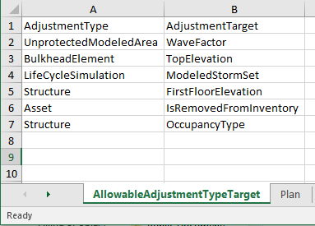

|  |  |
| --- | --- |
| **Plan** | |
| **Column** | **Description** |
| PlanTextID | Unique name for the plan alternative (corresponds to the sheet names that hold the plan details) |
| PlanDescription | Description for the plan alternative |

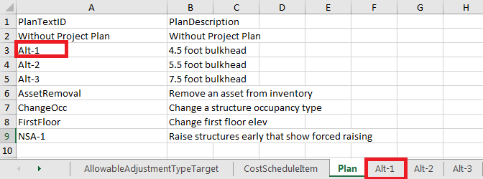

|  |  |
| --- | --- |
| **CostScheduleItem** | |
| **Column** | **Description** |
| PlanTextID | Not used |
| ItemDescription | Not used |
| ItemDate | Not used |
| ItemCost | Not used |

|  |  |
| --- | --- |
| **Plan Detail (should be named after PlanTextID)** | |
| **Column** | **Description** |
| PlanTextID | Unique identifier for the plan alternative from the Plan sheet |
| AdjustmentTextID | Unique identifier for the adjustment item |
| AdjustmentTime | Time the adjustment item is to be performed in format M/D/YYYY H24:MM |
| AdjustmentGroup | Not used |
| AdjustmentCost | Cost of the adjustment item |
| AdjustmentType | Object type to be adjusted (from the AllowableAdjustmentTypeTarget sheet) |
| AdjustmentElement | Element that should be adjusted (for assets and structures this is the AssetID; for all others, this is the name of the object) |
| AdjustmentTarget | Property of the adjustable object to be adjusted (from the AllowableAdjustmentTypeTarget sheet) |
| ValueFixedOrRelative | Fixed = 1, Relative = 0 |
| AdjustedValue | Value that the property should be adjusted to or by (depending on if the adjustment is fixed or relative) |

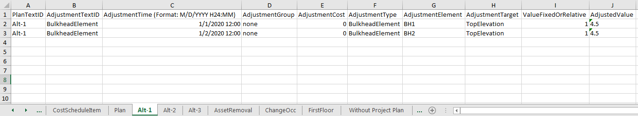

Import a plan alternative data set by selecting the “Import” item from the “Plan Alternative” button group. The file explorer will request a path to the data file and will import the file when “Open” is clicked. A pop-up confirming import will display when the import is complete. When plan alternative data is imported, the data is inserted or updated in the database. This import can be redone at any time and will replace the old data with the newly imported data.

# Viewing/Editing Data

The data grids found in the representation explorer may be used to view or edit data. These data grids have sorting and filtering functionality. The sorting functionality is very straightforward, as users only need to click the header for the column that they wish to sort. The filtering functionality provides users with the ability to view a subset of the data in that table. The filter functionality has a wildcard character (*) so users can search for data that begins or ends with a certain pattern (example shown below). Please note that this wildcard character can be used at the beginning or at the end of a search string, but cannot be used in the middle (“A*B”, for example) because of a limitation with the C# programming language.

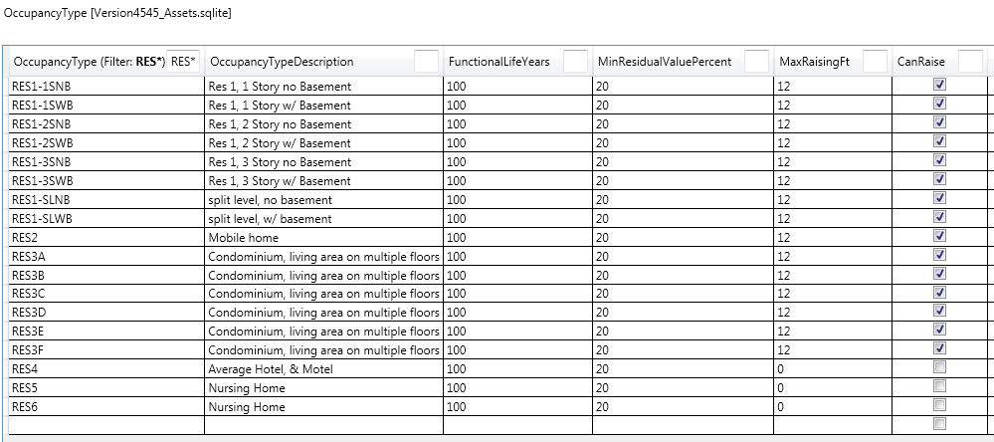

## Bulk Editing Data

The bulk editing features allow users to update multiple rows of a table inside the application with minimal user input. At this time, only the StructureAsset table has bulk editing features. The bulk editing options are available in the context menu produced by right-clicking the table headers. There is no undo functionality at this time, so take care to backup any studies by exporting them to a zip file before making changes.

### Basic Bulk Editor

The basic editor allows users to make changes to the value of a column for a whole table or a subset of the table’s rows using a form-based approach, which has limited functionality, but does not require knowledge of SQL or Excel-syntax.

Before entering the basic editor, decide if you want to edit all or a subset of the rows in the table. If you want to edit a subset, either manually select the rows to be edited (hold the Control button to select multiple) or use the advanced filter.

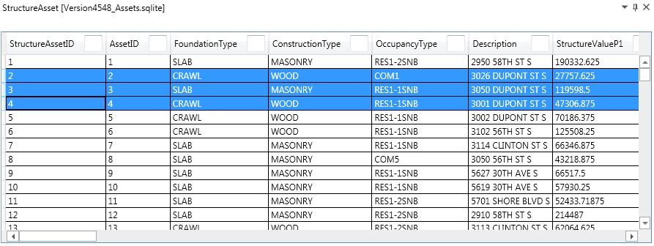

Produce the context menu by right-clicking the header of the column that you would like to edit. Select “Basic Editor”.

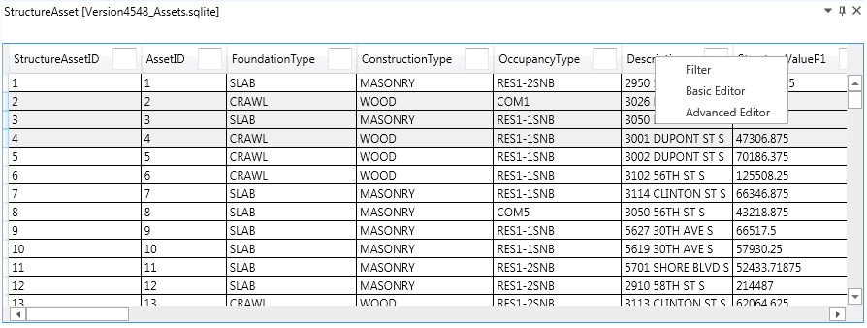

Select constant for the value type if you would like the column to be updated with a static value. Enter the value in the text box.

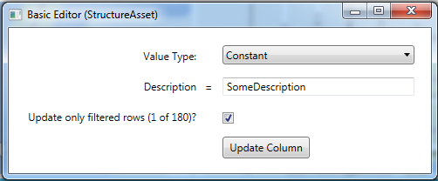

Select column for the value type if you would like the column to be updated with the value of another column. Select the column whose value will be used for the update from the drop-down.

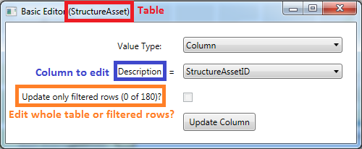

If rows were selected, you can set the update to only operate on the selected rows (by checking the checkbox) or to operate on the whole table (by unchecking the checkbox). After all fields are set, click “Update Column”.

### Advanced Bulk Editor

The advanced editor allows users to make changes to the value of a column for a whole table or a subset of the table’s rows using an excel-based syntax.

Before entering the advanced editor, decide if you want to edit all or a subset of the rows in the table. If you want to edit a subset, either manually select the rows to be edited (hold the Control button to select multiple) or use the advanced filter.



Produce the context menu by right-clicking the header of the column that you would like to edit. Select “Advanced Editor”.



Use the columns in the left box and the operations in the right box to produce the update expression in the bottom box. The update expression should match the type of the column being updated. If there is a parsing issue, the error log button will produce an explanation. The image below shows the other components of this window, including a checkbox to apply the update to only the selected subset of rows. The “Execute” button applies the update.

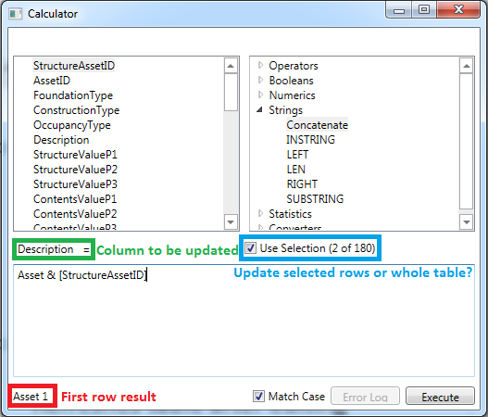

### Advanced Filter

There is basic filtering functionality built in to the table header. Please note that this is a separate feature from the advanced filter, and is not connected with the bulk editing capabilities of the tables. The advanced filter is an extension of this functionality that allows more complex Excel syntax-based queries, which can be used to select rows for the basic or advanced editors. The advanced filter can also be used to do a sub-selection.

Before entering the advanced editor, decide if you want to filter the whole table or a subset of the rows in the table. If you want to filter a subset, either manually select the rows to be filtered (hold the Control button to select multiple) or use the advanced filter.



Produce the context menu by right-clicking the header of the column that you would like to edit. Select “Filter”.



Use the columns in the left box and the operations in the right box to produce a Boolean expression in the bottom box. Rows that evaluate to true will be selected from the filter. If there is a parsing issue, the error log button will produce an explanation. The image below shows the other components of this window, including a checkbox to filter only the selected subset. The “Execute” button applies the filter by sending the new rows that should be selected back to the table.

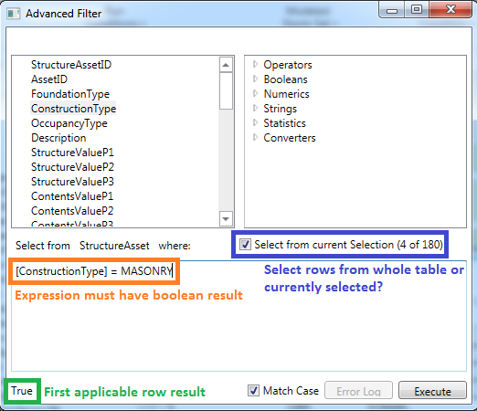

# Performing Model Runs

Before making a model run, users will need to first make sure that they have the desired study and representation open. Study and representation names are viewable on the bottom of the G2CRM window in the blue bar.

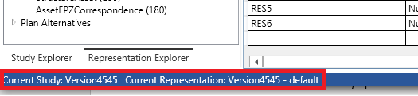

Once the study and representation have been verified, navigate to the “Run” tab. Users should have already imported any data (see “Importing/Exporting Data” for details about this) and created desired run conditions (see “Run Condition Management” for instructions). Users can now select their run conditions, modeled storm set, and plan/project condition from the drop-downs (shown in the image below). It is recommended to go through the steps below of verifying configurations and file controls before users proceed to the “Starting the Simulation” section.

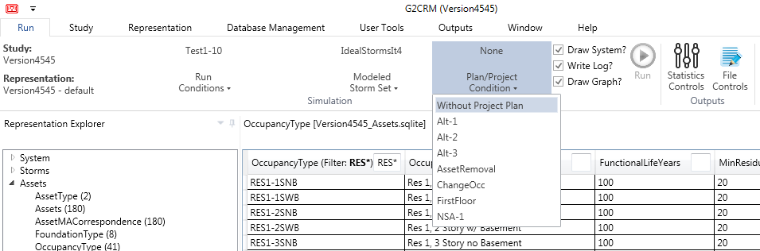

## Representation Report

Once users have made their run selections from the drop-downs on the “Run” tab, they can produce a representation report to see a summary of information about the data on which they are about to run a simulation. To produce a representation report, users should go to the “Representation” tab and click “Representation Report”. They will then select a file location and name. When the representation report has been produced, it will automatically open Microsoft Excel.

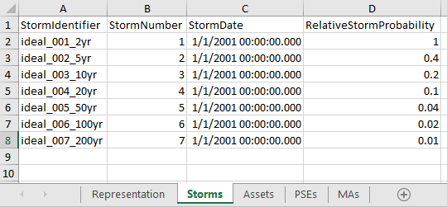

The ”Representation” tab of the workbook has the paths of all of the databases currently being used. The “Storms” tab lists the information from the selected modeled storm set (as shown above). The “Assets” tab lists the current assets. The “PSEs” tab lists all available PSEs in the currently selected data. Finally, the “MAs” tab lists all available MAs in the current representation. This report allows the user to briefly review the dataset that they are running before starting the simulation.

## Study Configuration Settings

Before starting a model run, users should navigate to the “Study” tab and ensure that the damage threshold for “significant rebuild”, to be used in counting number of rebuilds when examining asset removal, is a reasonable value. This value is calculated by dividing the current damage by the last pre-damage structure value. The default value is 0.50.



## File Controls

Users may modify output selections on the “Run” ribbon in the “File Controls” form (found in the “Outputs” button group). Using the refresh button on the output controls sets all the outputs to off. There are some pre-determined output profiles available on the drop-down button next to the save (diskette) icon.

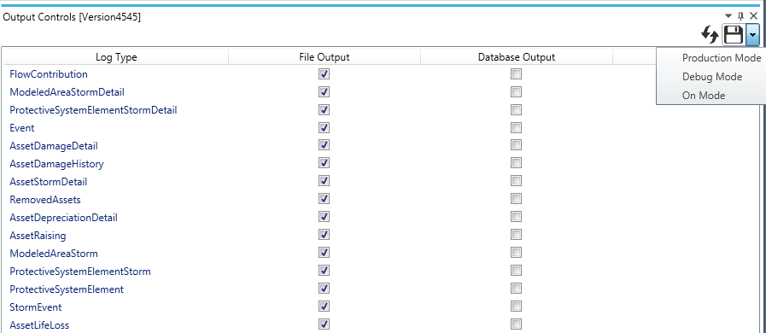

There are some outputs that are always set to on and not possible to turn off. These outputs will be on for all runs, no matter which profile is selected. These outputs are IterationSeason, IterationSummary, IterationYear, MessageFile, Tide, Timing, and WaveCalculation.

Users will be warned of any optional large outputs when they attempt to run the model.

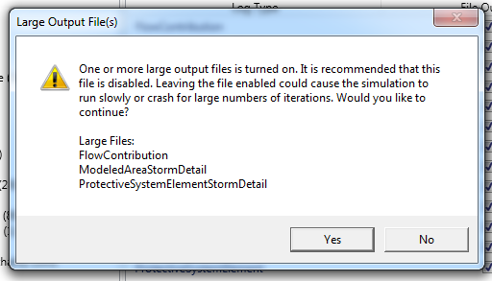

### On Mode

The most basic of these output profiles is “On Mode”. This changes all the file outputs to on, all the database outputs to off, and saves the selections.

### Debug Mode

Debug mode sets the StormEvent, Event, ModeledAreaStorm, AssetStormDetail, AssetDamageDetail, AssetDamageHistory, ProtectiveSystemElementStorm, and AssetRaising file outputs to on and all other file outputs and database outputs to off.

### Production Mode

Production mode sets the AssetRaising file outputs as on and all other file and database outputs to off.

### Off Mode

All optional outputs (both CSV and database) will be set to off. This output profile is selected by clicking the refresh icon.

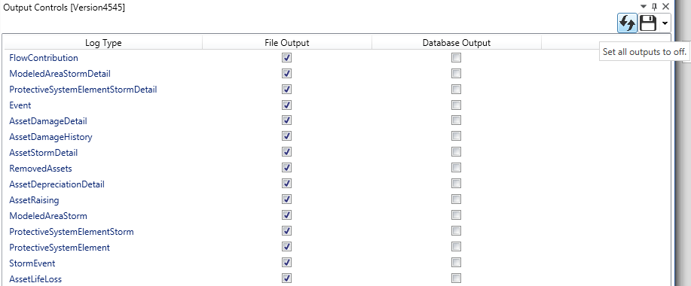

## Statistics Controls

Users may modify calculated statistics on the “Run” ribbon in the “Statistics Controls” form.

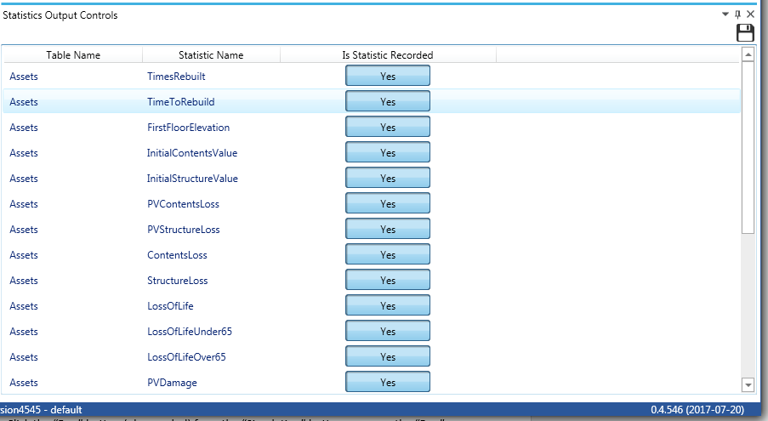

## Window Display Selections

Users will make selections for drawing the system/graph and writing the run log on the “Run” tab. These are parts of the simulation window that feed information to the user as the simulation is running. While these can provide real-time information about the model, they come at a cost. Using these features can significantly slow down simulations, as it demands system resources that can also be used towards improving the time required for the simulation.

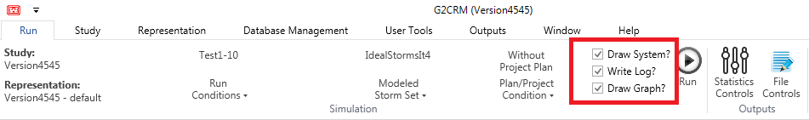

## Starting the Simulation

After the study, representation, run condition, configuration settings, and file controls have been verified, users should go to the “Run” tab and verify selections have been made from the drop-downs for run conditions, modeled storm set, and plan/project condition. Once users have made all desired selections and verified settings and configurations (as explained in the sections above), users are ready to begin the run. Click the “Run” button (play symbol) from the “Simulation” button group on the “Run” tab.

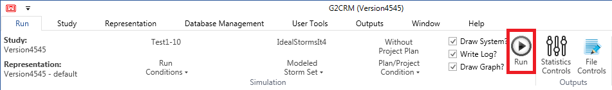

If you have selected large output files from the file control selection, you will receive a warning about your selections. Click “Yes” when prompted if you want to continue, despite possible large outputs. Enter a unique simulation name to ensure that no existing outputs are overwritten and click “Ok” on the “Name Simulation” window.

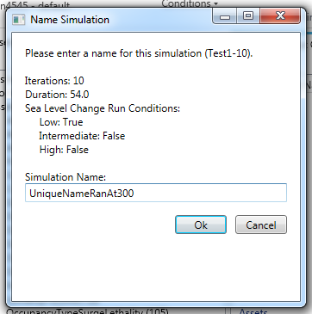

The run will now begin.

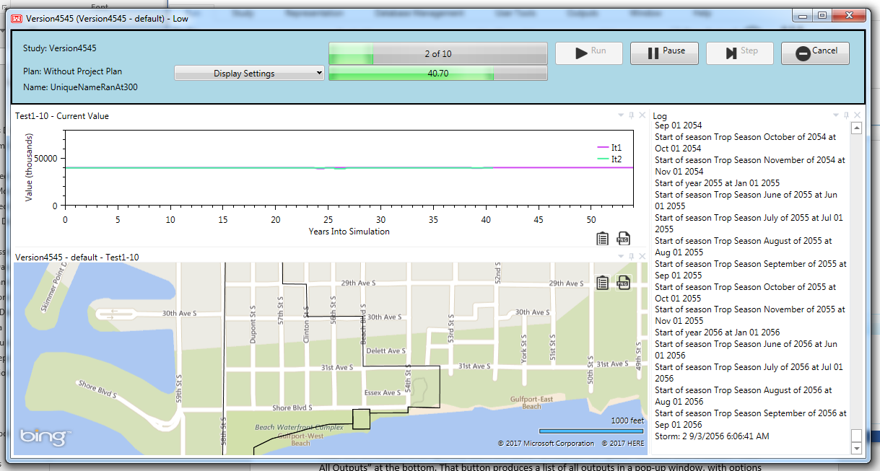

## Viewing Output

After the simulation is completed, users will see a “Simulation Complete” window with a button “View All Outputs” at the bottom.

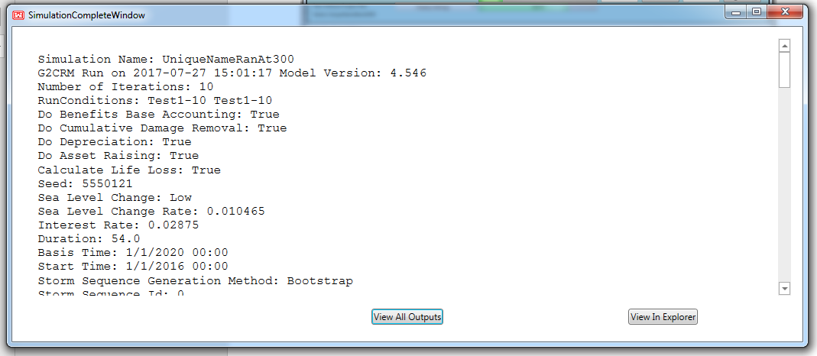

The “View All Outputs” button produces a list of all outputs in a pop-up window, with options to open them from there. Users can also see the simulation outputs in the file explorer. More details about the data is available in the “Output Data” section below.

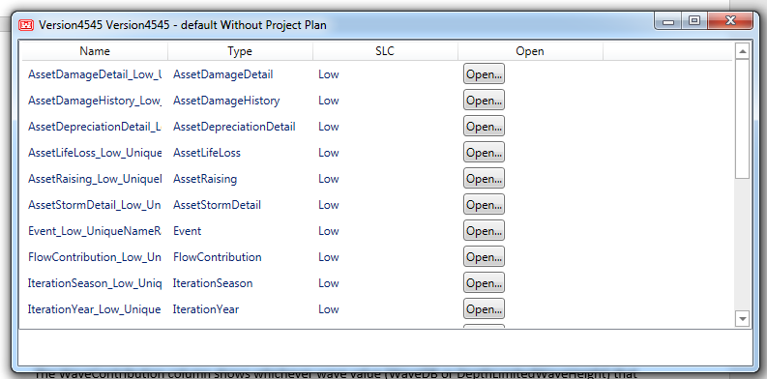

# Highlighted Model Behavior

While the purpose of the user manual is not to explain the detailed theory and inner-workings of the model, it is helpful to understand some of the components, as it will allow the user to better operate the model and understand the model outputs. Selected model features’ designs and verification outputs are highlighted to offer the user insight into the model logic.

## Wave Generation

Storm information is gathered in the H5 import. During this import, users can use an ADCIRC file format (no wave data) or an STWAVE file format (optional wave data). If users choose to use an ADCIRC file, their waves will be generated using depth-limited wave heights. If STWAVE is used, users will have the option to read the wave heights as-is, to auto-generate them if there is no data, or to depth-limit them if there is data.

|  |  |  |  |
| --- | --- | --- | --- |
| **File Type** | **Has Wave Data?** | **Read As-Is?** | **Wave Calculation** |
| STWAVE | Yes | Yes | Database values are used |
| STWAVE | Yes | No | Depth-limits the database wave heights |
| STWAVE | No | Yes | Database values are used (so there are no waves because the database has zero for all) |
| STWAVE | No | No | Auto-generated from depth-limited wave height |
| ADCIRC | No | No | Auto-generated from depth-limited wave height |

Whether the file should be read as-is will be determined by the “UseWaveDataAsIs” column of the “Metadata” sheet in the H5 import Excel workbook.

The details of the wave generation can be traced by using the wave calculation CSV file. The WaveDB column of this file shows the value from the imported H5 file for the storm, timestep, location, etc. The DepthLimitedWaveHeight column shows the generated wave height, which is 0.78 multiplied by the total water depth (surge + tide + sea level change – waterside ground elevation). Waterside ground elevation comes as a property of the PSE in the case of an upland or as a property of the MA in the case of an unprotected. From this point on, generated and read wave information is treated the same.

The WaveContribution column shows whichever wave value (WaveDB or DepthLimitedWaveHeight, as determined by the table above) that should be used, multiplied by the wave adjustment factor. The wave adjustment factor is set in the import of unprotected modeled areas. Upland modeled areas use a wave adjustment factor of 1, an uneditable configuration setting.

Finally, the wave contribution is adjusted by multiplying by 0.705 (per FEMA methods) and shown in the AdjustedWaveContribution column. This is the wave height that is added to the stillwater depth.

## Filling of Upland Modeled Areas

The upland modeled area has been enhanced to represent the fact that the exterior water level is not immediately transmitted to all points within the modeled area after the bulkhead is overtopped. This enhancement is an optional feature of the upland modeled area and can be turned on by associating a volume stage function with the modeled area and turned off by disassociating a volume stage function with the modeled area.

When using overtopping, the behavior of the upland is such that it will consider the time to fill the storage area behind the bulkhead. Once the bulkhead is overtopped, broad-crested weir flow is assumed. The volume-stage function associated with the upland is used to interpolate the MA stage based on the volume that has flowed in to the MA. Once the volume-stage function returns a value that is above the top elevation of the bulkhead, then the stage outside of the modeled area is immediately transmitted inside of the modeled area. The storage area is assumed to be empty at the beginning of each storm event.

An upland with no volume-stage function also has no stage until the bulkhead is overtopped. In contrast to the behavior explained above, the upland with no volume-stage function uses immediate stage transmission at the moment of overtopping.

## Asset Raising

Asset raising after a major damage event aligns the model with local zoning and flood plain regulations, as well as the National Flood Insurance Program. Raising of a structure is triggered when the damage meets or exceeds the raising damage threshold. The raising damage threshold is an uneditable configuration setting set to 0.50.

To raise structures, the run conditions must be set to allow for asset raising. The occupancy type of the asset must also allow for raising. The amount to be raised (the difference in the target first-floor elevation and the current first-floor elevation) must be within the allowable range for the occupancy type. Assets can only be raised once in an iteration.

When a structure is raised, the structure is rebuilt in kind. The only parameters that are changed are the first-floor elevation (set to the target first-floor elevation), the structure/contents values, and the time to rebuild. After raising, the calculations of structure/contents values and time to rebuild will be from the post-raising distributions. For the rebuild that includes raising, the time to rebuild will be the maximum value from the pre-raised structure. If the asset is not in the benefits base, then it will be added to the benefits base on raising.

The asset damage history and asset raising CSV files are useful in monitoring asset raising.

## Asset Depreciation

The assets are designed to depreciate (in content and structure value) over their useful life. The depreciation is straight-line, meaning the asset depreciates the same amount each year until it reaches a lower limit of value, as determined by the asset’s occupancy type’s minimum residual value percentage. The amount that the asset depreciates each year is based on the asset’s occupancy type’s useful life. The asset depreciation detail CSV file can be used to review each asset’s depreciation factor, initial structure/contents values, and depreciated replacement values. Depreciation can be turned off in the run conditions.

## Structure Removal

There are three ways of removing a structure from inventory:

1. After a user-defined number of significant damage events is exceeded
2. After a user-defined threshold for cumulative damage within an iteration is exceeded
3. After a raising event was attempted, but the asset did not qualify do to the number of feet of raising being larger than the allowable raising feet

The cumulative damage threshold is a structure-specific setting that is given as a fractional amount of the initial value of the structure. Once the structure damage has exceeded the cumulative damage threshold with respect to the initial value (e.g. 1.8 means 180% of the initial value), then the structure will be removed from inventory. Removal due to cumulative damage exceedance can be turned on and off via the run conditions.

The structure-specific setting for number of rebuilds will be compared throughout the iteration to the rebuild count for that structure. If a rebuild is due to damage that is greater than the study’s significant rebuild threshold, then the number of rebuilds will be incremented. Whenever the structure is damaged and cannot be rebuilt due to exceeding the allowed rebuild count, then the structure will be removed from inventory.

Each structure has a target first-floor elevation, a first-floor elevation distribution, and an occupancy type with a maximum raising feet. If a structure is scheduled to be raised (see “Asset Raising” above for those conditions) then the currently drawn first-floor elevation will be compared to the target first-floor elevation. If this comparison exceeds the maximum feet to be raised, then the structure will be removed from inventory.

To trace the structure removal, review the removed assets CSV file, which gives information about the structure and the reasons for removal.

## Benefits Base Accounting

The map output database contains a table called “AssetsAllStatistics” and a table called “Statistics” that holds some asset statistics. In these tables, the statistics only represent values for when the asset is included in the benefits base, except for life loss, which is always recorded regardless of the benefits base status. For example, if an asset is outside of the benefits base and is raised in one iteration of the simulation, then the “FirstFloorElevation” statistic will only reflect a count of 1 and a value of the initial first-floor elevation for that iteration.

This functionality can be turned on and off in the run conditions. If this functionality is turned off, then it is assumed that all structures are always in the benefits base.

Loss of Life CalculationsLife loss calculations may be turned on or off in the run conditions. If turned on, the loss of life calculations are performed on a per-structure per-storm basis. In order for life loss calculations to be made, the maximum stage in the modeled area has to be at least two feet over ground elevation for foundation heights greater than or equal to two feet or the maximum stage must be greater than the foundation height plus the ground location for foundation heights under two feet.

Loss of life calculations are separated out by age categorization with under 65 being one category and 65 and older being the second category. There are three possible lethality functions for structure residents: safe, compromised, and chance. Safe would have the lowest expected life loss, although safe does not imply that there is no life loss. Chance would have the highest expected life loss.

Each structure has an occupancy type, which has an entry in the OccupancyTypeSurgeLethality table. This table tells us at what surge over the foundation height is the minimum for a lethality zone (safe, compromised, chance). These surge over foundation heights are age-specific. There is on surge height for under 65 and another for 65 and older.

During each storm, we cycle through every active structure. For each structure, we default the lethality function to safe and check for the maximum lethality function such that the modeled area stage is greater than the sum of the structure’s first flood elevation and the lethality function’s surge above the foundation. This will be checked separately for under and over 65, as these two age groups can have different lethality functions depending on the age-specific surge above foundation in the OccupancyTypeSurgeLethality table.

The fraction of population remaining for each evacuation planning zone is calculated based off of the EvacuationPlanningZone table on a per-storm basis. If the maximum surge at the storm location exceeds the threshold defined by the EPZ, then the RemainingPopulationP1, P2, and P3 values will be used as the minimum, mode, and maximum to form a triangular distribution to choose the fraction remaining. If the surge threshold is not met, then 100% of the population will remain.

Using the proper lethality function, a random number is generated and interpolated using the LethalityFunctionValues table to get the expected fraction of life loss. The way the default lethality functions are formed is that the smaller the random number, the higher the life loss. This interpolation from the lethality function is multiplied by the nighttime population for the corresponding age range and the remaining population fraction in order to calculate the life loss under 65 and life loss for 65 and older. This is recorded in fractions of lives, so depending on the level of output, we may see small rounding differences.

## Triangular Distribution Calculations

Triangular distributions are used throughout the model in order to simulate random chance. Triangular distributions take three values: a minimum value, a maximum value, and a most likely (mode) value. The mode should be greater than or equal to the minimum value and less than or equal to the maximum value. The distribution also takes a random value to use to draw from the continuous distribution. The continuous distribution is shaped like a triangle (hence the name), with the tails lying at the minimum and maximum values, and the peak lying at the mode. The result will be between the minimum and the maximum value and will be most probable that it is near the mode.

Examples of places in the model where triangular distributions would be used are in structure attributes like structure value, contents value, first floor elevation, time to rebuild, post-raising structure value, post-raising contents value, and post-raising time to rebuild. Triangular distributions are also used in the evacuation planning zones to randomly sample the fraction of the population that remains during a storm evacuation. A triangular distribution is also used with the structure and contents damage functions. In these cases, the triangular distribution is not static. Instead the minimum, mode, and maximum values come from the corresponding damage function’s interpolation at the height of the water above the first floor. The resulting damage function values are used to form a triangular distribution.

## Present-Value Calculations

In order to calculate the present-value of damages, it is necessary to know the interest rate, *i*, set in the run conditions, as well as the number of days, *d*, between the current storm event and the first day of the base month in the base year (again, set in the run conditions). The present-value factor, *f*, is then calculated using the following formula:

$$f= \frac{1}{{\left(1+i\right)}^{\frac{d}{365}}}$$

This present-value factor is then multiplied by property damages, for example, in order to calculate the present-valued property damages.

# Output Data

## Model Output

The G2CRM simulation has a variety of outputs and output formats. The model output data files differ depending on the output profile or custom output combination was selected by the user in the “File Controls” tool, described above.

Outputs are written to SQLite/SpatiaLite database files, comma-separated value (CSV) files, and ascii files. Run-associated output files are stored in a pre-defined hierarchical structure that is relative to the user-chosen study location and the user-defined run name assigned at model run time. Output files are stored in the user-chosen study location in a directory that is named after the study. Inside the study directory, there is a fixed name “Outputs” directory that houses the model output in a hierarchical directory structure with the top level as the representation name, the next level as the plan alternative name, and the final level as the run name. The model output is found inside of the bottom level directory named after the run name.

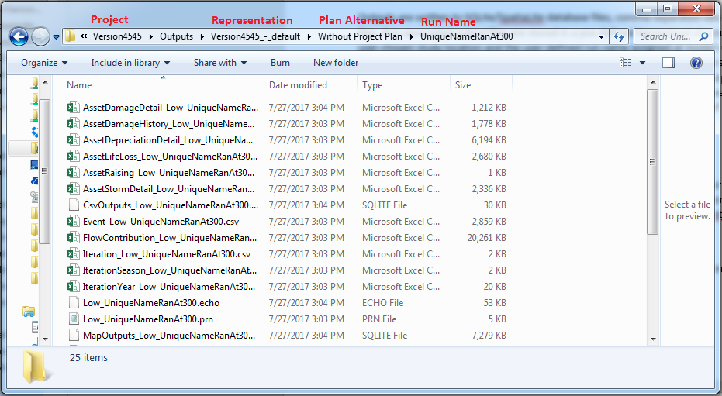

The CSV and database files use the naming convention: [FileDescription]_[SeaLevelChangeRate]_[RunName].[Extention]. The file description in the filename matches the descriptor given in the “File Controls” tool. The ascii files are described by their suffixes so the naming convention for them is: [SeaLevelChangeRate]_[RunName].[Extention]. For more details about these files, please see the individual output descriptions below.

### Asset Damage Detail

The asset damage detail file is a user-controlled CSV output that provides information for checking damage calculations for each asset on a damaging event.

|  |  |
| --- | --- |
| **Column** | **Description** |
| Iteration | Simulation iteration number |
| Event | Simulation event number |
| Time | Time of damage event |
| DaysFromStart | Damage event days from start |
| Storm | Damage event storm name |
| AssetId | Numerical identifier of asset |
| AssetExternalReference | Text identifier of asset |
| ModeledAreaTextId | Asset’s modeled area’s text identifier |
| FoundationType | Asset’s foundation type’s text identifier |
| ConstructionType | Asset’s construction type’s text identifier |
| OccupancyType | Asset’s occupancy type’s text identifier |
| TimeToRebuild | Asset’s time to rebuild drawn from the triangular distribution (or the maximum value from the distribution in the event of raising) |
| RandomValue | Random value created prior to the damage event to prevent impact on the RNG |
| StructureDamageFunctionP1 | Numerical identifier of the minimum damage function for the structure |
| StructureDamageLookupP1 | Damage fraction based on the minimum damage function for the structure |
| StructureDamageFunctionP2 | Numerical identifier of the mode damage function for the structure |
| StructureDamageLookupP2 | Damage fraction based on the mode damage function for the structure |
| StructureDamageFunctionP3 | Numerical identifier of the maximum damage function for the structure |
| StructureDamageLookupP3 | Damage fraction based on the maximum damage function for the structure |
| ContentDamageFunctionP1 | Numerical identifier of the minimum damage function for the contents |
| ContentDamageLookupP1 | Damage fraction based on the minimum damage function for the contents |
| ContentDamageFunctionP2 | Numerical identifier of the mode damage function for the contents |
| ContentDamageLookupP2 | Damage fraction based on the mode damage function for the contents |
| ContentDamageFunctionP3 | Numerical identifier of the maximum damage function for the contents |
| ContentDamageLookupP3 | Damage fraction based on the maximum damage function for the contents |
| GroundElevation | Ground elevation |
| FirstFloorElevation | First-floor elevation, as drawn from the triangular distribution or based on the target first-floor elevation, if the structure has been raised |
| MaxStormStage | Max modeled area stage for the damage event (includes surge, tide, sea level change, and waves) |
| WaterLevelAboveFirstFloor | Water level above first-floor, calculated by the modeled area stage minus the first-floor elevation |
| UnprotectedSignificantWaveHeight | For unprotected MAs, the wave height at the maximum stage for the storm; For all other MAs, zero |
| UnprotectedCombinedWaterLevel | For unprotected MAs, the combined sea level change, tide, surge, and wave; For all other MAs, zero |
| StructureValuePreStorm | Structure value pre-storm (with respect to the current damage and depreciation for the current year) |
| ContentsValuePreStorm | Contents value pre-storm (with respect to the current damage and depreciation for the current year) |
| ValueLossStructure | Structure value loss in damage event, as calculated by the fractional structure damage incurred by this storm event multiplied by the current structure value |
| ValueLossContents | Contents value loss in damage event, as calculated by the fractional contents damage incurred by this storm event multiplied by the current contents value |
| PresentValueFactor | Net present value factor as calculated by the interest rate, the current event time, and the base month/year |
| StructureLossPV | Present-valued structure loss in damage event |
| ContentsLossPV | Present-valued contents loss in damage event |
| TotalLoss | Total (contents and structure) loss in damage event |
| TotalLossPV | Total present-valued loss in damage event |
| StructureValuePostStorm | Depreciated structure value post-damage event |
| ContentsValuePostStorm | Depreciated contents value post-damage event |
| NumberOfTimesRebuilt | Number of times the structure has been rebuilt (counted on rebuilding when the significant rebuild damage threshold is exceeded by the fraction to be rebuilt) |
| PercentDamaged | Percent damaged in damage event divided by the current depreciated structure value before the damage took place |
| IsRebuild | Boolean indicating if the structure will be rebuilt (true if the percent damaged is larger than the significant rebuild threshold) |
| CumulativeDamage | Damage sustained by the structure over the current iteration |
| FractionalCumulativeDamage | Fractional cumulative damage, as calculated by the ratio of cumulative damage to the structure’s full initial non-depreciated value |
| CumulativeDamageThreshold | Asset’s fractional cumulative damage threshold (used to determine when an asset should be removed from inventory) |
| CanRebuild | Boolean indicating if the asset can be rebuilt, as determined by cumulative damage, rebuild count, and floor elevations when raising |
| FullInitialStructureValue | Asset’s initial value before damage or depreciation |
| DepreciatedFullStructureValue | Asset’s full initial value after depreciation for the current event’s date |
| IsRaised | Boolean indicating if the asset has been raised |
| IsInBenefitsBase | Boolean indicating if the asset is in the benefits base |

### Asset Damage History

The asset damage history file is a user-controlled CSV output that provides summarizing information for each asset event on initialization, damage, and rebuild.

|  |  |
| --- | --- |
| **Column** | **Description** |
| Iteration | Simulation iteration number |
| Event | Simulation event number |
| Time | Event time |
| DaysFromStart | Days from start of simulation to event |
| AssetExternalReference | Asset text identifier |
| AssetID | Asset numerical identifier |
| MA | Asset’s modeled area text identifier |
| Event | I = initialization, D = damage, R = rebuild, PR = partial rebuild (on successive damages) |
| AssociatedStormID | Numerical identifier of associated storm event |
| NumberOfRebuildsRemaining | Number of rebuilds for this asset remaining in iteration |
| PostEventStructureValue | Post-event depreciated structure value |
| PostEventContentsValue | Post-event depreciated contents value |
| TimeToRebuild | Time to rebuild asset |
| StructureValueChange | Structure value change in event |
| ContentsValueChange | Contents value change in event |
| CostOfRaising | Cost of asset raising on rebuild |
| WasRaised | Boolean indicating if asset was raised on rebuild |
| IsInBenefitsBase | Boolean indicating if asset is in the benefits base |
| RebuildFactor | Fraction of the structure rebuilt in a partial or full asset rebuild. |

### Asset Depreciation Detail

The asset depreciation detail file is a user-controlled CSV output that provides depreciation information about each asset by year. This output is only written for the first ten iterations during the year end event.

|  |  |
| --- | --- |
| **Column** | **Description** |
| Iteration | Iteration number |
| Year | Year that is ending |
| AssetExternalReference | Text identifier for the asset |
| OccupancyType | Text identifier for the asset’s occupancy type |
| YearlyDepreciation | Factor of yearly depreciation as determined by the occupany type’s useful life |
| StructureDepreciatedReplacementValue | Structure full replacement value after depreciation for the specified year |
| ContentsDepreciatedReplacementValue | Contents full replacement value after depreciation for the specified year |
| StructureInitialValue | Structure value as determined by drawing from the triangular distribution at the beginning of the iteration |
| ContentsIntitialValue | Contents value as determined by drawing from the triangular distribution at the beginning of the iteration |
| IsInBenefitsBase | Benefits base status of the structure at the end of the year |

### Asset Life Loss

The asset life loss file is a user-controlled CSV output that provides internal life loss calculations for each asset and damage event.

|  |  |
| --- | --- |
| **Column** | **Description** |
| Iteration | Simulation iteration number |
| Event | Simulation event number |
| Time | Event date and time |
| DaysFromStart | Days from start of simulation until damage event |
| Storm | Numerical identifier of the associated storm |
| AssetExternalReference | Text identifier of the associated asset |
| MA | Text identifier of the asset’s modeled area |
| PopulationUnder65 | Population under age 65 for the asset at night |
| PopulationOver65 | Population age 65 or older for the asset at night |
| NonEvacPopulationUnder65 | Non-evacuated population under age 65 for the asset at night |
| NonEvacPopulationOver65 | Non-evacuated population age 65 or older for the asset at night |
| MaxStormStage | Modeled area’s maximum stage for the storm event |
| FirstFloorElevation | Asset’s first-floor elevation (either from the triangular distribution or from the target first-floor elevation if the asset has been raised) |
| OccupancyTypeTextId | Asset’s occupancy type text identifier |
| LethalityZoneUnder65 | Lethality zone determined by the occupancy type and surge above foundation (max stage – first-floor elevation) as listed in the occupancy type surge lethality table for those under 65 |
| LethalityZoneOver65 | Lethality zone determined by the occupancy type and surge above foundation (max stage – first-floor elevation) as listed in the occupancy type surge lethality table for those over 65 |
| LostLivesUnder65NoEvacuation | Lives lost under 65 with no evacuation as determined by the population, lethality zone, and lethality function |
| LostLivesOver65NoEvacuation | Lives lost over 65 with no evacuation as determined by the population, lethality zone, and lethality function |
| LostLivesUnder65 | Lives lost under 65 with evacuation as determined by the population, lethality zone, and lethality function |
| LostLivesOver65 | Lives lost over 65 with evacuation as determined by the population, lethality zone, and lethality function |
| IsInBenefitsBase | Boolean indicating if the structure is in the benefits base |

### Asset Raising

The asset raising output is a user-controlled CSV file that reports the details for each asset raising event within the simulation. It is written during raising, which occurs within the rebuilding event.

|  |  |
| --- | --- |
| **Column** | **Description** |
| Iteration | Iteration number |
| Event | Simulation event number |
| Time | Event date and time |
| DaysFromStart | Days from start of simulation until event |
| AssetExternalReference | Text identifier of the asset raised |
| AssetId | Numerical identifier of the asset raised |
| CostOfRaising | Total cost incurred by raising |
| FeetRaised | Total number of feet raised |
| MaxFeetRaised | Maximum number of feet that can be raised (determined by the structure’s occupancy type) |
| StructureValuePreRaisePostDamage | Structure’s value before raising |
| InitialStructureValue | Structure’s initial value |
| InitialStructureValuePostRaise | Structure’s value after rebuilding/raising |
| InitialContentsValuePreRaise | Contents’ value before raising |
| InitialContentsValuePostRaise | Contents’ value after rebuilding/raising |
| IsInBenefitsBase | Benefits base status of the structure before raising (after raising, structures are always in the benefits base) |

### Asset Storm Detail

The asset storm detail output is a user-controlled CSV file that reports asset damage by asset, event, and storm.

|  |  |
| --- | --- |
| **Column** | **Description** |
| Iteration | Simulation iteration number |
| Event | Simulation event number |
| Time | Event date and time |
| DaysFromStart | Days from start of simulation until event |
| Storm | Associated storm text identifier |
| AssetExternalReference | Associated asset text identifier |
| ModeledAreaTextId | Asset’s modeled area text identifier |
| FoundationType | Asset’s foundation type |
| ConstructionType | Asset’s construction type |
| OccupancyType | Asset’s occupancy type |
| FirstFloorElevation | Asset’s first-floor elevation, as determined by the triangular distribution or the target first-floor elevation |
| MaxStormStage | Maximum stage for the storm at the asset’s modeled area |
| WaterLevelAboveFirstFloor | The max MA stage less the first-floor elevation |
| TotalLossPV | Present-valued structure and contents loss in storm event |
| ValueLossStructure | Asset’s structure value loss in storm event |
| ValueLosseContents | Asset’s contents value loss in storm event |
| IsInBenefitsBase | Asset’s benefits base status |

### Deployment Event

The deployment event output is a user-controlled CSV file that records information about deployable PSEs.

|  |  |
| --- | --- |
| **Column** | **Description** |
| Iteration | Simulation iteration number |
| Event | Simulation event number |
| Time | Event date and time |
| DaysFromStart | Days from start of simulation until event |
| FloodBarrierPSEID | Identifier for the flood barrier |
| MaxUndeployedStormStage | Water level used to compare to the threshold and determine deployability |
| WaterExceedTopElevation | Boolean indicating if the water level exceeded the top elevation |
| DeploymentProbability | Probability of successful deployment |
| IsDeployed | Boolean indicating if the PSE was successfully deployed |
| DeploymentLookup | Random number used to compare to the deployment probability to determine if the PSE would be successfully deployed. |
| DeploymentCost | Cost of deploying the PSE (only applied if successfully deployed) |
| MobilizationCost | Cost of attempting to deploy the PSE |

### Event

The event output is a user-controlled CSV file that records the details of each simulation event.

|  |  |
| --- | --- |
| **Column** | **Description** |
| Iteration | Simulation iteration number |
| EventNumber | Simulation event number |
| Time | Simulation event time |
| DaysFromStart | Simulation event days from start |
| EventType | Simulation event type |
| StormName | Associated storm numerical identifier |
| AssetExternalReference | Associated asset text identifier |
| StructureValueChange | Asset structure value change |
| ContentsValueChange | Asset contents value change |
| TimeToRepair | Asset time to rebuild |
| PSETextId | Associated PSE text identifier |
| RepairCost | Cost of repair |
| EventDescription | Description of simulation event |

### Flood Barrier PSE Detail

The flood barrier PSE output is a user-controlled CSV file that reports the water level information on successful flood barrier deployment.

|  |  |
| --- | --- |
| **Column** | **Description** |
| Iteration | Simulation iteration number |
| Event | Simulation event number |
| Time | Simulation event time |
| DaysFromStart | Simulation event days from start |
| FloodBarrierPSEID | Identifier for the flood barrier |
| ProtectedElementType | Type of element that the flood barrier is associated with (either Unprotected MA or Bulkhead PSE) |
| ProtectedElementID | ID of the protected element |
| PreStormStage | Water level at the MA before the storm event |
| MaxStormStage | Maximum water level at the MA during the storm event (-9999 if the PSE fully protected the MA) |

### Flow Contribution

The flow contribution output is a user-controlled CSV file that reports the details of flow contribution by storm and timestep for verifying hydraulics calculations of the MA stage. For modeled areas that have a storage area, this file is reported to only when the bulkhead is overtopped. For modeled areas that don’t have a storage area, this file is report to on each time step of the storm.

|  |  |
| --- | --- |
| **Column** | **Description** |
| Iteration | Simulation iteration number |
| Event | Simulation event number |
| DaysFromStart | Days from start of the iteration |
| Time | Date and time of storm event |
| Storm | Numerical identifier of storm |
| TimePeriod | Simulation time step |
| Surge | Surge at given location for time step |
| SeaLevelChangeModifier | Sea level change at given location for the days into the simulation and the basis |
| TideModifier | Tide modifier for the given location and time step |
| TotalWaterLevel | Sum of the surge, sea level change, tide, and wave modifier |
| Stage | Stage at the modeled area |
| Location | PSE location |
| ModeledArea | Related modeled area |
| Type | PSE type |
| Element | PSE text identifier |
| Elevation | PSE top elevation |
| Head | Combined surge less the top elevation |
| Length | Length of the PSE |
| WeirCoefficient | Weir coefficient for the PSE |
| FlowContributionCFS | Flow rate given the combined surge |
| FlowInPeriodCF | Flow volume in period for overtoppable elements |

### Iteration

The iteration output is a default CSV file that summarizes the number of storms and damage statistics by iteration. The averages displayed in this file are running averages, as calculated at the end of the associated iteration. The last iteration has the average for the overall simulation.

|  |  |
| --- | --- |
| **Column** | **Description** |
| Iteration | Iteration number |
| NumberOfStormsInIteration | Number of storm events in the specified iteration |
| PresentValueStructureDamage | Damage structures sustained inside the benefits base during the iteration in present-valued dollars |
| PresentValueContentsDamage | Damage contents sustained inside the benefits base during the iteration in present-valued dollars |
| PresentValueDamage | Total damage sustained inside the benefits base during the iteration in present-valued dollars |
| LifeLossUnder65 | Life loss during the iteration for the under 65-year-old population inside or outside of the benefits base |
| LifeLossOver65 | Life loss during the iteration for the 65-year-old and older population inside or outside of the benefits base |
| TotalLifeLoss | Total life loss during the iteration inside or outside of the benefits base |
| AverageNumberOfStorms | Running average number of storms for all iterations up to and including this one |
| AveragePVStructureDamage | Running average amount of present-valued inside the benefits base structure damage for all iterations up to and including this one |
| AveragePVContentsDamage | Running average amount of present-valued inside the benefits base contents damage for all iterations up to and including this one |
| AveragePVDamage | Running average amount of present-valued inside the benefits base damage for all iterations up to and including this one |
| AveragePSERepairCost | Running average amount of protective system element repair cost for all iterations up to and including this one |
| AveragePVPSERepairCost | Running average amount of protective system element present-valued repair cost for all iterations up to and including this one |
| AverageLifeLossUnder65 | Running average amount of life loss for populations under 65 for all iterations up to and including this one |
| AverageLifeLossOver65 | Running average amount of life loss for populations 65 and over for all iterations up to and including this one |
| AverageLifeLoss | Running average amount of life for all iterations up to and including this one |
| InitialStructureValue | Sum of the initial structure values for all online assets inside or outside of the benefits base |
| InitialContentsValue | Sum of the initial contents values for all online assets inside or outside of the benefits base |
| NumberStructuresRemoved | Number of structures removed from inventory during the simulation |
| FinalStructureValue | Sum of the final structure values for all online assets inside or outside of the benefits base |
| FinalContentsValue | Sum of the final contents values for all online assets inside or outside of the benefits base |
| NumberStructuresRaised | Number of structures raised to target first-floor elevation |
| NumberStructuresAddedToBenefitsBase | Number of structures added to the benefits base |

### Iteration Season

The iteration season output is a default CSV file that summarizes the storm counts by season and iteration.

|  |  |
| --- | --- |
| **Column** | **Description** |
| Iteration | Iteration number |
| SeasonNumber | Storm numerical identifier |
| Description | Storm text identifier |
| TotalNumberOfStormsInSeason | Number of storms in the iteration and season |
| AverageAnnualNumberOfStormsInSeason | Total number of the storms in the season divided over the duration of the simulation in years |

### Iteration Year

The iteration year output is a default CSV file that reports damage and loss of life totals by iteration and year of simulation during the year end event.

|  |  |
| --- | --- |
| **Column** | **Description** |
| Iteration | Iteration number |
| Year | Calendar year |
| NumberStorms | Total number of storms for the year during the specified iteration |
| LossOfLife | Total life loss for the year during the specified iteration from structures inside or outside of the benefits base |
| PropertyDamage | Total property damage for the year during the specified iteration from structures inside or outside of the benefits base |
| StructureDamage | Total structure damage for the year during the specified iteration from structures inside or outside of the benefits base |
| ContentsDamage | Total contents damage for the year during the specified iteration from structures inside or outside of the benefits base |
| PVPropertyDamage | Total present-valued property damage for the year during the specified iteration from structures inside or outside of the benefits base |
| PVStructureDamage | Total present-valued structure damage for the year during the specified iteration from structures inside or outside of the benefits base |
| PVContentsDamage | Total present-valued contents damage for the year during the specified iteration from structures inside or outside of the benefits base |
| BenefitsBaseCount | Number of structures in the benefits base at the end of the year during the specified iteration |
| NonBenefitsBaseCount | Number of structures not in the benefits base at the end of the year during the specified iteration |
| StructuresRaised | Number of structures raised for the year during the specified iteration |
| RaisingCost | Cost incurred by raising structures for the year during the specified iteration |
| StructuresRemovedFromInventory | Number of structures removed from inventory for the year during the specified iteration |

### Message File

The message file is a default CSV output that records critical and warning messages associated with the run.

|  |  |
| --- | --- |
| **Column** | **Description** |
| Iteration | Simulation iteration number |
| DaysFromStart | Days from beginning of iteration |
| Category | Short description of the message |
| Status | Error level (informational, warning, etc.) |
| StormId | Storm numerical identifier |
| PSETextId | Text identifier of the related PSE element, if applicable |
| MA | Text identifier of the related MA element, if applicable |
| Message | Long description of the issue |

### Modeled Area Storm

The modeled area storm file is a user-controlled CSV output that summarizes information by MA, iteration, and storm.

|  |  |
| --- | --- |
| **Column** | **Description** |
| Iteration | Simulation iteration number |
| Event | Simulation event number |
| Time | Storm event time |
| DaysFromStart | Storm event days from start of iteration |
| Storm | Storm numerical identifier |
| ModeledAreaTextId | Modeled area text identifier |
| ModeledAreaName | Modeled area description |
| HasVSF | Boolean indicating if the modeled area has an associated volume-stage function |
| PreStormVolume | Volume in the modeled area pre-storm if the modeled area is a volume area (only upland with storage area) |
| PostStormVolume | Volume in the modeled area post-storm if the modeled area is a volume area (only upland with storage area) |
| TotalOvertoppingVolume | Total volume overtopping for volume area |
| PreStormStage | Stage at the beginning of the storm; -9999 for stage areas (upland without storage area and unprotected) and 0 for volume areas (upland with storage area) |
| MaxStormStage | Maximum stage during storm event |

### Modeled Area Storm Detail

The modeled area storm detail file is a user-controlled CSV output that reports information by MA, iteration, storm, internal storm time step, and MA stage.

|  |  |
| --- | --- |
| **Column** | **Description** |
| Iteration | Simulation iteration number |
| Event | Simulation event number |
| Time | Storm event time |
| DaysFromStart | Days from iteration start |
| Storm | Storm numerical identifier |
| TimePeriod | Storm time step |
| ModeledAreaTextId | Modeled area text identifier |
| Volume | Volume in modeled area (only valid for volume areas, which are only uplands with a storage area at this time) |
| Stage | Stage in modeled area (calculated by overtopping flow or immediate transmission of water level) |
| OvertoppingVolume | Volume contribution in time step |
| SeaLevelChange | Sea level change at given location for the days into the simulation and the basis |
| Surge | Storm surge for given storm, location, and time step |
| Tide | Tide modifier for the given location and time step |
| Wave | Wave modifier, where calculation depends on if waves are read from the database or if they are auto-generated |

### Protective System Element Storm

The protective system element storm file is a user-controlled CSV output that reports information by PSE, iteration, and storm, including the maximum damage parameter.

|  |  |
| --- | --- |
| **Column** | **Description** |
| Iteration | Simulation iteration number |
| Event | Simulation event number |
| Time | Storm event date time |
| DaysFromStart | Storm event days from iteration start |
| Storm | Storm numerical identifier |
| PSE | PSE text identifier |
| PSEDescription | PSE description |
| PSEType | PSE type |
| Location | PSE location number |
| MaxStormStage | Storm maximum stage, including sea level change, storm surge, and tide, and wave contribution |
| IsOvertopped | Boolean indicating if PSE was overtopped in storm. |
| TopElevation | PSE top elevation |

### Protective System Element Storm Detail

The protective system element storm detail file is a user-controlled CSV output that details water level contributions (sea level change, surge, tide, wave) at each PSE by iteration, storm event, and internal storm time step.

|  |  |
| --- | --- |
| **Column** | **Description** |
| Iteration | Simulation iteration number |
| Event | Simulation event number |
| Time | Storm event date time |
| DaysFromStart | Days from start of iteration |
| Storm | Storm numerical identifier |
| TimePeriod | Storm time step |
| PSETextId | PSE text identifier |
| PSEDescription | PSE description |
| SeaLevelChangeContribution | Sea level change at given location for the days into the simulation and the basis |
| StormSurgeContribution | Storm surge given the location and the time step |
| TideContribution | Tide contribution at the given location for the time step |
| WaveContribution | Wave modifier given the wave generation method for the storm set (and possibly depending on the surge, tide, and sea level change) |
| TotalWaterLevel | Sum of the sea level change, storm surge, tide, and wave |

### Removed Assets

The removed assets file is a user-controlled CSV output that reports assets removed due to exceeding cumulative damage threshold, number of rebuilds allowed, or raising feet outside of range.

|  |  |
| --- | --- |
| **Column** | **Description** |
| Iteration | Iteration number |
| Event | Simulation event number |
| Time | Simulation event date time |
| DaysFromStart | Days from start of iteration |
| AssetID | Numerical asset identifier |
| AssetExternalReference | Text asset identifier |
| ResidualValue | Structure value at the time of removal |
| CauseForRemoval | Cause(s) for removal from inventory |
| InitialStructureValue | Initial structure value or initial post-raising value depending on raising status |
| LastStructureDamageValue | Last structure damage amount |
| TimesRebuilt | Number of times the structure has been rebuilt |
| NumberOfRebuildsAllowed | Number of rebuilds allowed for the structure |
| FeetToRaise | Feet the asset would need to be raised as calculated by the target first floor elevation less the initial first floor elevation |
| MaxRaisingFeet | Maximum feet the structure’s occupancy type can be raised |
| CumulativeDamage | Value of the damage the structure has sustained |
| FractionalCumulativeDamage | Ratio of the damage the structure has sustained to the initial (non-depreciated) value of the structure |
| CumulativeDamageThreshold | Upper limit of the ratio of the damage the structure has sustained to the initial (non-depreciated) value of the structure |
| IsInBenefitsBase | Boolean indicating the benefits base status of the structure at the time of removal |

### Storm Event

The storm event file is a user-controlled CSV output that reports storm events by iteration, storm name, and time, including present value factor calculations for verification.

|  |  |
| --- | --- |
| **Column** | **Description** |
| Iteration | Iteration number |
| Event | Simulation event number |
| Time | Date and time of storm |
| DaysFromStart | Days into simulation |
| StormType | Type of storm |
| StormSeason | Numerical identifier of the storm season |
| StormNumber | Numerical identifier of the storm |
| StormName | Text identifier of the storm |
| SeaLevelChange | Sea level change for the storm event calculated by the days into the simulation and the basis year |
| NetPresentValueFactor | Net present value factor as calculated using the interest rate, event time, and base month/year |
| InterestRate | Interest rate for the simulation |
| BaseYear | Base year for net present value calculation |
| BaseMonth | Base month for net present value calculation |
| DaysSinceBaseYearMonth | Difference in the storm event’s date and the first day in the base month and year in days |

### Tide

The tide file is a default CSV output that reports the tide data for a given protective system element or modeled area’s location’s tide stations by time step and storm. This file is only written for the first iteration of the simulation.

|  |  |
| --- | --- |
| **Column** | **Description** |
| Iteration | Simulation iteration number |
| Event | Simulation event number |
| Time | Storm event date time |
| DaysFromStart | Storm event days from start of simulation |
| StormId | Storm numerical identifier |
| PSETextId | PSE text identifier |
| MA | MA text identifier |
| TideStation | Tide station name |
| TimeStep | Storm time step |
| Tide | Tide modifier at the given location, storm, and time step |

### Timing

The timing file is a default CSV output that reports elapsed time for calculations by iteration.

|  |  |
| --- | --- |
| **Column** | **Description** |
| Event | Simulation event |
| Time | Time of event occurrence |
| MinutesSinceStart | Time between simulation start and event occurrence |

### Wave Calculation

The wave calculation file is a default CSV output that can be used to verify the depth-limited wave contributions or the input from the H5 files. This file is only written for the first three storms of the first iteration.

|  |  |
| --- | --- |
| **Column** | **Description** |
| Iteration | Simulation iteration number |
| Event | Simulation event number |
| Time | Simulation event date time |
| DaysFromStart | Simulation event days from start of simulation |
| TimeStep | Iteration time step number |
| StormLocation | Numerical location identifier |
| AreaElementTextID | PSE or unprotected text identifier |
| WatersideGroundElevation | PSE or unprotected waterside ground elevation |
| StormWaterLevelDB | Surge for the given storm location and time step |
| WaveDB | Wave height as read from the database |
| DepthLimitedWaveHeight | Generated wave height (0.78 multiplied by the total water depth, surge + tide + sea level change – waterside ground elevation) |
| SLCContribution | Sea level change given the days into the simulation and the basis date |
| TideContribution | Tide modifier for the given location and time step |
| WaveContribution | WaveDB or DepthLimitedWaveHeight, depending on factors described in the “Wave Generation” section of “Highlighted Model Behavior”, multiplied by the wave adjustment factor |
| AdjustedWaveContribution | Adjusted wave contribution calculated by multiplying by 0.705 (per FEMA methods) |
| TotalWaterLevel | Total water level (surge + SLC + tide + adjusted wave) |

### Echo

The echo file is a default ascii output that has some of the input data written to it.

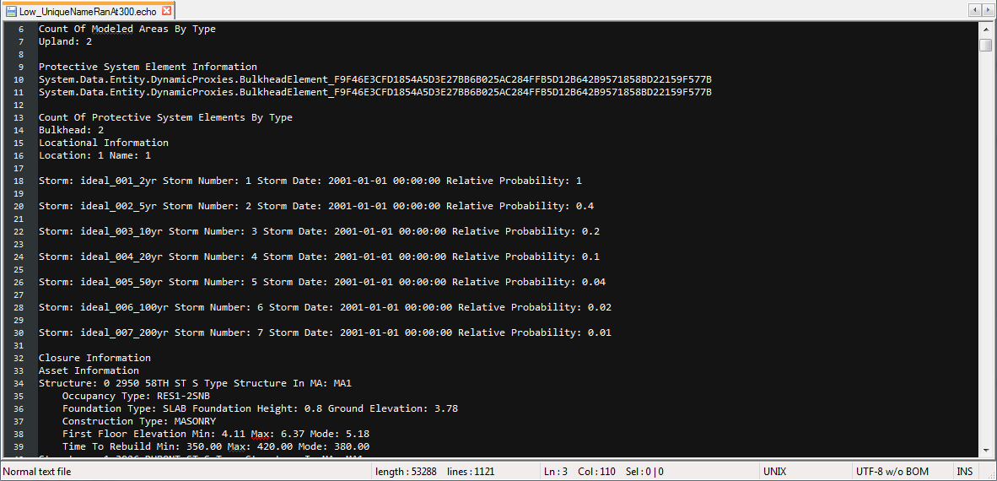

### PRN

The prn file is a default ascii output that has a summary of run settings and results for the run written to it. This output is specifically written for structures that are inside the benefits base.

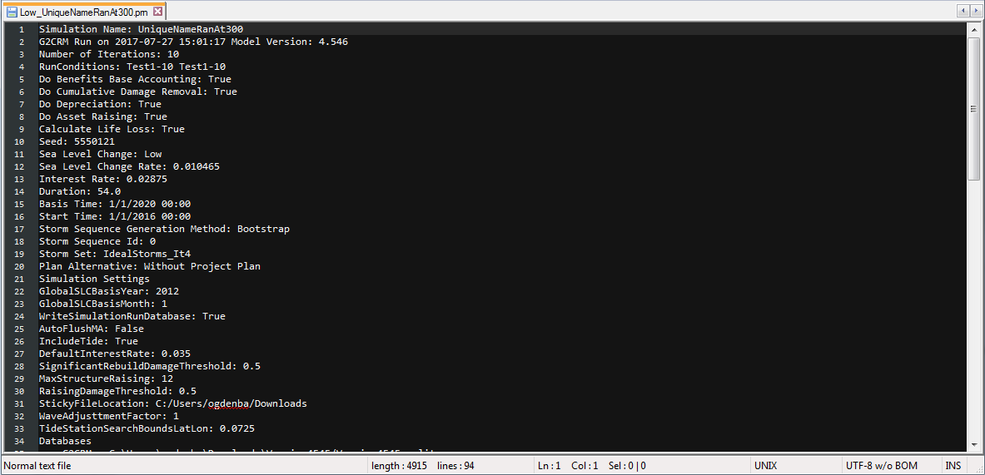

### CSV Output Database

The CSV output database is a default SQLite database output that contains user-controlled contents. The contents are individual tables for each default CSV file and optional tables for each user-controlled CSV file. An example is shown below in SpatiaLite GUI.

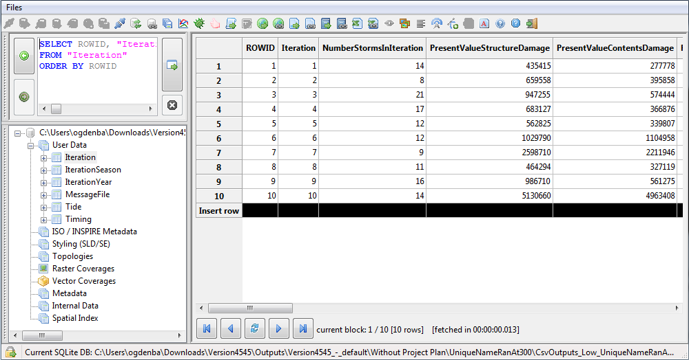

### Map Output Database

The map output database is a default SpatiaLite database output that contains statistical results that can be mapped using GIS software. Results can also be opened in a SQLite viewer like SpatiaLite GUI, as shown below.

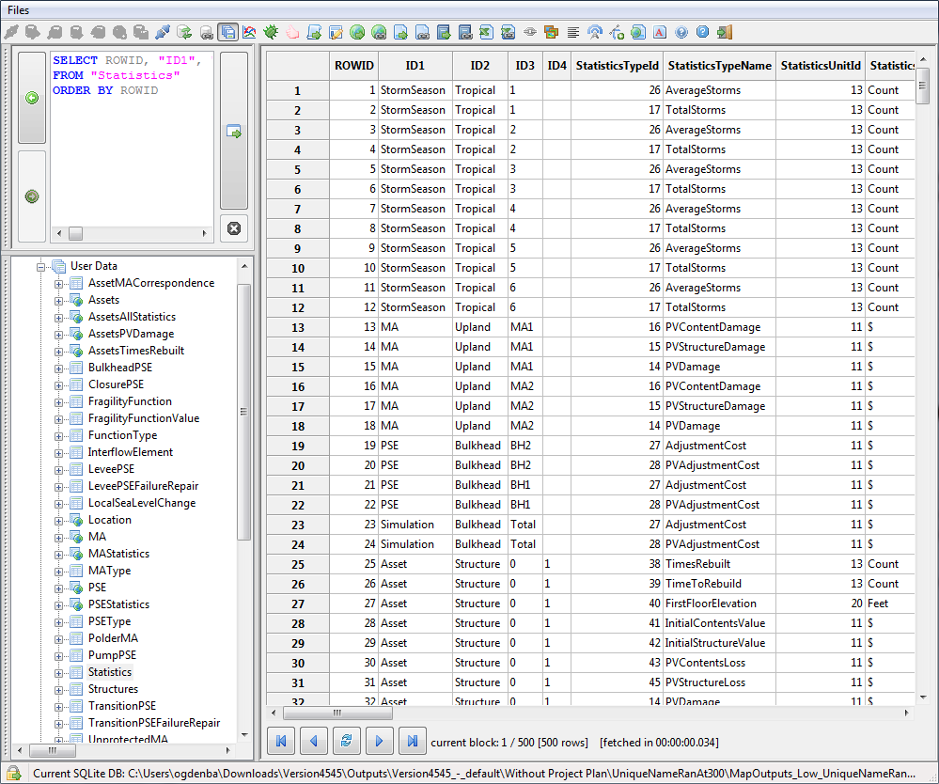

## Post-Processing

The post-processing reports are available on the “Outputs” tab. The post-processing reports can be configured to select specific runs that should be included in the reports. To select outputs for the reports, go to the “Outputs” tab and click the “Select” button.

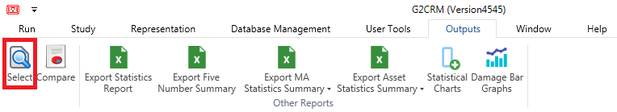

Enter a non-zero number in the far-left column of the table for the runs which should be included. Click “Save Processing Selections” and run the desired reports.

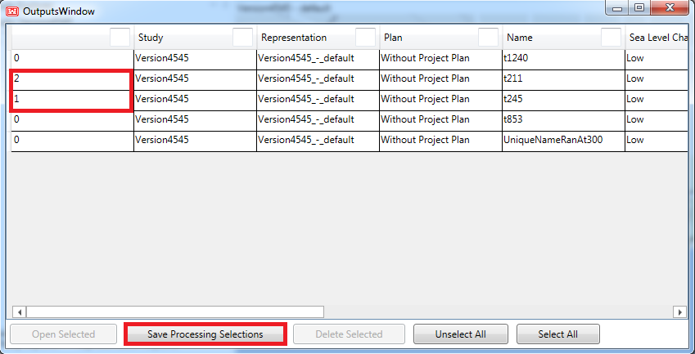

Runs which are no longer relevant can also be deleted from the study using the same window. Simple highlight the desired runs (holding the Ctrl button if there is more than one) and click “Delete Selected”. Confirm that you are sure, and the runs will be deleted from the simulation log.

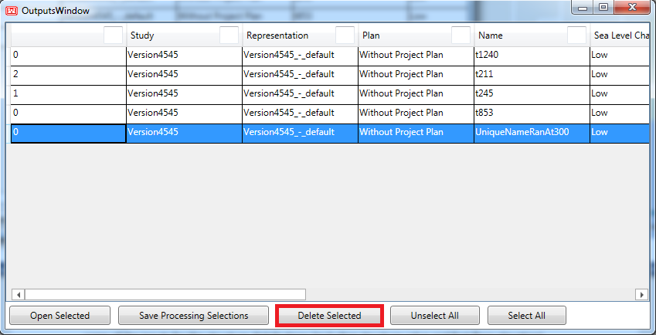

### Representation Statistics

Selected statistics about the input data are available in the “Representation” tab under the “Statistical Summary” button.

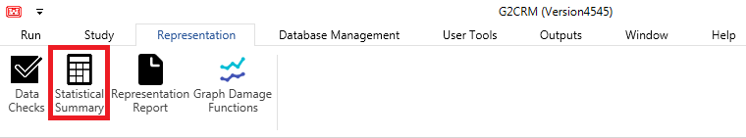

These statistics include minimum, maximum, count, mean, and standard deviation of some of the inputs for the structure distributions (including structure value and first-floor elevation).

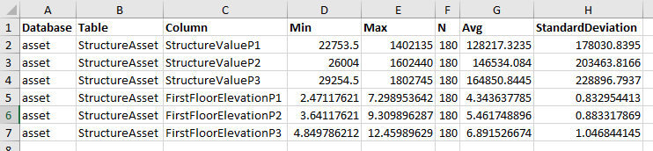

### Comparison Report

The Comparison Report is an excel worksheet available on the “Compare” button of the “Outputs” tab that compares basic information about the run and the results of the run.

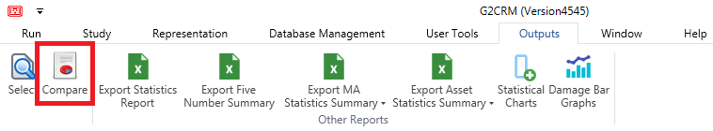

This report includes the representation, run conditions, plan alternative, damage costs, life loss, number of storms, and computation time for the selected runs. Damages are only shown for the in benefits base assets, while life loss is for any assets.

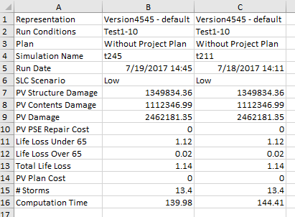

### Statistics Report

The Statistics Report (“Export Statistics Report” button on the “Outputs” tab) gives a complete record of all statistical information that is captured for a run for storms, modeled areas, and the simulation. Damages are only shown for the in benefits base assets, while life loss is for any assets.

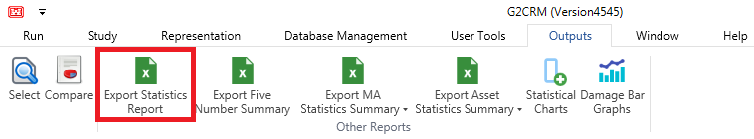

This includes mean, standard deviation, maximum, skew, kurtosis, quantiles, and CDF. It does not provide individual asset statistics, these are available through the “Export Asset Statistics” option.

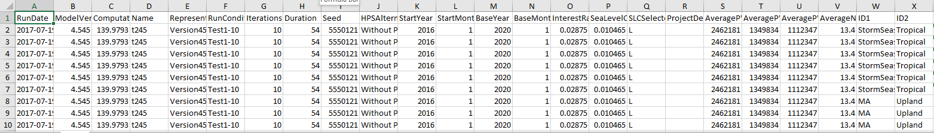

### Five Number Summary

The Five Number Summary is a subset of the Statistics Report, with the same rows, but no reporting of the CDF statistics that are present in the Statistics Report. Damages are only shown for the in benefits base assets, while life loss is for any assets.

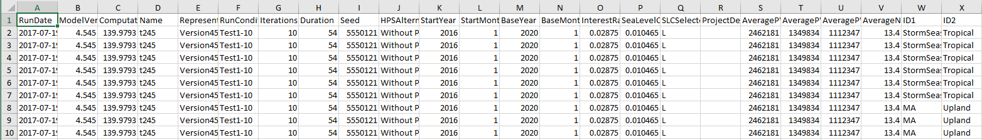

It is available on the “Export Five Number Summary” button of the “Outputs” tab.

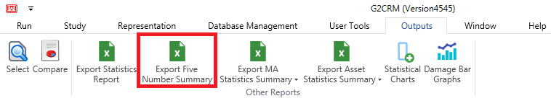

### MA Statistics Summary

The Export MA Statistics Summary requests from the user a choice of the individual statistics to be reported at the MA level, through a pull-down on the “Export MA Statistics Summary” button. This output is specifically written for structures that are inside the benefits base, unless the benefits base is turned off in the run conditions.

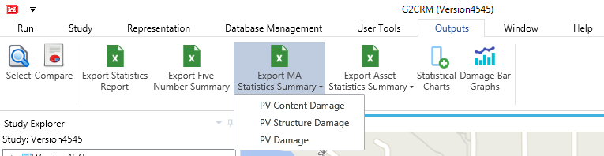

This Excel report generates one worksheet for each selected run name, giving all the standard statistics for each MA.



### Asset Statistics Summary

The Asset Statistics Summary report provides the complete set of available statistics by asset for the selected statistics type, based on the pulldown menu on the “Export Asset Statistics Summary” button. Note that this is a scrolling menu, and more options are presented if the down arrow on the menu is selected. Damages are only shown for the in benefits base assets, while life loss is for any assets.

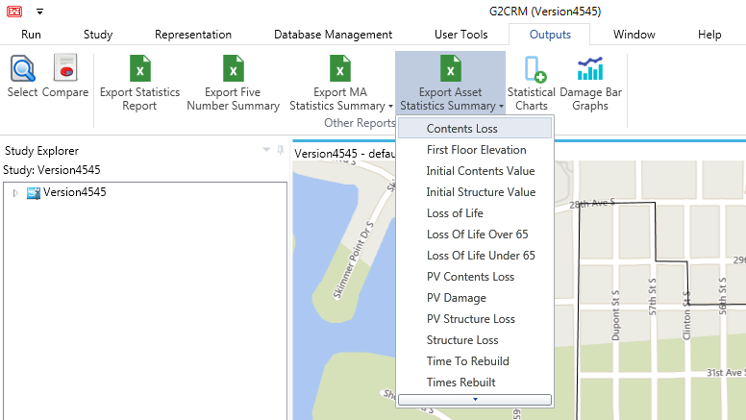

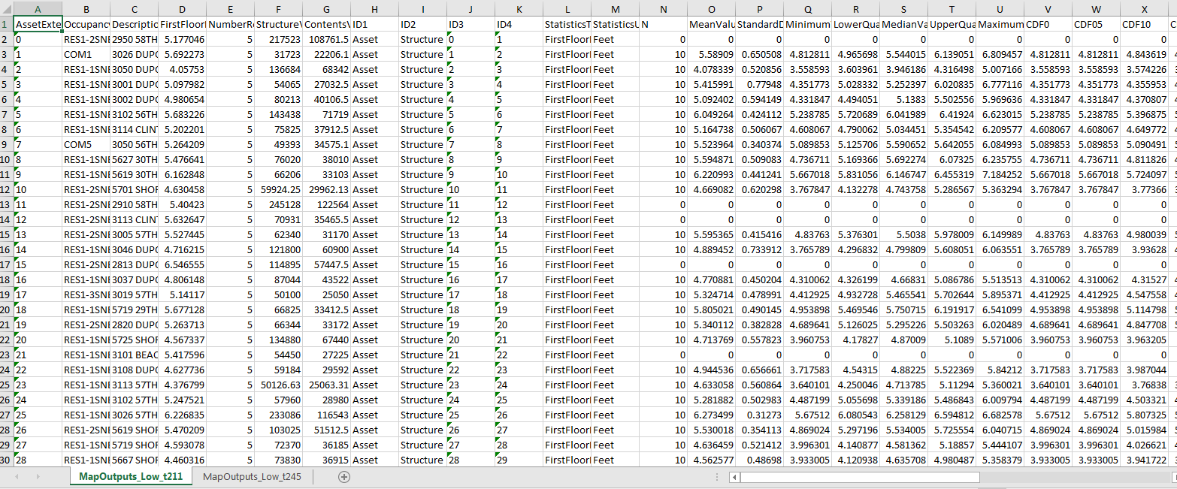

## Graphics

The processing selection statistics are also displayable in graphical form using Python plugins. Python generated charts and graphs have an inherent limited customization and export capability using the top bar menu of the generated figure. At this time, these graphics are to serve as a proof of concept. The development team welcomes any feedback on the utility of the graphs and possible improvements.

### Statistical Charts

The Statistical Charts (“Outputs” tab, “Statistical Charts” button) tool provides three different depictions (box plots and graphs) of the present-valued damages for the selected runs.

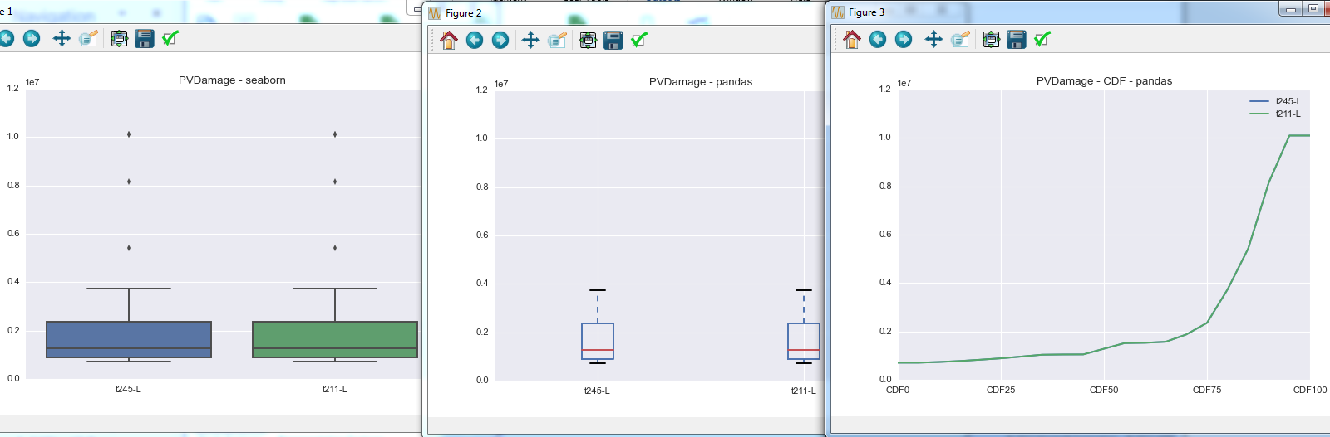

### Damage Bar Graphs

The Damage Bar Graphs tool provides three different depictions of histograms that allow the user to compare structure, contents, and overall damage values to each other and to those of different runs.

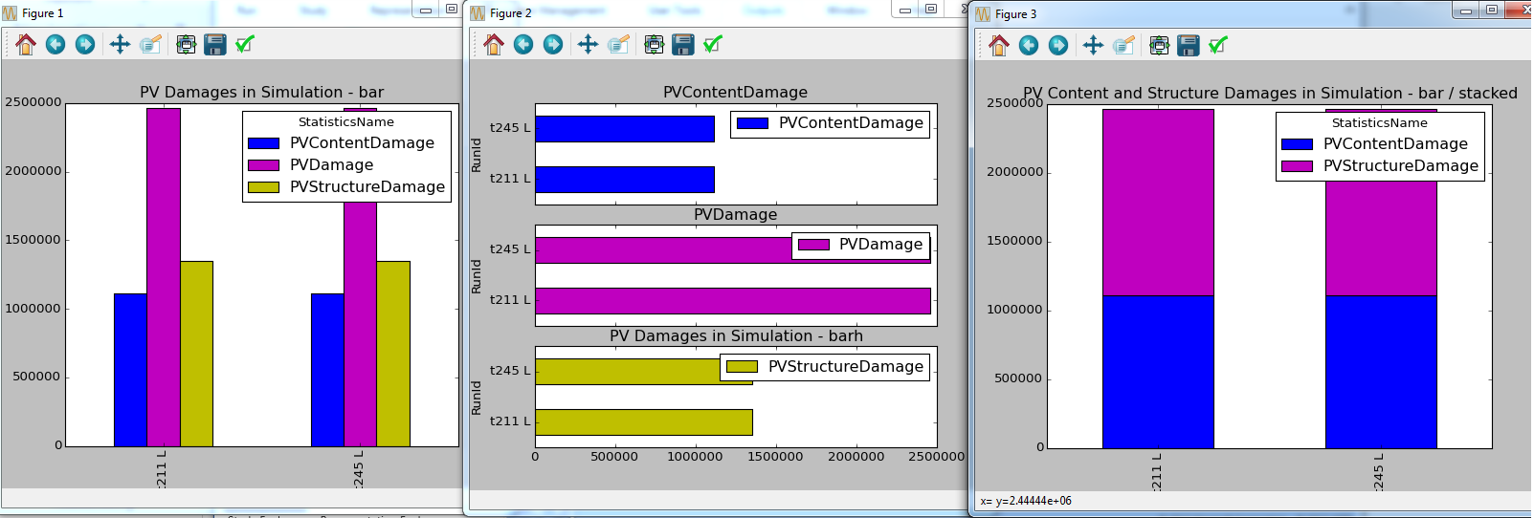

## Mapper

The Mapper tool, available on the “User Tools” tab by clicking “GIS Mapper”, is an application written by USACE and incorporated into the model with the support of Will Lehman as a way of visualizing output data from runs in a spatial context.

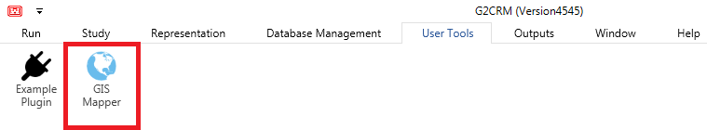

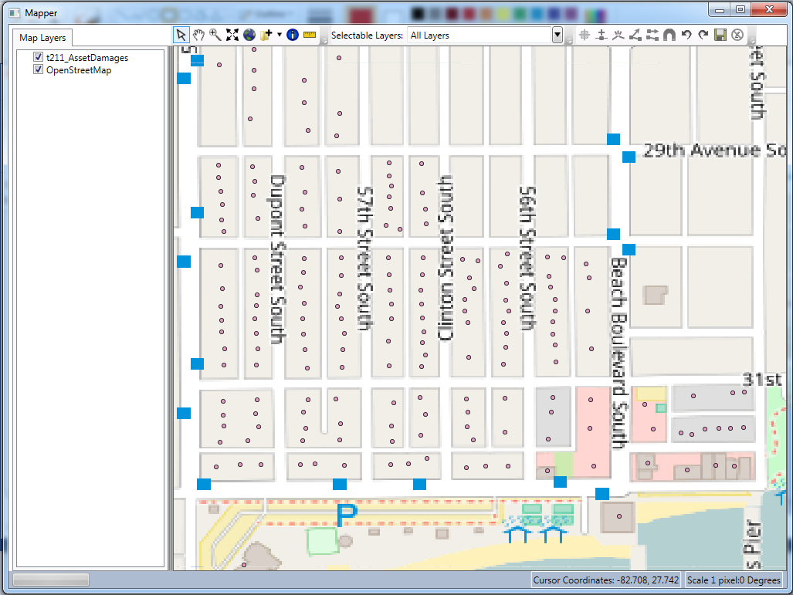

This tool has its own documentation, available on the “Help” tab by clicking “Mapper Help”.

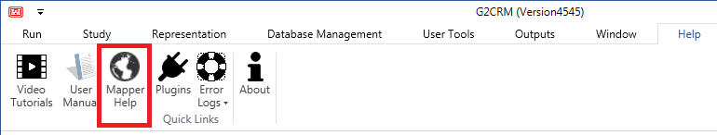

# Appendices

## Troubleshooting

### Data Validation

Often unexpected behavior in the application is caused by invalid data in the databases. To ensure that the data is consistent with the model’s expectations, consider running a data check on the currently selected databases. Run a data check by going to the “Representation” tab and clicking on the “Data Checks” button. If you have data that does not pass the data check, you will need to follow the prompt and enter a name for an excel workbook, which will detail any issues by table (where the worksheet is named after the table). Each row will have a column at the far-right, which describes the issue found. Any blue cells highlighted are informational. Yellow cells highlighted are warnings. Red cells highlighted are critical and should be resolved. This data checking plugin has limited data checks at this time and will be expanded later. Below is an example of an UplandMA table item having a different text identifier than used in the MA table. Information is given to aid the user in solving the issue in the “Messages” column.



Additional data validation can be done by ensuring damage functions adhere to the convention where the first parameter is the minimum value, the second parameter is the mode, and the third parameter is the maximum. This can be assisted by using the damage function graphs available in the “Graph Damage Functions” button on the “Representation” tab. This tool can be cumbersome if there are many damage functions. When using this tool to review the damage functions, the user should be looking for functions that are not monotonically increasing and for the occupancy type graphs where the lines (min, mode, max) cross. The graph below shows an invalid damage function lookup because P1 (minimum) shows higher damage than P3 (maximum).

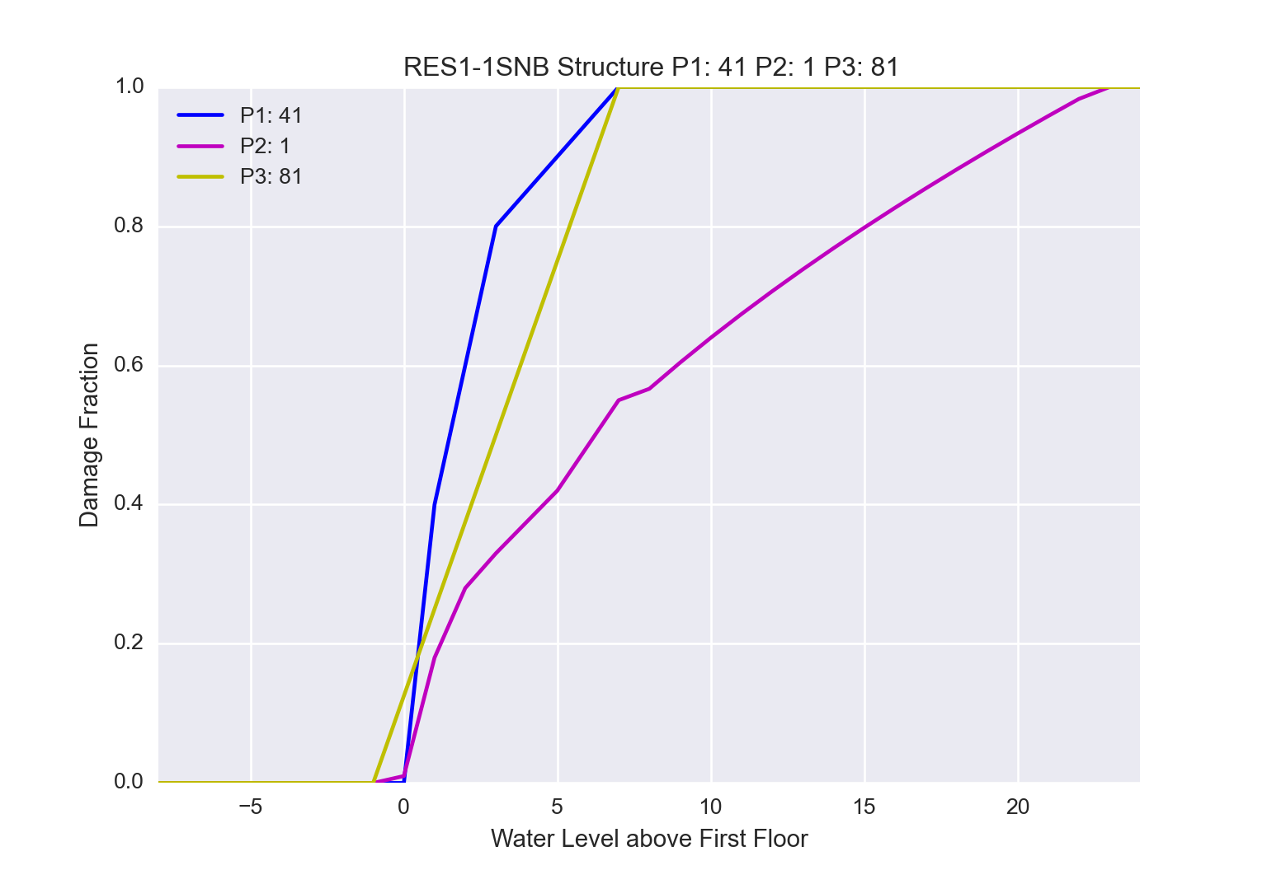

### Plugin Log Files

If users are encountering unexpected behavior from plugins, the log files will prove helpful to those with programming (specifically python) knowledge. These log files are located at AppData/Local/G2CRM/Log. There is a shortcut to this directory accessible on the "Help" tab in the "Error Logs" drop-down on the "Plugins" button.

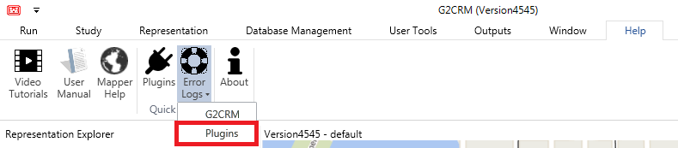

### Simulation Log Files

If users are encountering unexpected behavior during a simulation, it may be useful to share the simulation error file with the development team. This file is located at [StudyDirectory]/Outputs/[RepresentationDirectory]/[PADirectory]/[SimulationName]. This file has a .err extension.

### Model Error Output

If the model unexpectedly quits or encounters some exception, check the application error log for any messages. There is a shortcut to this directory accessible on the "Help" tab in the "Error Logs" drop-down on the "G2CRM" button.

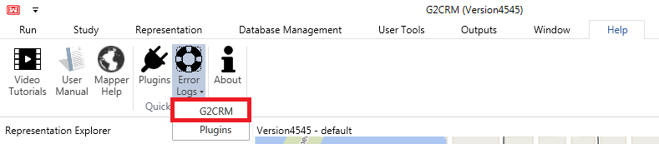

## Quick-Start

This guide contains detailed information intended to help the user understand many of the intricacies of the G2CRM model. If you would like to by-pass understanding the model in this detail, following the instructions in the sections below will provide an express route to a simulation run:

1. Create a study: This is described in detail in the “Study Management” section under “Creating Studies”.
2. Export/import data: If you already have data files then exporting will not be required. Detailed import/export instructions are found in the “Importing/Exporting Data” section.
3. Create run conditions: The “Run Condition Management” section defines many of the terms associated with the run condition variables. The “Creating Run Conditions” section under “Run Condition Management” provides instructions for creating the run conditions.
4. Set file output: The “Performing Model Runs” section lists the output profiles available and how to select an output profile. For long runs or many iterations, minimal output is suggested.
5. Begin the simulation: The “Performing Model Runs” section has instructions for starting the simulation under “Starting the Simulation”.
6. Review output: Instructions for viewing the output are in the “Performing Model Runs” section under “Viewing Output”. Information about the output and post-processing of the output can be found under the “Output Data” section.

The videos, found in the “Help” tab by clicking “Video Tutorials” may also be helpful in gaining a quick understanding of running the model.

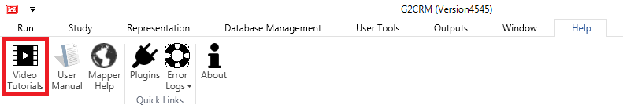

## Adding Custom Plugins

The model allows the user to add custom python plugins. The user may navigate to the “User Tools” ribbon and use the “Example Plugin” button to see an example of a custom plugin. The dialog that pops up will notify the user of the location of this example plugin. In the directory that contains this example plugin, there will be two required files: example_plugin.py and example_plugin.crply. After adding plugin files, the user will need to re-open the application to display the button and register the listener for the newly added event.

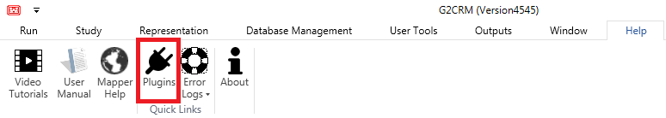

A shortcut to the plugins directory is available on the “Help” tab on the “Plugins” button.

### Python Files

The example plugin code (example_plugin.py in the directory whose shortcut is provided on the “Help” tab under the “Plugins” button) is provided to serve as an example of how to use the given parameters in a custom python plugin. All code in this file should be copied and pasted as boilerplate code in any custom python plugins. The main function shows an example of how to use the arguments provided.

Please keep in mind that while we have many libraries included in the python environment, depending on what kind of plugin you are writing, you might need to expand our existing environment. The python environment can be found in the program files folder for G2CRM.

The location of the python plugin is flexible. The relative location of the python file will be given to the model in the CRPLY file’s path to script property.

### CRPLY Files

This file provides a definition for the plugin. It lets the user interface know the path to the script (python file) and what the interface button for this plugin should look like. The example is found at example_plugin.crply in the directory whose shortcut is provided on the “Help” tab under the “Plugins” button. Each plugin should have the same format as the example plugin:

* Name: This is the name of the plugin, and provides an identifier for the user to find the log files while debugging the plugin.
* Version: Increment as needed when changes are made to the python plugin.
* Author: This is the author of the python plugin.
* Author Email: This is the email of the author.
* Path to Script: This is the relative path of the script. The example python and .crply files are in the same directory, so this is just the python file name.
* Package Directory: Leave this blank.
* DLL Directory: Leave this blank.
* Events: The events should be unique to the newly created plugin. Events cannot be reused for different plugins.
* Interface Icon: This is the relative path to the icon used for the plugin’s button interface.
* Interface Tooltip: Provide a short description of the plugin that will be visible when the user hovers over the plugin’s button.
* Interface Header: This is the title of the plugin, to be placed on the plugin’s button.
* Interface RibbonTabItem: This is the name of the ribbon tab that the button should appear on. An existing ribbon tab (“Run”, “Study”, “Help”, etc.) may be used, or the user may create a new ribbon tab simply by entering a new name in this field.
* Interface RibbonGroupBox: This is the name of the group on the ribbon tab. For example, the “Run” tab has groups “Simulation” and “Outputs”. Again, the users may use an existing group name or create a new one by entering a new name in this field.

The CRPLY file must be located in the ProgramData/G2CRM/Plugins folder (navigable through the “Help” tab on the “Quick Links” button group by the “Plugins” button).

### Troubleshooting

If the user is experiencing difficulties with a plugin, the log files at the following path could be of use: AppData/Local/G2CRM/Log. The user can also reach these log files by clicking on the “Plugins” item from the “Error Logs” drop-down on the “Help” tab.



## Additional Software

Although no external software is necessary to run G2CRM, if users build the G2CRM data files themselves or choose to analyze data outputs from the SQLite or SpatiaLite databases, they will find the following tools helpful.

### QGIS

QGIS is a free and open-source geographic information system (GIS). It can be used to aid users in adding data to the shapefiles that are exported by the model. Some GIS experience would be helpful when using this tool. QGIS can be downloaded at the following link: <http://www.qgis.org/en/site/forusers/index.html#download>

### SpatiaLite GUI

SpatiaLite GUI is an open-source graphical user interface tool that supports SQLite and SpatiaLite database formats. This tool will be helpful for analyzing the map output or CSV output databases for model runs. Users will need to be familiar with basic SQL to use this tool. This tool can be downloaded at the following link: <https://www.gaia-gis.it/fossil/spatialite_gui/index>

### HDF5 Viewer

The data contained in the storm .h5 files can be viewed using the HDFView software, available from: <https://support.hdfgroup.org/products/java/hdfview/index.html>

## Installation Guide

G2CRM is distributed by internet download. In order to complete the installation of G2CRM, users must have administrator permissions on the computer.

### Install Procedure

1. If an earlier version of G2CRM was installed on the system, please be sure to uninstall the earlier version before installing a new version.
2. Download the installation file to a temporary directory.
3. Double click the downloaded executable to open the G2CRM Setup window.
4. Select “Install”.
5. When the installation is complete, the G2CRM Setup window will read “Installation Successfully Completed”, and the user can close the window.

### Uninstall Procedure

1. Open the Control Panel from the Start Menu.
2. Select Uninstall a Program from Programs and Features.
3. Select G2CRM from the table and click “Uninstall” in the table header. This will open the G2CRM Setup window.
4. Click “Uninstall” in the G2CRM Setup window.
5. When the uninstallation is complete, the G2CRM Setup window will read “Uninstall Successfully Completed”, and the user can close the window.

### Troubleshooting Install/Uninstall

Always be sure to follow the install and uninstall procedures noted above. If there are issues installing or uninstalling G2CRM from the system, please make sure all traces of the application have been deleted from the machine. This includes:

* Removing the app data directory at: C:\Users\YOURUSER\AppData\Local\G2CRM
* Removing the program data directory at: C:\ProgramData\G2CRM
* Removing the program data directory at: C:\Program Files\G2CRM
* Using the registry editor to remove any data at: HKEY_CURRENT_USER\Software\IWR\G2CRM
* Using the registry editor (regedit.exe) to search for “G2CRM” and remove any other registry keys
* Using command line “Reg delete” to delete any registry keys that cannot be deleted in the registry editor

Once all traces of the application have been removed, a new G2CRM version can be installed, adhering to the instructions above.

## Glossary

### A

#### ADCIRC

The Advanced Circulation Model (ADCIRC) is a high-fidelity model that predicts water levels and currents over a large area using finite element techniques based on input parameters including subsurface bathymetry, wind velocity, atmospheric pressure, and storm tracks. Results in the form of water level hydrographs are reported on specific Save Points of the finite element grid.

#### Asset

An asset is a general term for elements of a study that are not part of the protective system and can be damaged by storms. Structures (residential, commercial, industrial, etc.) are the most typical types of assets, and are currently the only asset type implemented within G2CRM.

#### Asset Database

A SpatiaLite database used within G2CRM to hold information on assets, structures, damage functions, lethality zones and functions, and evacuation planning zones.

### B

#### Benefit Base

The Water Resource Development Act (WRDA) of 1990, Section 308, requires (in simplification) that damage to certain structures built in flood plains cannot be included in the benefits calculation as damages avoided. Structures are identified for this purpose as being inside or outside the ‘benefit base’. G2CRM does not include structures outside the benefit base in summaries of damage avoided, but loss of life associated with residents in those structures is calculated, and detailed information on damages is available. Per WRDA, structures that are outside the ‘benefit base’ are primarily structures built/improved after 7/1/1991 with a first-floor elevation below the 100-year flood plain. WRDA also has additional definitions for placing structures outside the benefits base. Every structure in the asset database must be defined as initially inside or outside of the benefit base.

#### Bounding Polygon

A bounding polygon is a polygon shapefile that defines the boundaries of the study area. It is a required input for establishment of a G2CRM study. The projection used for the bounding polygon is expected to be used for all imported data, i.e. data should be consistent in terms of the projection used. The bounding polygon, other than being used to obtain local tide stations, is only used for map display purposes. It is only necessary that it approximates the display area. Below is an example of a bounding polygon (in blue) with the associated modeled areas shown in orange.

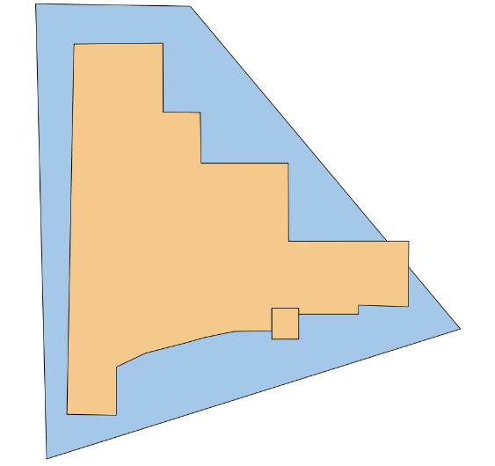

#### Box Plot

A box plot, sometimes referred to as a box and whisker plot, is a graphical means of summarizing a distribution of data based on the quartile statistics for the data (minimum, first quartile, median, third quartile, and maximum).

#### Bulkhead

A bulkhead is a protective system element that prevents water from entering a modeled area if the total water level of the associated storm is below the bulkhead top elevation. Each bulkhead is associated with one and only one modeled area. At present, bulkheads do not fail. The term is used interchangeably with “sea wall”.

### C

#### C#

C# (C Sharp) is a widely-used modern object-oriented programming language. It is commonly used on Windows computers in conjunction with the .NET Framework, a library of reusable modules. G2CRM is programmed largely in C#.

#### Coastal Hazard System

The coastal hazard system (CHS) is a repository of synthetic and historic storms, storm tracks, and associated storm probabilities that has been developed by the USACE Coastal Hydraulics Laboratory. It is a basic source of storm data for G2CRM.

#### CSV File

A CSV (comma-separated values) file is a plain text format file that is useful for storing tabular (row and column) data. It is a widely used format for import and export to a variety of programming tools.

#### Cumulative Distribution Function

A cumulative distribution function (CDF) is a statistical representation of the probability that a particular variable from a data set is less than or equal to a given value. Within G2CRM, output statistics are reported as CDFs.

### D

#### Damage Function

A damage function provides the relationship between a ‘damage driving parameter’, typically the water elevation above the lowest walking floor, and the fractional structure and contents damage to the asset in question. Damage functions have been developed from post-flood assessments and expert elicitation. Damage functions are the fundamental method of determining structure damage within G2CRM. Damage functions are organized by occupancy type.

#### Data Projection

Spatial data is always associated with some kind of coordinate system, e.g. latitude/longitude, Universal Transverse Mercator, state plane coordinates. Within a G2CRM study, a single data projection must be specified by defining a unique Spatial Reference System Identifier (SRID) that defines the projection in which the basic study data is developed and presented within a GIS.

#### Datum

A datum is a base elevation reference from which heights or depths are determined. Storm water levels are typically (but not always) referenced to local Mean Sea Level (MSL). Ground and first floor elevations for structures are typically referenced to the North American Vertical Datum of 1988 (NAVD88). Tide hydrographs G2CRM obtains from the internal tide tool are served up referenced to Mean Lower Low Water (MLLW). G2CRM requires conversion factors between MLLW and the Storm Datum (typically but not always MSL) and between the Storm Datum (typically but not always MSL) and the Asset Inventory Datum (typically NAVD88).

#### Depth-Limited Wave

The height of a breaking wave is dependent upon water depth, and typically will not exceed .78 x the water depth. The input storm data set may or may not have associated wave height data. Wave data may or may not be present in the imported high fidelity modeling storm data. If wave data is present, the user can specify that wave data is to be used as stored, or to limit wave height based on the above relationship to water depth. If no wave data is present, i.e. the wave data source is ADCIRC modeling, then the relationship is used within G2CRM to estimate an associated wave height.

### E

#### Evacuation Planning Zone

An evacuation planning zone is a spatial area, defined by a polygonal boundary as a shapefile, that is used within loss of life calculations in G2CRM to determine the population remaining in structures during a storm.

#### Extra-Tropical Storm

An extra-tropical storm (extra tropical cyclone) is a meteorological term used to distinguish large damaging storms such as Nor’easters from hurricanes (tropical cyclones). G2CRM allows for specification of storms as either tropical (T) or extra-tropical (ET), such that they are then associated with the differing storm seasons for the two types of storms.

### F

#### Five-Number Summary

The five-number summary is a simplified representation of the statistics for a continuous variable, consisting of: the minimum value; lower quartile; median; upper quartile; maximum value. G2CRM provides a five-number summary report for each collected statistic, and certain of these statistics are displayed graphically in a box plot.

#### Fragility Function

A fragility function is used in conjunction with protective system elements to determine the probability of failure of the element as a probability (0,1) based on water elevation on the structure. It is used in conjunction with wall, levee, and transition elements, but is not currently implemented for bulkheads/seawalls. Given a water level, the fragility function is used to look up the critical probability. A random number is then generated, and, if greater than the critical probability, then the protective system element has failed.

### G

#### Gate

A gate is a protective system element that, if open, allows water to pass from inside/outside of a modeled area. It is associated with a polder modeled area. It is not available in the current certified version of G2CRM.

### H

#### HDF5

An HDF5 (hierarchical data format) or H5 file is common data storage format that is self-describing, i.e. each element within it carries information about itself in addition to the value. The H5 format is used by G2CRM for storm hydrograph representation. It can be read or written from a variety of computer languages, including C# and Python.

#### High Fidelity Storm Model

A high fidelity storm model is a computationally-intensive model that uses basic hydrodynamic theory to predict storm water levels and currents over time at points on a detailed finite element mesh representation of a coastal region. The ADCIRC model is an example of a high fidelity storm model that has been used extensively by the Corps of Engineers to forecast storm surge.

#### Hurricane Protective System

A hurricane protective system (HPS) is the umbrella term for all of the elements that serve to protect coastal areas from storms.

### I

#### Iteration

An iteration is used within a Monte Carlo Simulation (MCS) such as G2CRM to represent a single simulation of a life cycle (a number of years over which the project is being analyzed). A G2CRM run consists of one or more iterations. At each iteration, different variables are sampled to allow for representations of uncertainty in variables, such as the number of storms in a year. Over a large number of iterations, the overall results should return values representative of the input variabilities.

### L

#### Lethality Function

A lethality function is an exceedance function of proportional loss of life. It Is used within G2CRM to estimate the number of deaths for population remaining in a structure. Three such functions are provided, one for each of the three lethality zones (Safe, Compromised, Chance). For each structure, each population cohort (over 65, under 65) is assigned to a lethality zone based on structure occupancy type and water level. The associated function is then sampled randomly to determine the fractional loss of life at the structure for a given storm.

#### Lethality Zone

Lethality zones are assigned within the loss of life estimation procedure, based on age cohort, structure occupancy type, and water level. G2CRM contains data based on empirical studies and expert opinion that assigns zones based upon surge above the foundation. This information is used to select the appropriate lethality function during simulation runs.

#### Levee

A levee is a protective system element within G2CRM that protects a modeled area. It is subject to overtopping and failure and is typically of earth construction. It is not currently exposed to the user in the certification version of G2CRM. It is similar in character and data requirements to walls and transitions, which are also not exposed to the user.

#### Life Cycle

A life cycle is a user-input number of years for which each iteration of a simulation run is to be carried out, e.g. 50 years. It is used to represent the planning horizon associated with the study.

### M

#### Model Run

A model run is a user-initiated launch of the G2CRM. A model run is associated with a set of run conditions (number of iterations, duration of life cycle, etc.); a plan alternative (without project or with project alternatives); and a modeled storm set (an initial set of pre-stored storms to be used). Each model run has an associated user-specified identifying name. Model results are organized by the identifying name.

#### Modeled Area

A modeled area (MA) is a spatial area within a G2CRM study that contains assets, may be defended from storm surge by a protective system element, and has a defined water level at any given time. It is a fundamental element of the G2CRM analytical framework.

#### Modeled Storm Set

A modeled storm set (MSS) is a method for organizing the pre-defined storms within the Storm database into groups. The G2CRM data framework can store different such sets of storms, for example to represent storm surge in a without project condition and in a with-project condition where a tidal barrier is in place. Each G2CRM run starts using an initial MSS which determines the storms that are drawn randomly by bootstrapping. Plan alternatives allow for changing the modeled storm set at a later time in the life cycle.

#### Monte Carlo Simulation

Monte Carlo Simulation (MCS) is a method for representing uncertainty by making repeated runs (iterations) of a deterministic simulation, varying the values of the uncertain input variables according to probability distributions. At each iteration, variables are sampled and used in the deterministic representation. Results are aggregated over a large number of iterations to provide a distribution of results that can be used for risk communication and decision-making.

### N

#### .NET Framework

The .NET (dot Net) framework is a programming construct used primarily in Windows computers, operating systems, and programming languages to simplify the construction of programs through provision of standardized reusable components. It is usable from a variety of programming languages, including C#, C++, and Visual Basic. G2CRM makes extensive use of .NET.

#### National Structure Inventory

The National Structure Inventory (NSI) is a set of representative synthetic structures derived from terrain and census data that can be used within G2CRM when a real-world inventory is not available or has not yet been created. It was originally created by the Hydrologic Engineering Center and is now maintained by FEMA.

### O

#### Occupancy Type

An occupancy type is associated with each structure. It is a required data element, used for the identification of damage functions and lethality curves. Occupancy types are identified by a code and descriptions (e.g. RES1-1SNB/Residential One Story, No Basement; COM1/Average Retail; IND1/Average Heavy Industrial) and can be user-defined as long as the appropriate damage functions and lethality curves are specified.

### P

#### Plan Alternative

A plan alternative is a set of adjustments made to structures and elements of the protective system during a life cycle. An adjustment is a change to the properties of an element value at a particular time within the life cycle, e.g. raise a bulkhead to 6’ in 2040. It is used to represent plans such as bulkhead raising, structure raising, and structure removal. Each model run must be associated with a particular plan alternative (which may include the default ‘Without Project’ alternative that contains no such adjustments).

#### Plan Alternative Database

The plan alternative database stores the collection of plan alternatives that have been defined by the user. Plan alternative definition is through an Excel™ spreadsheet that is imported into the database. Multiple plan alternatives can be represented. Once imported, each defined plan alternative is available to be associated with a model run.

#### Plugin

A plugin is a Python-language script that is included within G2CRM to extend model functionality. A number of such plugins are provided with the G2CRM install to perform functions such as data checking and output reporting and visualization. Plugins can also be written and added by the user such that they become an integral part of G2CRM, available from the user interface.

#### Polder MA

A polder modeled area is a basin typically surrounded by a set of ring levees. It has an associated volume-stage function such that the water level in the polder MA is determined by the volume of water within the polder. It is not available in the current certification version of G2CRM.

#### Probabilistic Life Cycle Analysis

Probabilistic life cycle analysis (PLCA) is a generic term for modeling uncertainty over a period of years. It can be implemented through a frequency analysis approach, as in the HEC-FDA software, or through an event-based Monte Carlo life cycle simulation as in G2CRM.

#### Protective System Element

A protective system element (PSE) is a component of a hurricane protection system, such as a bulkhead/seawall, gate, pump, or levee/wall/transition. It is used to mediate the flow of water and water levels for an associated modeled area.

#### Pump

A pump is a protective system element that can remove water from a polder MA. It is not available in the current certification version of G2CRM.

#### Python

Python is a well-known programming language that is used with G2CRM to add functionality and to allow users to write their own plug-ins to extend base G2CRM capabilities.

### Q

#### QGIS

QGIS (Quantum Geographic Information System) is an open-source, freely available, multi-platform GIS that can be used in conjunction with the SpatiaLite databases of G2CRM to visualize output in mapped format. It is a free alternative to commercial software that can be used to develop Import data (in the form of shapefiles) used for basic description for assets, modeled areas, the protective system, and other elements used within G2CRM.

### R

#### Representation

A G2CRM study consists of one or more representations. Each such representation consists of a set of four databases (storms, system, assets, and plan alternatives). A given database can be used in one or more representations. The purpose of a representation is to allow different levels of definition during the course of a study. For example, at the early stages of a study, storm and system information may be available but detailed asset data has yet to be developed. In that case, a simplified asset representation can be used. At any given time, G2CRM is operating on a single representation within a study, but results from different representations can be compared.

#### Run Conditions

Run conditions are the specifications that are made by the user and used when a model run is launched. Multiple run conditions can be created and stored. Elements of a run condition include: the number of iterations; the length (duration in years) of the life cycle; the start and base years for the simulation; the sea level change rate and scenarios (low, intermediate, high); the interest rate to be used; and the method of storm sequence generation.

### S

#### Save Point

A save point is a location on a finite element mesh, typically associated with a high fidelity storm model such as ADCIRC, at which results are recorded and stored. Storm data for G2CRM is typically obtained from information stored in the Coastal Hazard System for save points located in the study area.

#### Sea Level Change

G2CRM takes into account the water level contribution associated with sea level change (SLC). Sea level change is calculated per Corps policy and guidance. Each model run can make use of one of the three Corps-defined sea level change scenario curves: low, intermediate, high. User input is required for the base sea level change rate.

#### Seawall

A seawall is a protective system element that prevents water from entering a modeled area if the total water level of the associated storm is below the seawall top elevation. Each seawall is associated with one and only one modeled area. At present, seawalls do not fail. The term is used interchangeably with “bulkhead”.

#### Shapefile

A shapefile is a standard GIS format file that stores location and attribute information. Each shapefile is associated with one geometry type: point, line, or polygon. G2CRM uses shapefiles as basic input elements and has defined templates specifying the data attributes for each such file.

#### Spatial Reference Code

A spatial reference code (SRID) is a standard code that is associated with the projection used for spatial data within G2CRM.

#### SpatiaLite

SpatiaLite is an open-source spatial relational database that is capable of storing both spatial and attribute information in a set of tables. It allows for performing spatial operations such as queries to find all points within a polygon. It is an extension of the widely used SQLite database. G2CRM uses four such SpatiaLite databases for each representation to hold data for assets, storms, the system, and the plan alternatives.

#### Specified Storm Sequence

G2CRM provides two alternative methods of generating storm sequences within a life cycle, specified as part of the run conditions. The Bootstrap method makes uses of sampling of the stored storms according to probabilities within seasons. This results in different selected storms during each life cycle. The Specified Storm Sequence method allows the user to define a specific set of storms that take place at a defined time within the life cycle for each iteration. It is an optional user input, defined as an Excel™ spreadsheet.

#### SQLite

SQLite is a public domain relational database that is very widely used. The SpatiaLite databases used within G2CRM are built upon the SQLite platform, with extensions for spatial data storage and manipulation.

#### Stage

Stage is the water level for a modeled area. G2CRM calculates a single value of stage for each modeled area, it does not vary within the area. It is referenced to the datum used for the asset inventory, typically NAVD88.

#### Stage-Volume Function

Volume-stage functions (alternatively called volume-stage functions) are associated with polder modeled areas, and may also be associated with an upland MA. They are typically derived from digital terrain models and describe the relationship between the volume contained in the modeled area and the associated stage (water depth) for the modeled area. These functions are stored in the System database. They are imported through an Excel™ spreadsheet.

#### Still Water Depth

The still water depth is comprised of three water level components: storm surge; sea level change contribution; astronomical tide contribution less the relevant ground elevation (water-side ground elevation at protective system element, or representative unprotected model area ground elevation).

#### Storm Basis Year

In order to properly capture the effects of sea level change, modeled storms stored in the G2CRM database need to have an associated storm basis year. In the process of generating high fidelity modeling results a value of Mean Sea Level (MSL) is used. There is no explicit calendar time associated with a particular high-fidelity model result, but the selection of MSL in a situation of sea level change implies a calendar date that is associated with the results. By choosing MSL, some amount of sea level change is “baked in” to the results. In order to account for this the user must supply a storm basis year that is associated with each modeled storm. This storm basis year is used within the sea level change calculations to position the storm on the relevant sea level change over time curve.

#### Storm Database

The storm database is a SpatiaLite database that stores information on individual storms, storm seasonality, storm sequences (if defined by the user), and location of tidal stations.

#### Storm Surge

Storm surge is the water level contribution to total water level from an individual stored storm. It is defined within the storms database by a storm surge hydrograph that gives storm surge at time increments over the modeled duration of the storm.

#### Structure

A structure is a type of asset (at present, the only type of asset supported within G2CRM). It is characterized by a point location and a large number of attributes needed for modeling, including occupancy type, first-floor elevation, population, and values of the structure itself and the structure contents. Data is typically imported from a shapefile that may be derived from local data or use synthetic data as in the National Structure Inventory.

#### Study

The study is the fundamental organizing principle for G2CRM data. It is a defined area for which the planning level analysis is to be performed. A study consists of one or more representations, each of which has a definition of the storms, assets, hurricane protection system, and plan alternatives that are to be examined. G2CRM can store multiple studies (and representations within studies) but at any given time it is operating only on a single representation within a study. Results comparisons can be made within a study (i.e. across different representations) but cannot be made across studies.

#### STWAVE

The STWAVE (Steady State Spectral Wave) model predicts near-shore wind-driven wave formation and water levels. STWAVE results for a variety of storms have been stored in the Coastal Hazard System and can be used as input to G2CRM.

#### System Database

The system database contains information on the hurricane protective system (modeled areas and protective system elements, volume-stage relationships) that are used within G2CRM

### T

#### Tide Contribution

The tide contribution to total water level is calculated internally within G2CRM based on an astronomical tide calculation using standard harmonic methods to determine tide at a given tide station on a given date/time.

#### Tide Station

A tide station is a location at which harmonic constants have been developed to allow for calculation of astronomical tide for any date/time. The G2CRM storms database contains a pre-defined list of some 7500 tide stations worldwide, including some 4600 for the United States.

#### Theme

G2CRM is organized conceptually into the four themes that are reflected in the associated databases: driving forces (storms); hurricane protective system (system); assets; and plan alternatives.

#### Total Water Level

Total water level for a storm is comprised of the four components of: storm surge; sea level change contribution; astronomical tide contribution; and wave height contribution. Total water level is used to determine modeled area stage.

#### Transition

A transition is a protective system element that can fail. It was used in original modeling of the New Orleans System, where transitions between levees and walls were points of possible failure. It is not currently exposed to the user in the certification version of G2CRM. It is similar in character and data requirements to walls and levees, which are also not exposed to the user.

#### Triangular Distribution

A triangular distribution is a three-parameter statistical distribution (minimum value, most likely value, maximum value) used throughout G2CRM to characterize uncertainty in data elements such as structure and contents value, time to rebuild, and first-floor elevation. It is often used when expert opinion rather than empirical distributions are appropriate.

#### Tropical Storm

A tropical storm (tropical cyclone) is a meteorological term defining a type of storm that may be characterized as a hurricane depending upon maximum wind speeds. It is one of two types of storms that can be used within G2CRM. G2CRM allows for specification of storms as either tropical (T) or extra-tropical (ET), such that they are then associated with the differing storm seasons for the two types of storms.

### U

#### Unprotected MA

An unprotected modeled area is a polygonal boundary within G2CRM that contains assets and derives associated stage from the total water level (storm surge plus wave contribution plus sea level change contribution plus tide contribution) calculated for a given storm, without any mediation by a protective system element.

#### Upland MA

An upland modeled area is a polygonal boundary within G2CRM that contains assets and derives associated stage from the total water level (storm surge plus wave contribution plus sea level change contribution plus tide contribution) calculated for a given storm, as mediated by a protective system element such as a bulkhead/seawall that must be overtopped before water appears on the modeled area. It may have an associated volume-stage relationship to account for filling behind the bulkhead during the initial stages of overtopping.

### V

#### Volume-Stage Function

See Stage-Volume Function.

### W

#### Wall

A wall is a protective system element that can fail. It is typically composed of structural elements as opposed to an earthen levee. It was used in original modeling of the New Orleans system. It is not currently exposed to the user in the certification version of G2CRM. It is similar in character and data requirements to levees and transitions, which are also not exposed to the user.

#### Wave Contribution

The wave contribution to the total water level is computed internally within G2CRM and is determined through application of the relationship: TotalWaterLevel = StillWaterDepth + 0.705 * WaveHeight

#### Windows Presentation Foundation

The Windows Presentation Foundation (WPF) is a methodology and set of components used in modern Windows programming to separate the user interface elements from underlying code. It is a flexible method of making use of reusable components and easily changing aspects the user interface without changing background code.